Workbench End User Document Control Training Guide

Contents

Table of Contents 2
Using Document Control 3
Introduction 3
Document Control User Guide. 3
How to section 4
Document Control Module 5
Creating a DocList 6
Creating a document in Workbench 7
Adding documents to a DocList 8
Marking for approval after creating a document 9
Approving Documents 9
Adding Questions 10
Issuing a document 11
Submit for Training before Issue 12
Acknowledging Receipt of an Issued Document 13
Acknowledge receipt and answering questions from the Questionnaire. 14
Viewing Documents 15
Viewing Documents using DocLists 16
Selecting your document 17
Raising a change request 18
Annotate a document when raising a change request 19
Approve/Rejecting a Change Request 21
Approving the change request with annotated document. 22
Assigning change requests and editing documents 23
View CRQ’s whilst editing, and Stay on Top 23
Editing the document with an annotated document associated. 24
Edit Complete 25
Requesting a Document Review 26
Starting a Review 28
Responding to a review 29
Closing the review 30
Complete a Review 31
Withdraw a document 32
Checking In and Checking Out of Documents 33
Using Document Control

Introduction
Workbench is a highly flexible and configurable solution to the ever increasing world of compliance management, and the overall business requirements of management, control and completion of all business processes.
It is not intended to replace the need for ISO9000 or any other compliance system and it will not remove the requirement to create the documentation. It will however give a controlled, disciplined environment in which to hold and manage that documentation. Further, it will give you a configurable platform to store and distribute that documentation in a paperless environment. In addition, it allows for the recording, managing and resolution of all and any event that needs an element of control.
The software consists of a number of modules aimed at giving businesses the ability, with one software solution, to manage all their company documentation, record, manage problems and issues, audit, and follow through suggestions and recommendations, and all with a detailed configurable workflow and audit trail.

Document Control User Guide.
This getting started guide is designed to help end users perform the day to day tasks involved with Document Control.
It is not a guide to configure the software, this should already have been done by the relevant administrators and there is no intended guidance to configure the system in this manual.
Users should also be aware that not all the variations of operation are shown within this document.
Full training should have been undertaken.

“How to” section

This is the typical Document Workflow and Lifecycle.
Raise Change Request
Create or Import Document
Define Attributes
Issue Document
Approve Change Request
Edit Document
Mark for Approval or Review
Request a Review
Start a Review
Respond to Review
Close and complete Review
Approve Document

Master Templates
Master Templates used for the creation of documents are stored within Workbench.
As a user creates a new document in Workbench, then a pre-defined format or “template” will be invoked.
At least one document (blank or “template”) for each application required must be stored if NEW documents are to be created within Workbench.
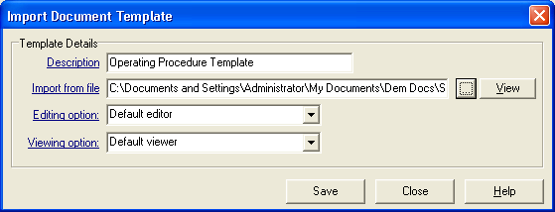
You will need to create a document by opening the application, for example MSWord, and then saving this to your local disk to use as the template master. This Master will hold formatting information, style and layout, wording and content details as required.

From the “Settings” menu, select Master Templates|New, give the template a name, then navigate to and select the document you have just created to use as a template.
HOWEVER, unlike MSWord templates, these templates should NOT be of the .dot or .dotx extension.

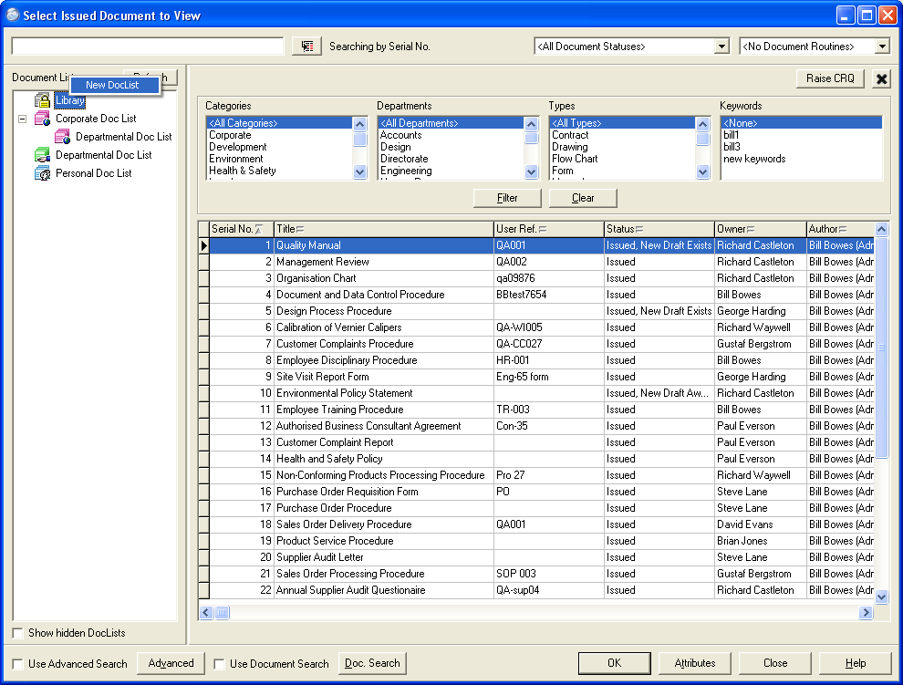
Creating a DocList
To create these areas, select the “Library” label and right mouse click. This will present a new label called “New DocList”. Selecting this will then request a name for the new folder.
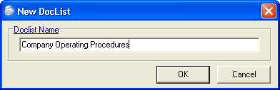
Right Clicking on the folder will give a number of options:
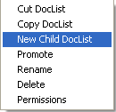
Cut DocList removes it and allows it to be pasted elsewhere.
Copy DocList copies it and allows it to be pasted elsewhere.
New Child DocList allows creation of a new DocList under current one.
Promote allows DocList and its su-lists to be promoted to Global DocList.
Rename allows it to be renamed.
Delete allows for the deletion of the DocList and all its sub or child lists.
Permissions allows the identification of users or groups to be allowed to see the lists and its child lists.

Creating a document in Workbench
Assuming that you have successfully created a Master Template; category, department and types have been set up and that a policy on the approval and distribution of documents exists, you can create a new document in the database.
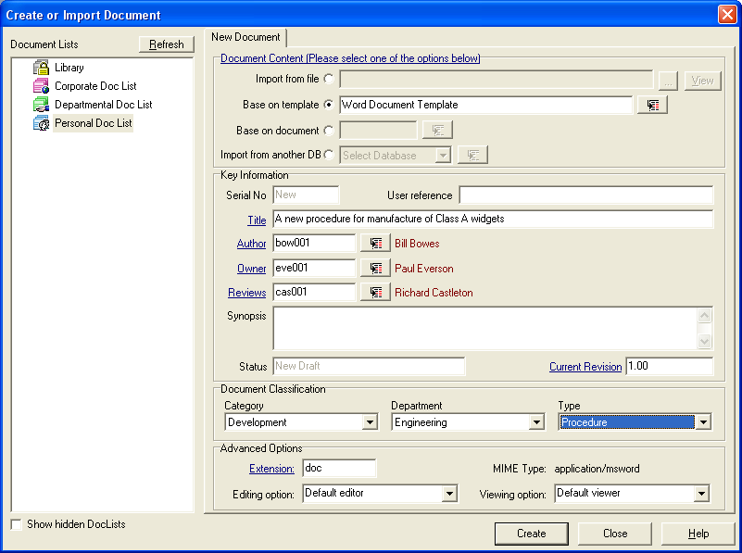
Complete the form for a new document
Note the Mandatory fields, the only one of which you will need to fill in will be the Title field; the other mandatory fields will be filled in as default settings.
Do not forget that the correct Document Classification will help you find the document more easily.
The Owner of a document is the person who will be responsible for its maintenance. The Owner will receive a task or notification of the events and actions associated with the document.
The Author is the person who created or imported the document.
The Author and the Owner can be the same person.
Reviews is the person responsible for starting and stopping the documents reviews. By default, this person will normally be the person nominated as the document owner, the person creating or importing the document.

Adding documents to a DocList
Select the documents you want to appear in the folder in the Document Lists, and drag the document from the list of documents in the main search screen on to the folder name. The titles of the documents will then appear under that folder list.
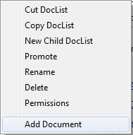
To add a document whilst creating a new document, right click on the folder and select the Add Document menu.
Alternatively, once the document is imported into the database, highlight the document in the main screen and right mouse click. This will give the option to copy document to the selected DocList on the DocLists pane.

Documents can be added to a Global Document list, but only by the DocList Folder owner.
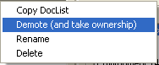
Once a DocList has been “Promoted” to a Global DocList, the DocList Owner can add documents to that DocList, otherwise, those with the relevant permissions must demote and take ownership before being able to add documents to a Global DocList.
A new document can be added to any number of DocLists at the time of creation or import, by selecting the relevant DocList folder before moving on to the Workflow and Access screens. The DocLists in to which the document will be added at creation will be highlighted in Bold.

Marking for approval after creating a document
Once created or imported, the next stage will be to mark the document ready for approval. This is done at the end of an editing session or from the Control menu.
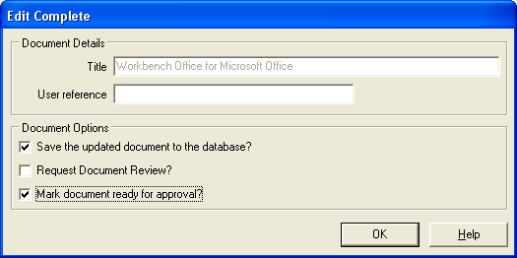

Approving Documents
As soon as the document is marked ready for approval, you will not be able to make any editorial changes to it.
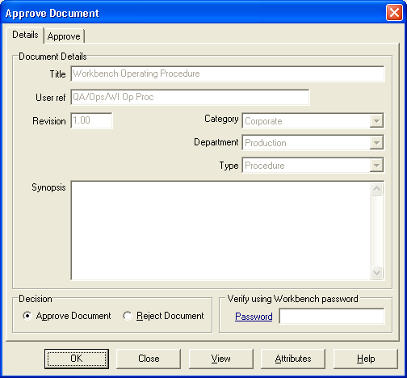
Everyone on the approval list must approve the document before it can be issued.
From the menu, select Approve Document.
Select the document and you will be presented with the “Approve Document” screen.
Type your password in to the “Password” box.

If the Approval Reason is activated in the document attributes then you will have a second Tab to complete requiring you to give a reason for approving the document. The reasons will be available from a drop down menu.

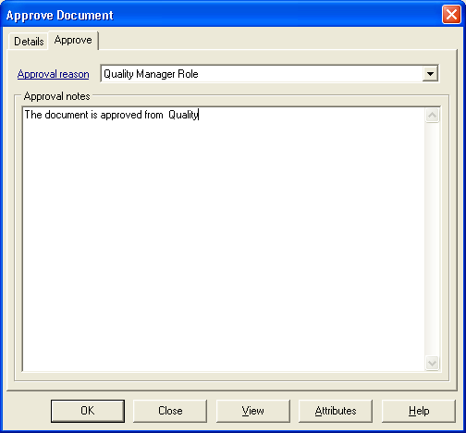

Adding Questions

The Questions can be created or added to the documents attributes at the time the document is created or imported, at the time it is being edited, or any time before the document is issued.
As part of the import routine, after setting the Workflow, Access lists, Keywords etc., select the Questionnaire tab at the top right of the screen. Select the “New Question” button, and type the question in the lower box on the screen.
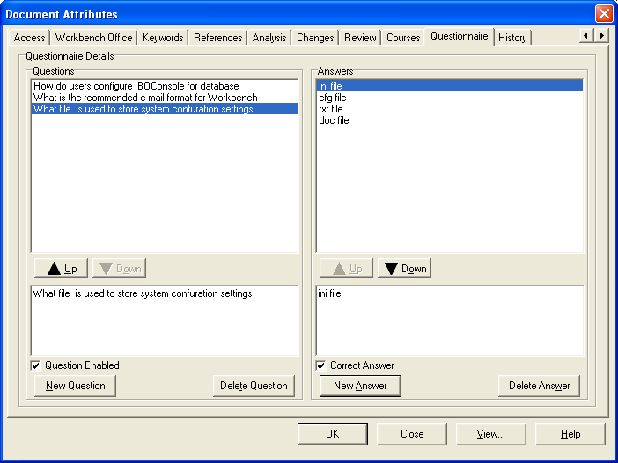
Once you have entered the question you require, select the “New Answer” button in the right hand section. Type the answers to the question in the lower right box and it will appear in the upper box.
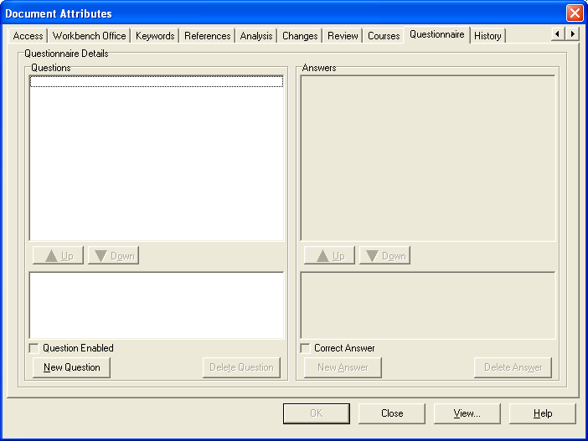
As this part of the system is multiple choice, you should create as many answers as you wish, some of which may be totally incorrect, but select one of the answers to be the correct answer.
To make it the correct answer, tick the “Correct Answer” box above the New Answer button. You can only select one answer as the correct answer.

Issuing a document
Once the document has been fully approved, it can now be issued.
From the menu, select “Issue Document” to give a list of documents available for you to issue.
After selecting the appropriate document, the following screen will be displayed:

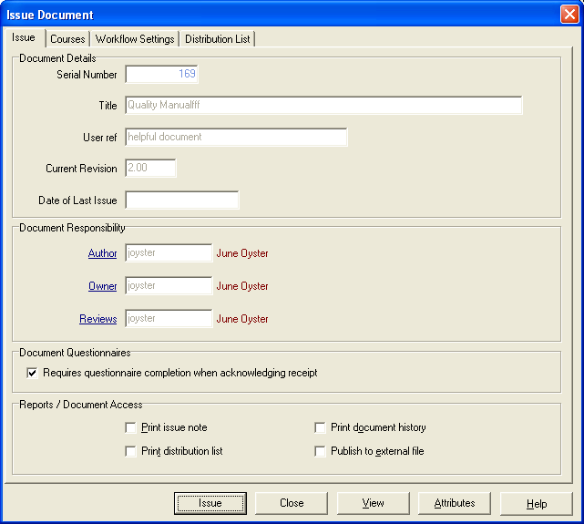

Simply select the issue button and the document will become “Issued”, and will be available to be viewed from the “View Issued Documents” menu.

Submit for Training before Issue
(The Training Module must be licensed for this feature to be available)
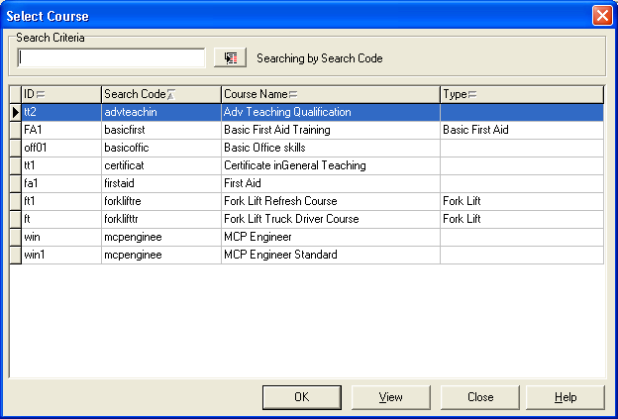
There is an option to associate a document with a training course by selecting the Course Tab.
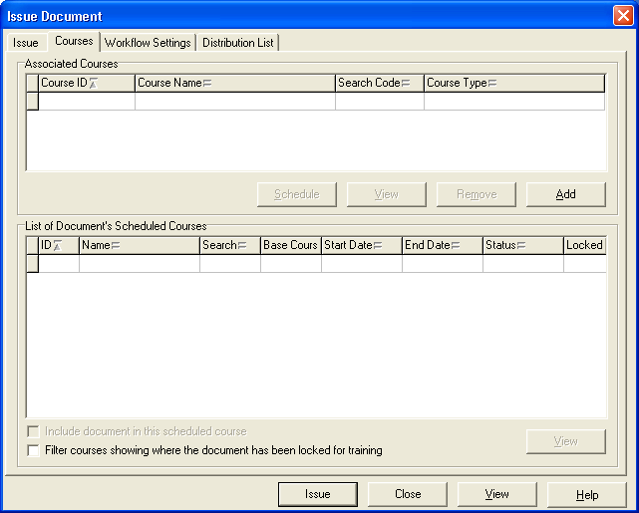

Before issuing the document, a course can be added at the point of issue by selecting the “Add” button and selecting from the available course list.

If the course selected has a scheduled course that has yet to be run, it will appear in the lower half of the screen.
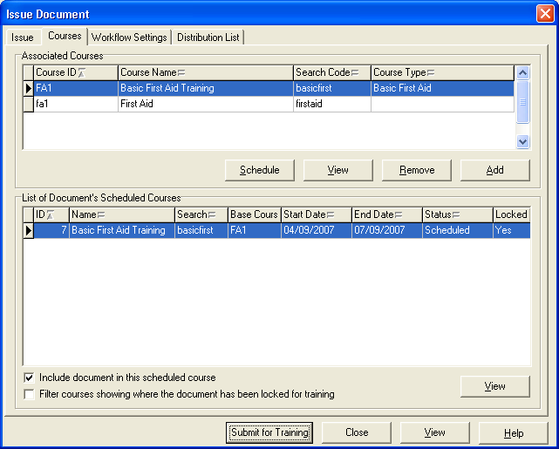
When the document is ready to be issued the courses tab will show the scheduled courses associated with the document. Select the tick box “Include document in this scheduled course”.
This will then change the “Issue” button to “Submit for Training”. Once submitted for training then the training course must be completed, after which the document will be automatically issued.

Acknowledging Receipt of an Issued Document
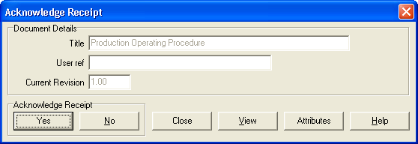
All the individuals on the distribution list for a document will be advised of the issue of that document and would normally be required to Acknowledge Receipt.

If users are required to Acknowledge Receipt of a document, they will be expected to read that document before they confirm receipt.

Acknowledge receipt and answering questions from the Questionnaire.

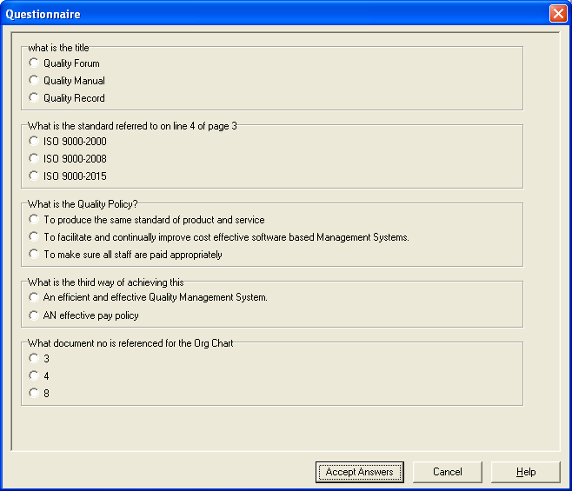
If the document Workflow settings require it, a user must respond to, and answer a number of predetermined questions before the acknowledgement can be completed. When responding “Yes”, after the warning about reading documents appears, the questionnaire screen allows the user to respond to the questions.

If all the questions have been answered correctly, then a message to that effect will be shown.
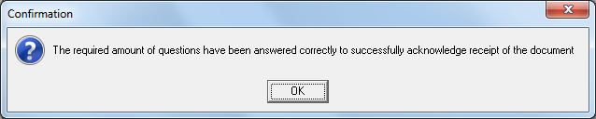
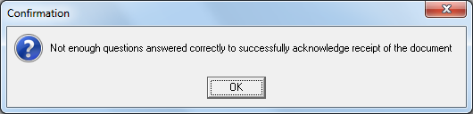
If, however not enough questions have been answered correctly, then the following message will be displayed and Acknowledge Receipt will not be allowed.

Viewing Documents
There are two different ways you may view a document. The standard document select screen and the DocLists screen.
The DocLists screen functionality will depend on the settings in the system manager module, or in the individual user preference settings.
First, there must be documents in the database.
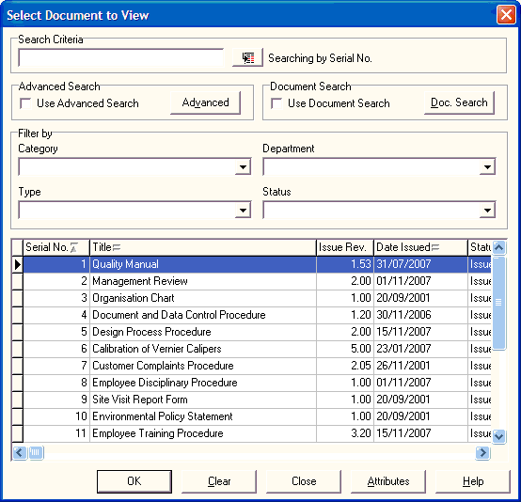
Scroll down using the scroll bar on the right to find the document you want.
Use the Category, Department and Type filters to reduce the list to a manageable list.
Right Click on the Search box next to Search Criteria and select by Options offered.

Viewing Documents using DocLists
There is an alternative dialogue screen for document searching.
DocLists uses a format similar to that found in IntraVista Pro, and all the features found in IVPro are repeated in DocList.
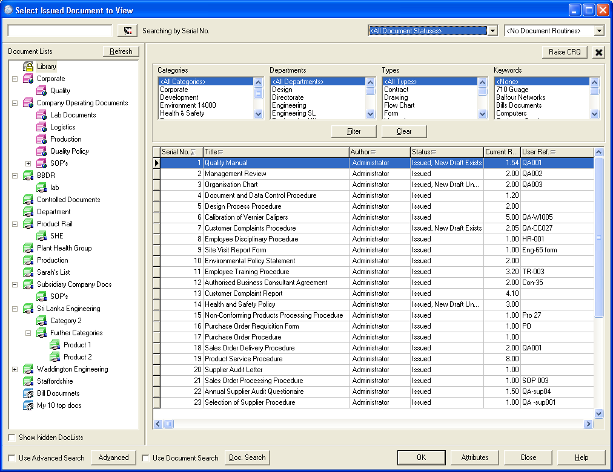
To be able to access the full functionality that the new DocLists provides, users will need to have access to the “View Documents” menu in the Document Control Module.

Selecting your document
There are a variety of different methods and combinations of criteria by which you can select your document.
Filtering
Select the Category and/or Department and/or Type and the Status of the document you wish to find. Within the DocLists view, use the Shift or Ctrl keys, to select multiple Category, Department and Type fields as well as Keywords as this will help in the search.
Ordering
In the Standard Document search screen, you can order the lists of documents by selecting the required column header and changing the order from Ascending to Descending using the mouse. The sort order uses the ASCII settings so order may seem a little unusual, but lower case letter “a” will follow upper case letter “Z”.
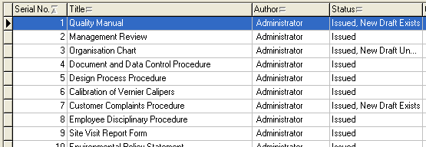
Within the DocList dialogue screen, all the columns are always available, and the order of view can be changed by clicking on the column header of the column.

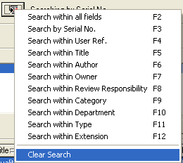
Using Search Criteria

A Right Mouse Click on the search button will allow a user to Search by Serial Number, User Reference or Words within the Title.

Raising a change request
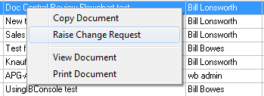
Raise a change request by selecting “Raise Change Request” from the Changes menu in Document Control, or by right mouse click on the document in the DocLists view .
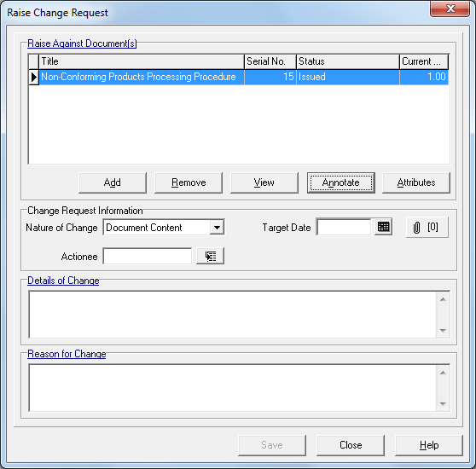
Select the document you want to change by using the “Add” button, which will present a list of all the documents in the system.

Select Document Content from the Nature of Change menu. Withdraw Document and Document Content are the only Actions that cannot be made without a change request.
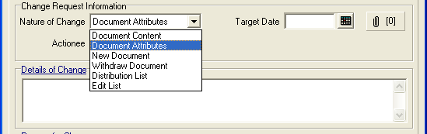
There are two mandatory fields to be completed. These are the Details of Change and the Reason for Change, or what needs changing and why does it need changing. It is possible to cut and paste into these boxes from the document to be changed, but it does NOT carry across any formatting into these boxes. It is also possible, when editing the document, to cut and paste from these boxes directly into the document, so saving a great deal of re-typing.

Annotate a document when raising a change request

Documents can be annotated when a change request is made and when responding to a review. The annotated document can be saved into the database and used as the basis of a new draft version from a Review or from a Change Request.
To annotate a document when raising a change request, select the document to be changed using the “Add” button, and then select the “Annotate” button.
This will open the document where changes can be made.
(It is recommended that the “Track Changes” functionality of the editor is used to highlight the suggested changes).
If the issued document has the setting “Issue to PDF switched on”, and the Raise Change Request against Issued documents only is set, then it is possible to allow users to annotate the original application version of the document rather than the issued PDF.
NOTE: If there are more than one annotated documents created against the same document from different change requests then none of them will be available to replace the draft document.

If annotations are made against the PDF version of the document this will not be available to replace the draft document although the annotated version will be visible when editing the document.
When the required annotation changes have been made to the document, save the document using the editor’s save feature and close the application. It is important that the Editor Application is closed as this is the trigger to Workbench to save the document to the database.
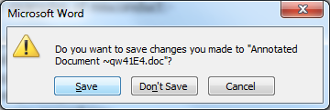

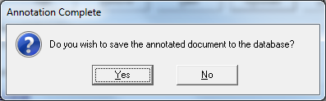

Once the application has closed Workbench will also ask to save the document to the database.
Save the annotated document to the database and continue completing the Change Request.

Approve/Rejecting a Change Request
The Change Request Approval screen is in two parts: -
The first part shows the details of the document and the Change Request itself,
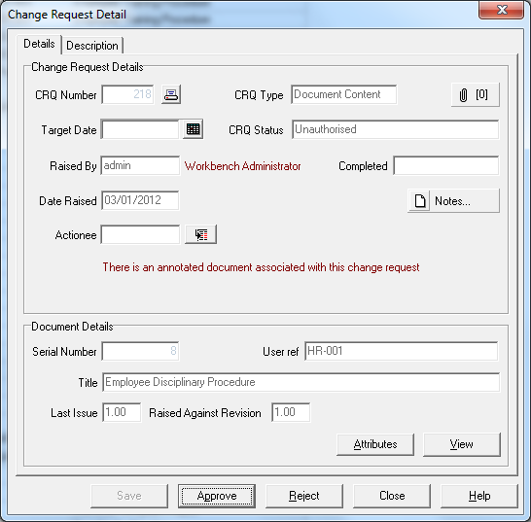

and the second shows the Change Request description and reason for the change.
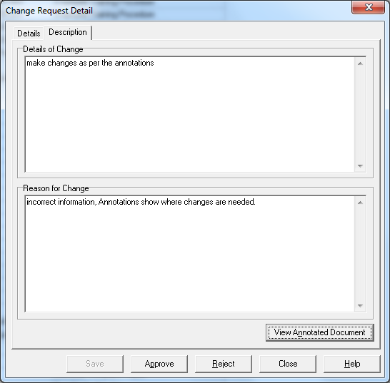

At this stage you may have the option to either Approve or Reject the change request.

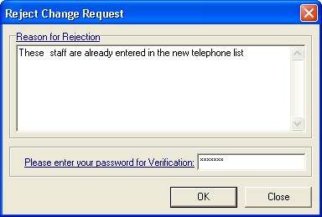
If you reject the change request, you will be asked for a reason.
This reason for the change request being rejected will also be recorded in the document history log detail.

Approving the change request with annotated document.
The change request will need approval, and will show that an annotated document is associated with the change request.
To view the annotated document,
select the Description tab
and the annotated document will be
available to view.

Continue to approve Change Request for the document in the normal way.

Assigning change requests and editing documents
When a change request has been approved then the document subject to that change request can be edited.
Select “Document” menu and “Edit” from the drop down list and select the required document.
Increase the revision level and assign the change request.
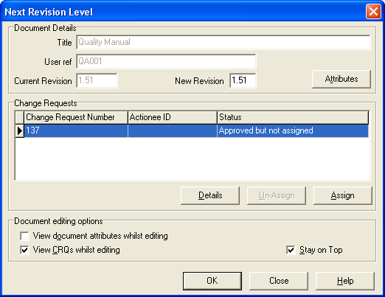
Note that there is no need to increase the revision level of the document again if re-editing the document between issues.

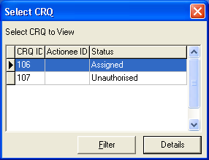
View CRQ’s whilst editing, and Stay on Top
It is possible, whilst editing a document, to have the relevant change request(s) available to view whilst editing the document in the editing application.
The list of approved change requests can be set to appear as a “floating box” over the document being edited so that reference can be made to it.
This facility can be switched off if required.

Editing the document with an annotated document associated.
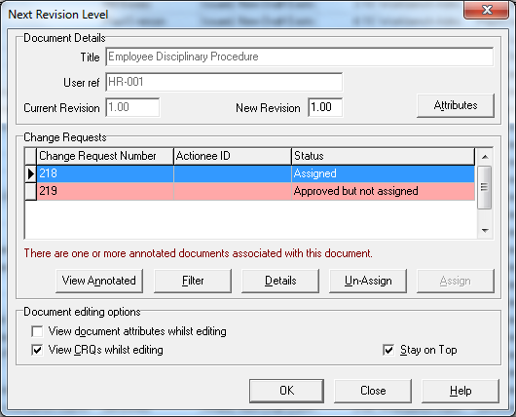
When a document is due to be edited, the Next Revision Level dialogue box shows that there are one or more annotated documents associated with this document, and the change request with the annotated document will be highlighted in Red.

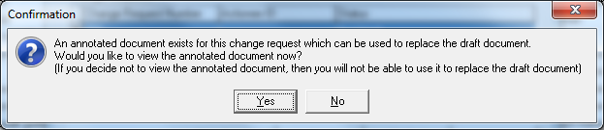
Assign the change request with the annotation and select OK. Workbench will then tell you that an annotated document exists for this change request and gives you the option to view it. It is VERY important that you view the annotated document when told to, before editing the document at this stage. Failure to do so will result in the annotated document NOT being available to replace the draft document.

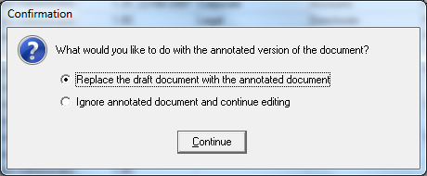
Once viewed, close the viewing application, and Workbench will then give you the option to either replace the unedited draft document with the annotated document, or to ignore the annotated document.

Edit Complete
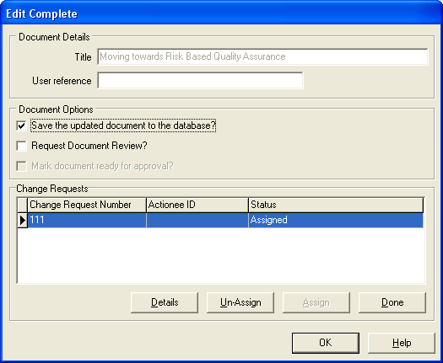
Once the editing is complete, CLOSE the editing application, and return to Workbench.

If editing of the document is complete and no further changes are required, then mark the Change request as “Done”.
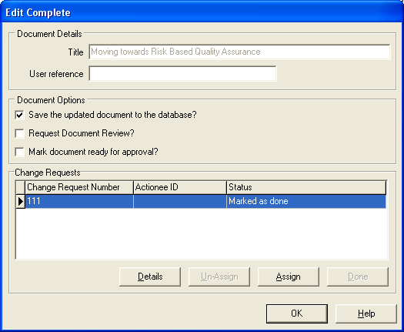
This will then activate the “Mark document ready for approval” field, tick the box and then select OK.

The document will now proceed round the Approval cycle as before (see Approving Documents).

Requesting a Document Review
Unscheduled reviews originate from two points:
- When the user finishes editing a document and checks the ‘Request Document Review’ check box. In this case, the version to be reviewed will automatically be the ‘draft’ version

- By selecting the ‘Request Review’ menu item, a request can be submitted to review any document. This can be either the draft or issued version.

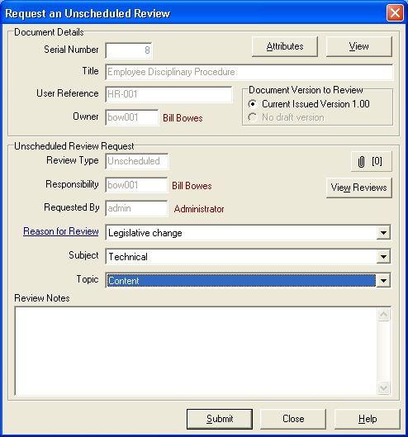
The Review Request will be sent to the person responsible for the document’s review, who will be able to either start the review, or reject the review if it is an unscheduled review.

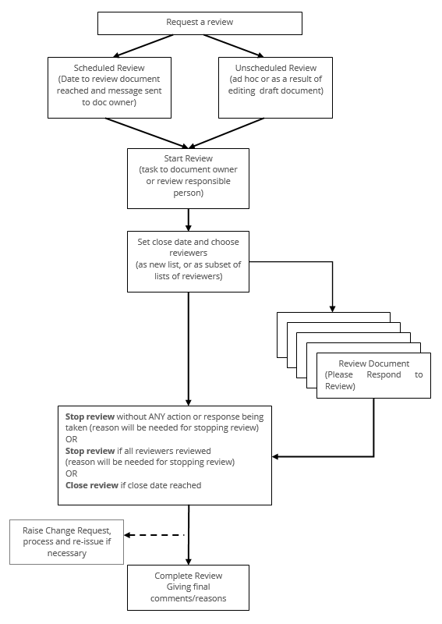

Starting a Review
Open up the Maintain Review document screen with the option to start the review.
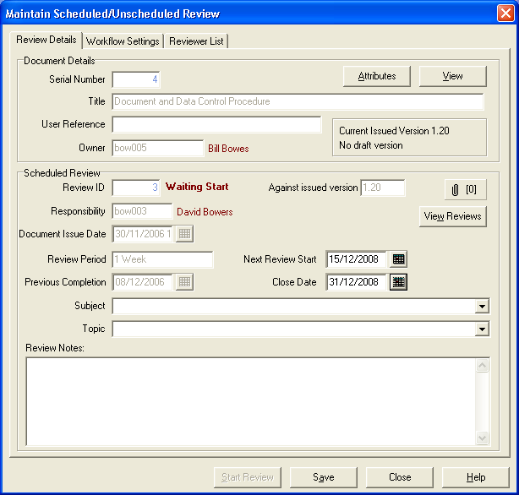
Although not mandatory, it is advisable to enter a close date for the review, but do not alter the start date.
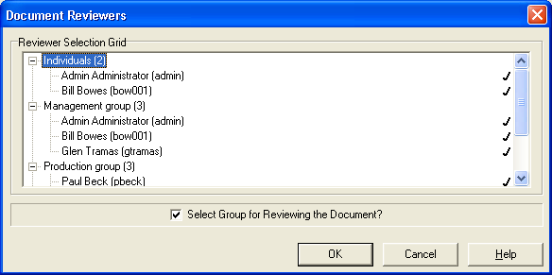
Select the people who you want to review the document and Start the Review.

Responding to a review
Once the Review has been started, all the people on the review list or subset will be tasked with carrying out the review of the document.
The screen will ask the reviewer to respond to the review and will give details on the first page of the document under review and the reason for the review.
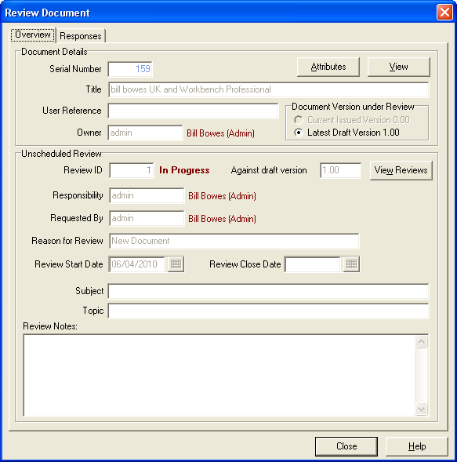
The person reviewing the document should then select the Responses tab to be able to enter details of their review.

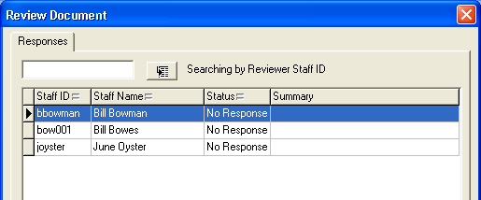
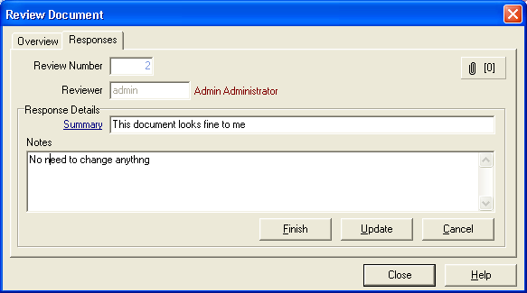

The Summary line is the only mandatory field required for a response.
Mark as Finished, when all the review notes have been entered.

Closing the review
Once all the reviewers have responded, and/or the close date has been reached, the person responsible for the review, can the close the review. (The review can be closed at anytime regardless of whether the close date has been reached or not, but a reason will have to be given).
This will unlock the document so that further changes, if necessary, can be made, change requests approved and assigned, and work done to the document.
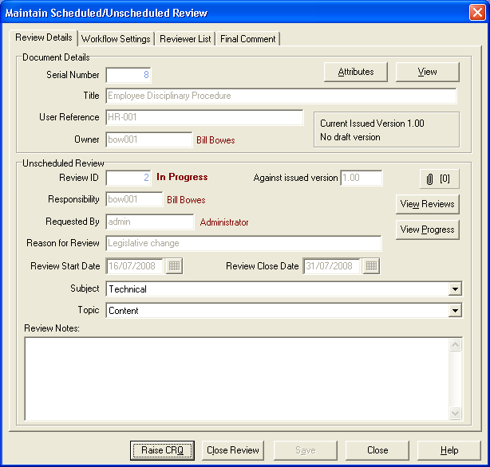
If any of the review responses suggest a change to the document, then a formal change request can be raised from this screen.
Whilst a document is undergoing review Change requests can still be raised against the document but CRQ’s cannot be approved or actioned.

Complete a Review
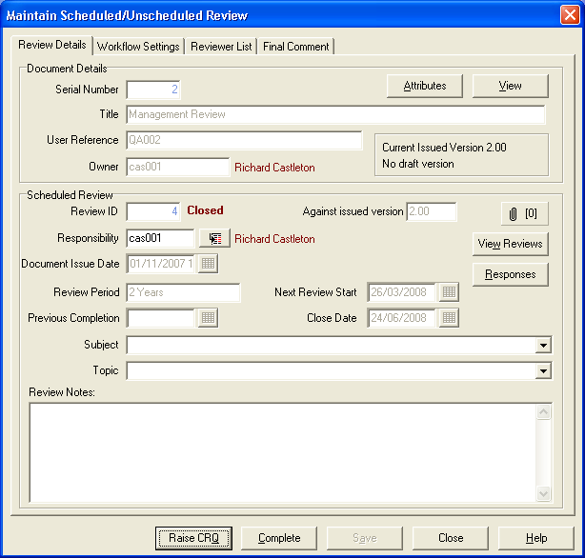
To complete and close out a review, final mandatory comments must be entered in the Final Review Comments dialogue box, and the person responsible for the review must enter their password to complete the review.

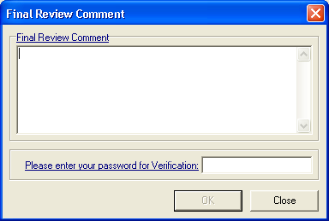
Once completed, no changes can be made to the review at all.

Withdraw a document
To withdraw a document from use, (remove the last issued version from view) there must be a change request raised and approved for this to happen.
Raise a Change Request from the Changes menu, select the document to withdraw, change the Nature of Change from Document Content to Withdraw document, and then complete the Detail of Change and the Reason for Change boxes.
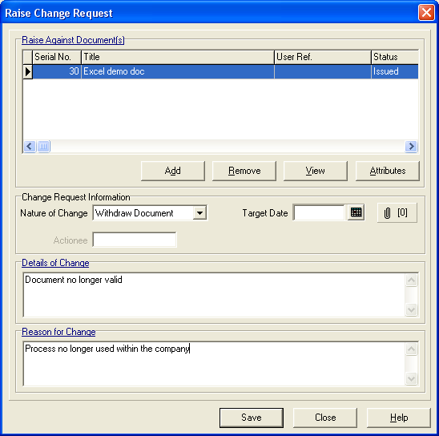
Once this has been approved, an instruction will go to the document owner to Please Withdraw the document.
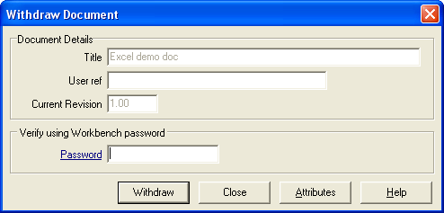
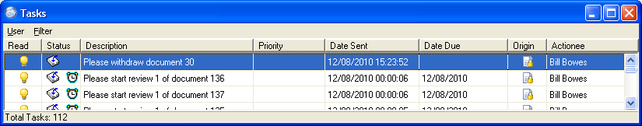
Withdraw the document by entering the correct password and selecting the “Withdraw” button.

Checking In and Checking Out of Documents
This allows documents to be worked on “off-line”, i.e. whilst away from the network, or where working on a document will hold a user license for an inappropriate length of time, such as when editing a drawing.
Checking a document out of the system can only be carried out on “Draft” documents where an approved change request is assigned to that document or the document has never been issued.
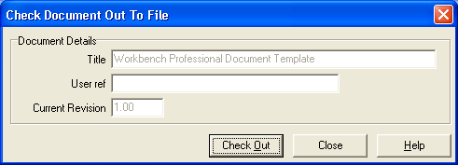
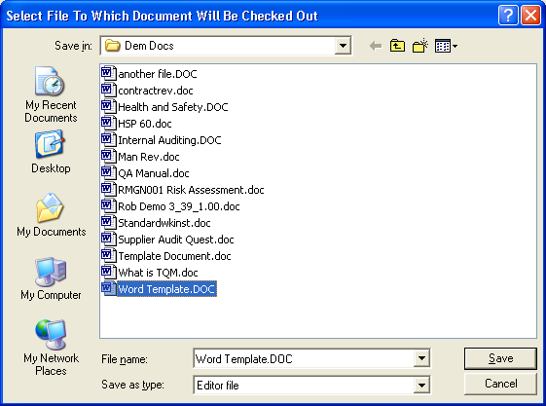
Select “Check out to File” from the Documents menu and then select the document to check out from the available list. When requested, create a file name for the document and select “Save”.
To check a document back in, select “Check in from File” which will show the documents currently checked out. Select the document to check in and select the “Check in” button to keep the changes made, or the “Uncheckout” button to revert to the previous document.
