Workbench Nonconformities Module Training Notes

Contents

Conventions used in Workbench Professional/Quality Workbench. 5
Logging on to Workbench 7
Navigation around Workbench 9
User Preferences 12
Workload Manager 13
Delegates 14
Workflow Settings 15
Web Page settings 16
Nonconformities Module 17
The life cycle of a nonconformity. 18
The NCR record 18
TASKS and NOTIFICATIONS 18
Setting up the NCR Module 19
NCR Settings 21
Corrective Action Templates 21
Creating a Corrective Action Template List 21
NCR Types and Subtypes 23
NCR Severity Levels 24
NCR Sources 25
Corrective Action Types 26
Recording of Suppliers and Products. 27
Product or Services. 27
Customer Information 29
Customer / Maintain 29
Customer / Search for Contact 30
Customer / Move Contact 31
The Business Rules 32
Default Business Rules 33
Setting up Multiple Business Rules (Licensed Area for Quality Workbench) 34
NCR Reported. 34
NCR Assessed 35
NCR Sign Off 36
User Defined Analysis (Licensed Area) 37
The Nonconformity Life Cycle 39
The Corrective Action Life Cycle 40
Reporting a completed NCR into the database through the Wizard 41
Quick Wizard screen. 41
The method for reporting a new NCR 46
Adding an attachment to an NCR or Corrective Action(Licensed Area) 48
Personnel Notification 49
Processing an NCR. 50
The “On Behalf Of” menu 53
The “NCR and Corrective Action Sign-off Progress” menu(Licensed Area for Quality Workbench) 53
Reassign Ownership of an NCR 53
Changing Target Date of an NCR 55
Assign Additional Corrective Actions 56
Processing a corrective action 57
Changing Target Date of Actions 59
Change User Reference and Search Code 60
Sign off Corrective Actions 61
Reassign Corrective Actions 62
NCR Final Review 63
NCR Final Review with No Corrective Actions 64
Sign off Completed NCR 64
View an NCR 66
Withdraw Completed NCR’s 68
Purge Completed NCR’s 69
Reports 70
Viewing reports 70

Conventions used in Workbench Professional/Quality Workbench.

Workbench follows the normal conventions defined by and used in Microsoft Windows XP/Vista standard software. Some of the more common keystroke commands and conventions are mentioned here as a guide.

- Tab Key
This key is used to move from field to field. As you Tab from field to field, you will know where you are by the flashing cursor or the entry in the field being highlighted in reverse colours. If the field is a button then a dotted halo appears around the button label.

- Esc Key
The Escape key allows you to close from any of the screens in Workbench.

- Alt Key
This key, used in conjunction with the underlined letter in the menu, or where a selection is requested, will perform the action or allow further choices to be made.

- Mandatory Fields
Mandatory fields are those fields where you must enter information before you can complete the specific task. The labels (Titles) to these fields are highlighted in blue and are underlined.

- Search Buttons
Search buttons allow you to filter search within a list of specific data. By typing some or all of the information you require in the box, and using either the mouse or “F” keys, you can narrow the range of information presented to the first instance of required search choice. Use the “Right Mouse Click” to reveal the choices available.

- Date or Calendar Fields
Clicking on this icon presents a calendar representing the current month with the current date highlighted.
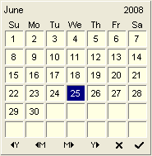

Select your required date by using the month and year symbols at the bottom of this calendar screen and then selecting the tick symbol.
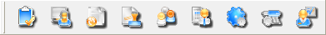
- Module Icons

These icons appear across the top of the screen.

Simply select the icon with the mouse and the screen display will change to the selected module.

- Right Mouse Button
Using the right mouse button will bring up a floating dialogue or action button box in many areas of Workbench.
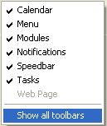
For example: - This menu appears whenever you right mouse click on the Workbench desktop, which allows you to switch of or on any of the menu bars at the top of the screen

- Speed Buttons

In each of the modules, a number of speed buttons enable common actions to be accessed quickly. One mouse click on the speed button will open the dialogue for that action.

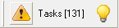
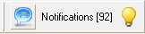
- Task and Notification Icons

Alongside the Module and Menu icons, are the communication icons called Tasks and Notifications.

Workbench generates tasks and sends them to an individual user to perform. These tasks will appear in the user’s task box and new tasks will be indicated by a “light bulb” symbol, which will change to yellow for new tasks.

- Shortcut Keys

As with all Windows applications there are a number of key combinations which perform tasks as alternatives to using the mouse or drop down menu items.

Common among these the following can be used within Workbench:-

Ctrl+C – copies highlighted text to clipboard
Ctrl+V – pastes data from clipboard to application

NOTE for Quality Workbench Users Some of the elements discussed in this document will not apply unless you have licensed them. Where possible these will be highlighted as licensable areas and in red type.

Logging on to Workbench

Select the Workbench Icon from your desktop and double click to open the program.



The “Login to Database” screen enables you to select the database you wish to work with and for you to login to that database.

Whether you are using the Workbench Login, or using the Windows NT login, you will first have to set up yourself as a registered Workbench user.

From the Log on to Workbench Screen, select a database, for example, “Live” or “Sample”.
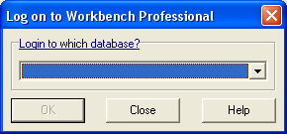

Select the down arrow to select your database

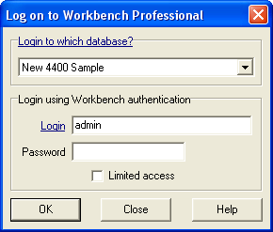
In the Login ID, enter “admin” login name and password “admin”.

Each database has a default “super user” whose login is “admin” and whose password is “admin”, and you will need to login as “admin” to begin setting up the system.

You will use this login to set up your own initial Personnel information.

Once your Personnel information has been logged in the system, and access permissions granted, then you should log out of the “admin” account and log in as yourself, using that account to enter the system configuration defaults and any further Personnel information. This will ensure that an accurate audit trail is created with the named people performing the tasks.

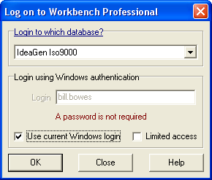
This Log on to Workbench Professional Dialogue Box will depend on whether your system is configured to use Windows NT Authentication login or not.

If your system is set to use Windows NT authentication, then the screen will ask you to select a database, but will tell you that you are using Windows Login and Password to access Workbench.
Depending on the configuration, you may be asked for a password to login in at this point as well, but you will use the same password as used to log in to your network account
By Default logging on using Windows Authentication will use a system license. A system setting is now available to default this to a Limited Access, or Workgroup license.

You may also wish to limit license use by getting users to select “Limited Access” from the original Login Screen.
When a user selects the File menu and Login from drop down list, they can Login as themselves but then select the limited access button by adding a tick to the box. This utilizes the Workgroup License where available.

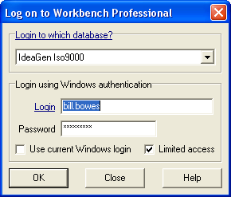
The use of a Workgroup license will restrict users from accessing any of the module menu items, but will still have access to the File menu, Task and Notifications buttons and the Workbench Calendar.

In addition, if external e-mail is implemented, responding via an e-mail message also uses a Workgroup license.

It is strongly recommended that you do not use the “admin” account for daily tasks, but for EMERGENCIES ONLY.

Navigation around Workbench

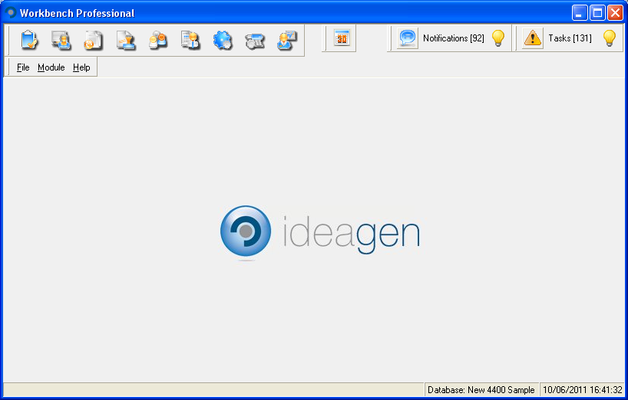
Main screen View
Tasks and Notification Bars
For Quality Workbench this will display Quality Workbench in this bar.
Menu Headers and Icon Bar
Status Bar
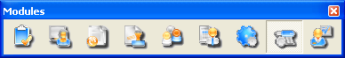
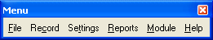
The Module Icon Bar and the Module Menu Bar can be detached from the top area and can float on the screen.

Task Bar
Workbench generates tasks and sends them to an individual user to perform. These tasks will appear in the user’s task box.
Each task will have a light bulb, either yellow or grey to denote “read” or “unread”.

The status of each message will also be shown with an icon.

Task is Outstanding and can NOT be deleted.
Task is Overdue and can NOT be deleted.
Task is Complete and CAN be deleted.
Task has been Superseded and CAN be deleted.
To help you navigate through Workbench you will need to become familiar with the drop down menus.
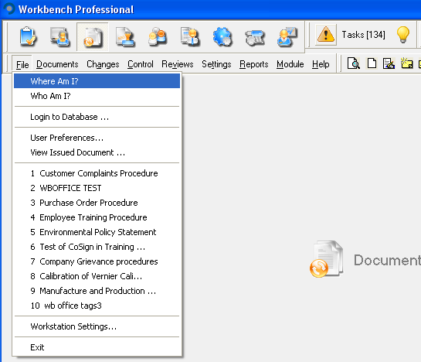

File
Where am I?
Who Am I?
Login to Database…
User Preferences…
View Issued Documents…
(Document Quick links)
Workstation Settings…
Exit

Modules
Audits
Customer Care
Document Control
Nonconformities
Personnel
ReportQuest
System Manager
Test and Calibration
Training

Help
Workbench Help
About Workbench

Select File menu item and view the options available.

“Where Am I?” will tell you which database you are currently in.

“Who Am I?” will tell you your login ID and what access rights you have, either as part of a template or if access is granted as an individual.

Choosing “Login to Database” allows you to select a different database and allows you to login if you are registered to use that database.

“User Preferences” will appear if you have been given access to that menu item. In User Preferences you can change your password, set your screen display preferences, nominate delegates and determine your own local workflow settings for your own tasks and notifications as well as test your e-mail account. Access rights can be also be set individually to most of the functions within this area.

“View Issued Documents” will allow you to view those documents that you have the rights to view and that have an Issued status.

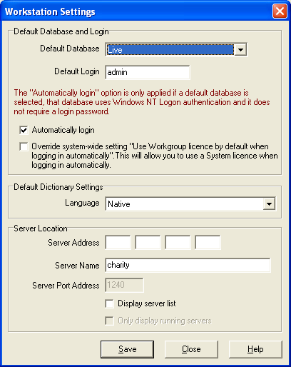
“Workstation Settings” allows you to personalize the startup options for your particular workstation, by pre-defining which database is selected, what your login details are, which server you can connect to and which language dictionary you want to use. Once selected here, this defines what parameters are selected as you log on to Workbench. This area will always be available to the end user, but some of the elements, such as the language dictionaries, may be set using the configuration setup on the main server, and may therefore be read only.

The Automatically Login option will depend on the database settings set on the server AND if this area has been licensed.
By Default logging on using Windows Authentication will use a system license. A system setting is now available to allow users to set Workbench to default to using a Limited Access, or Workgroup license.

User Preferences

In the User Preferences menu item there are five tabbed pages available to all users individually.

Many of the settings will inherit the default settings as defined in the System Manager Module under the New User Settings found in the Workflow Configuration Centre. These settings will apply to New Users entered into Workbench after these default settings have been created, and changes can be made by the individuals if the user permissions allow. Access to the User Preferences menu item is controlled on an individual user or group basis under the System Manager Access settings.

For users to be able to change their Password, access must be given to the User Preferences menu item. This will then give then the Password Tab where they can enter a new password. Any constraints established in the system Manager module will be shown under the Password Details box.

Password Constraints are NOT available in Quality Workbench.
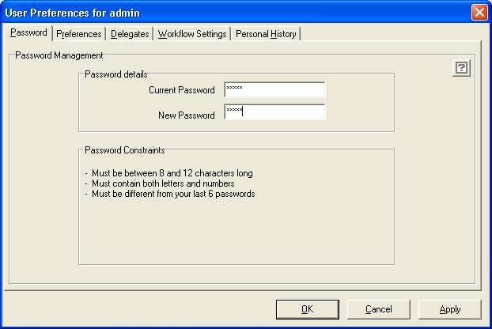
Access to the next four tabs can be limited through the access settings, found in the system manager access menu, and is controlled as part of user permissions settings in Access menu in the System Manager module of Workbench.

If allowed, a user can test his own e-mail address, change the database language he uses for that database and change the way his document search lists are displayed.
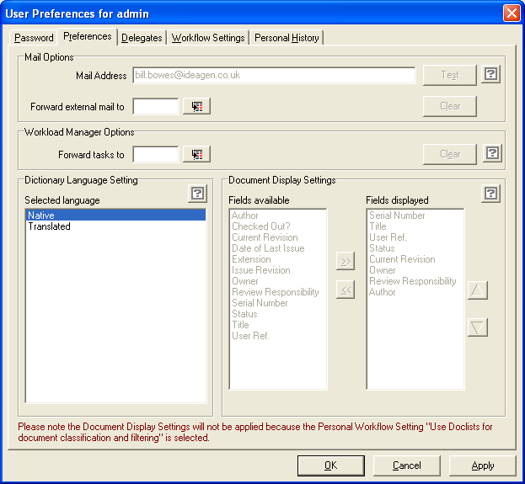

Forward external mail allows a user to nominate another user to receive ALL Tasks and Notifications that would be sent by the external e-mail system (if external e-mail is switched on). All the tasks will be redirected to the e-mail box of the nominated user who will be able to respond to them, i.e. approve document etc, and sign for them as “on behalf of” using their own password.
Whenever an action is carried out as a result of forward messaging, its corresponding history entry is suffixed with an asterisk (*). Right-clicking on theses entries will then provide details of the user who undertook the action - for an example of this see Document Attributes | History in the Document Control module.
NB. If mail attachments are sent via IntraVista Professional and are forwarded on to another user who subsequently carries out the action, the history entry will show that the action was carried out 'on behalf of' the original user.
If delegates are applied, then only those users who are defined as delegates will be available to select for forwarding external e-mail.
This forward external mail will stay in force as long as another users name is in the forward external mail box. Remove the name from the box using the “Clear” button to stop external messages being sent to the nominated user.

Workload Manager

It is also possible to re-direct messages to a nominated delegate using the Workload Manager functionality. This works in the same way that the forward e-mails works. Whenever an action is carried out as a result of forward messaging, its corresponding history entry is suffixed with an asterisk (*). Right-clicking on theses entries will then provide details of the user who undertook the action.

Delegates

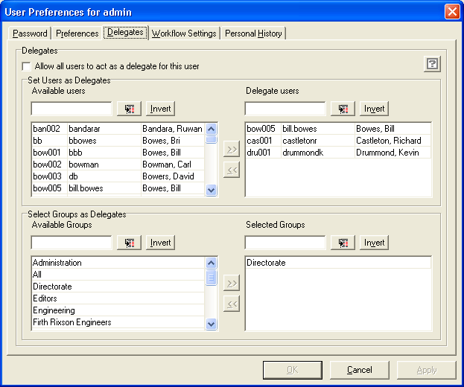
If access is allowed a user may nominate his own list of delegates, i.e. people who can act on his behalf. (This is a licensable area for Quality Workbench Users).

Workflow Settings

Where the system administrator has granted access, then a user may also change the workflow settings inherited from the default settings.

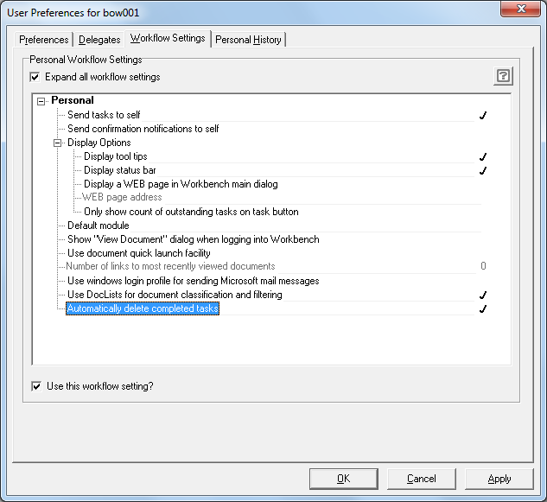

Each user can select to use the Quick Launch facility, which shows the last documents (up to 10) viewed in the file menu.
It is now possible to replace the default background screen, which shows the module name, and can now be replaced with a defined Website. This can be anything from the company default Intranet site, the IntraVista search page, or any other web site. In the Workflow settings, under Display Options, select “Display Web page in Workbench main dialogue”, and the type the URL in the “Web Page Address” dialogue.

“Only show count of outstanding tasks on task button” allows the control of the number being displayed in the “Tasks” button bar. With this selected, only the number of outstanding tasks, those still to be completed, will be shown next to the Tasks button.

When a user logs in to Workbench they can decide, not only which module the system opens up in, but can also select to open the “Select document to view” screen to see, select and open a document.

Web Page settings

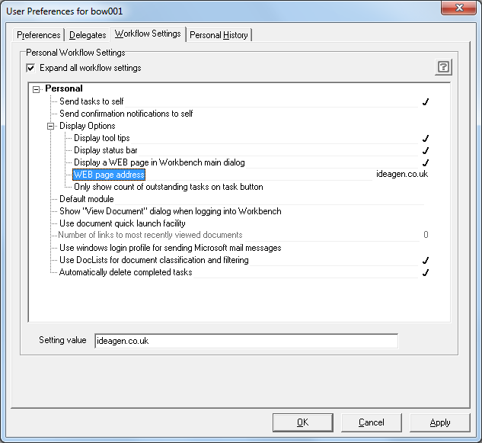
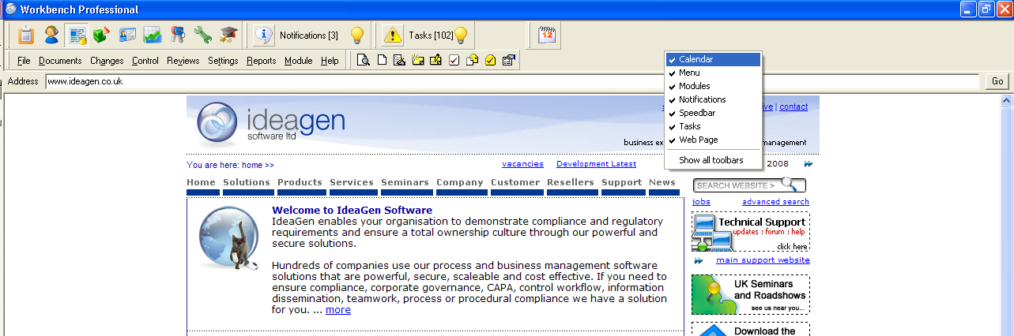
The Web screen view can be controlled to show just the web page as defined by the administrator or an address bar can be added to allow users to change their web page URL themselves. Access to control this is given through the Workbench Configuration Centre settings.

Nonconformities Module



The Nonconformities module has been designed to cater for a wide range of activities that are based on the need to record and control a business issue that may have corrective actions associated with it.
Quality Management ‘nonconformities’ are an obvious example, yet ‘accidents’ reported as part of a Health & Safety system or an ‘uncontrolled release’ in an Environmental System are equally applicable to this module.
The features of the module allow you to cope with the most complex situations that may be required, but they will also suit the smallest of organisations, perhaps even a single user PC.
A Nonconformities report form, which can be printed from a template, makes entering the data into Workbench extremely easy and a Quick NCR Wizard option allows quality managers to record and complete all details of a nonconformity in one simple operation.
Another new, separately licensed area enables you to report an NCR offline via a form, without connecting to a database. The form is then emailed to a Workbench user as an .eqm file which, when opened, fires up Workbench and automatically populates the NCR.

What is a Nonconformity?

A Nonconformity (NCR) or non-conformance is basically an observed deviation from an organisation’s stated quality aims and standards as defined in its Quality Manual and associated procedures. It may reflect the breakdown of a procedure or a defective product (a ‘nonconforming product’).
The Nonconformities module encourages the recording of nonconformities and then charts the subsequent steps taken to rectify the problem; these corrective steps are referred to as ‘corrective actions’.
In this way the data of nonconformities is built up over time and can be of immense management benefit in identifying patterns of problems; it may then be used to implement longer-term quality system improvements.

Nonconformity processing cycle

Nonconformities move through a basic processing cycle comparable to document approval in the Document Control module. The cycle takes an NCR from its initial reporting through to successful implementation of corrective actions and eventual sign-off (by senior management) when dealt with satisfactorily.
Wherever possible, each routine that potentially moves either a nonconformity or corrective action through the cycle is a separate menu item. This means, at the most basic level, any routine can simply be switched off for users who either do not need it or should not be granted it for security reasons (see Access and administration in the System Manager module).

The life cycle of a nonconformity.

The NCR record

A Nonconformity has five main parts:

Details
Description
Analysis
Actions
History

The detail is the essential information about the nonconformity – who reported it, what department was involved, when and to whom it was reported.
The description is the extra detail of the nonconformity.
The analysis is how the NCR can be categorised for reporting.
The actions area is where tasks to investigate and resolve the problem are initiated.
The history is where all the steps taken in the progress of the NCR is automatically recorded.

For any issue arising in an organisation, someone has to take responsibility for that issue. The person who assesses the NCR becomes the owner of the NCR. That person will then be able to monitor the progress of the NCR and assign actions to other people.

With any nonconformity, there are three instances in its existence that are particularly relevant,

When an NCR is first reported,
When it has been assessed,
When it has been completed.

At each stage, people are involved and they can be automatically notified to respond to the NCR.

There are two levels within each stage.

TASKS and NOTIFICATIONS

A Task is where someone who has been notified MUST respond and perform the requested task, and a Notification, where someone can just be informed that an event has taken place.

It is possible to automate this process by using Multiple Business Rules (Licensed Area for Quality Workbench).
(Quality Workbench Users have a single default Business Rule. See Page 28).

You will need to set up certain parameters before you can apply the Business Rules.

Setting up the NCR Module

There are certain settings in the System Manager Workflow Configuration Centre that need to be set before starting on the settings in the NCR Module itself.
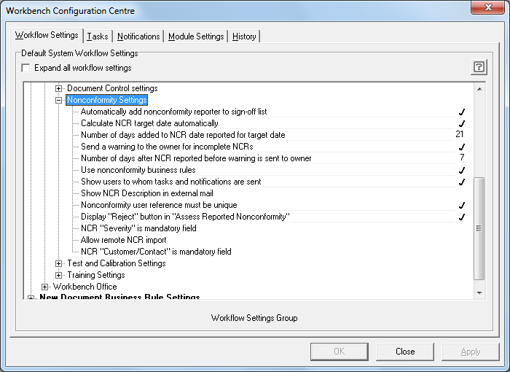

In the Configuration Centre the default elements of the NCR Module enable the system to:-

- Automatically add nonconformity Reporter to the sign-off list. This allows the reporter of the nonconformity to be able to sign off the NCR when it is completed. Most important when an NCR is raised as the result of an audit, allowing the auditor to sign off the issue he raised.
- Calculate the target date automatically. This allows the target date to be automatically set to a defined number of days after the NCR is reported. If the NCR has not been completed before this target date is reached a reminder will be sent to the NCR owner that the NCR is overdue.
- Number of days added to NCR date reported for target date enables a target date for the NCR to be calculated automatically.
- Set a reminder date to be sent to the NCR owner, or the person reporting the NCR, that the NCR has not been completed. This is over and above any reminders sent out with regard to target dates set.
- In Workbench Professional it is possible to determine whether the system will use business rules to automate the workflow, and if used, to determine whether users reporting or processing the NCR will see to whom the messages will be sent.
- When a task to assess, process or sign off an NCR is sent via external e-mail, the description field, as well as the summary line can be added to the body test of the e-mail.
- Determine whether to set the User Reference field to be unique. If it is decided not to set uniqueness, it will not be possible to set it to unique at a later stage, unless all User Reference fields are manually created as unique.
- Display “Reject” button in “Assess Reported Nonconformity” allows for the reject button to be removed when the NCR is sent for Assessment. This means in effect that the NCR MUST be dealt with, it cannot be rejected.
- NCR “Severity” can be defined as a mandatory field and an item from the drop down menu has to be selected before the NCR can be saved. This will apply to ALL NCRs reported in the system.
- Allow remote NCR import enables users to record an NCR on a user defined electronic form which is e-mailed as an .eqm file to a user who has Workbench. The NCR will then be automatically generated within Workbench.
- Customer Contact data is now available when reporting an NCR, so that NCRs can be directly associated with a customer record, whether it was originated by the customer or is about the customer, and it is possible to define this as a mandatory field.

Once these settings are decided then it is necessary to customise the specific settings in the NCR module itself.

NCR Settings

Customising the NCR module will allow you to reflect your organisations terminology for
NCR types, Severity levels, NCR Sources.
It will also enable the configuration of Corrective Action Templates and NCR Business Rules together with definition of Product and Supplier details, Customer details and Corrective Action types.
Where installed, you can also define the User Defined Analysis fields for the NCR module.

Corrective Action Templates

The Corrective Action Templates allow for the assignation of a series of pre-defined Corrective Actions to be assigned to an NCR.
Depending on the settings defined in the business rules each Business Rule can have its own set of Corrective Actions defined, which will appear when the NCR is assessed and accepted.

When an NCR is sent for Assessment, if no business rule is invoked, the person task with assessing the NCR is presented with a list of all the Corrective Actions defined in the Corrective Action Templates, and can choose any or all of the actions, or create new ones.

Creating a Corrective Action Template List

From the Settings menu in the Nonconformities module, select Corrective Action Templates, and select the “New” button.
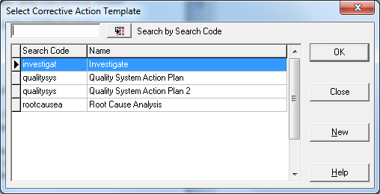

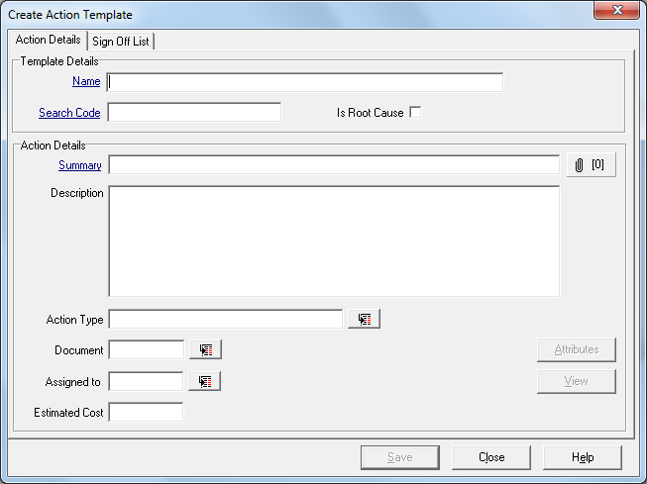

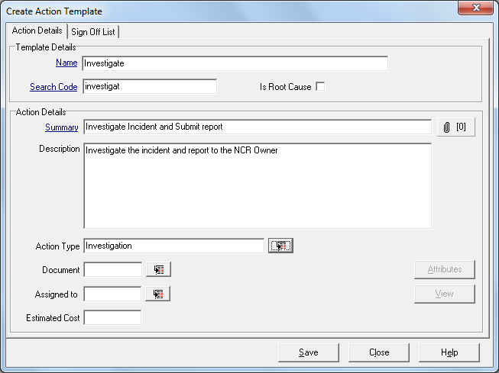
Give the action a generic name, and the complete the initial details of what you expect the actionee to do. You can build up a series of actions which are designed to address a particular problem.
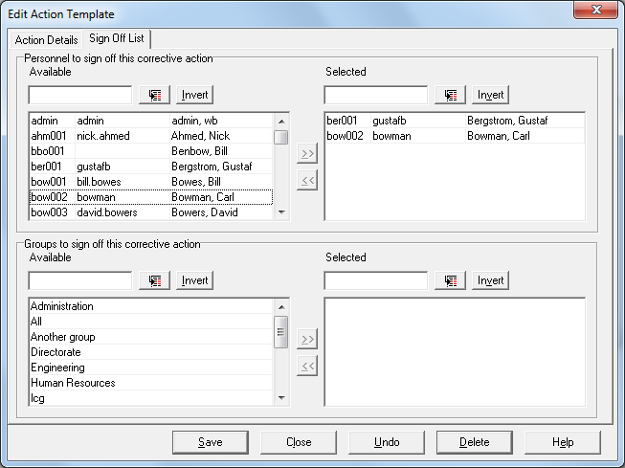

This generic Template name can be used multiple times on an NCR, with the detail being changed to make each iteration of it relevant to the particular corrective action.

If you know who the actionee should be then this can be defined in the Corrective Action Template, but in most cases it can be left blank, to be decided at the time the NCR Corrective Action is needed.
It can also have a defined Sign-Off List defined at this stage (if known), but this can also be defined at a later stage.
From this list of Corrective Action Templates a number of different actions can be defined as “Root Cause Analysis” actions, but in any one NCR, only ONE Root Cause action can be selected.

Once all the potential Corrective Actions have been defined as Templates, they can then be associated with an NCR Business Rule when an NCR is being Assessed. The List of available Action templates will be shown, as well as a list of Corrective Action Templates that have been associated with the rule.
See The Business Rules.

NCR Types and Subtypes

These settings will allow for the searching, sorting and grouping of NCR’s, and for a unique set of Business Rules to be applied to any Nonconformity so that it can automatically notify the correct people. Other settings, which are already part of Workbench, such as Department and Module, can also be used as parameters for the business rules.
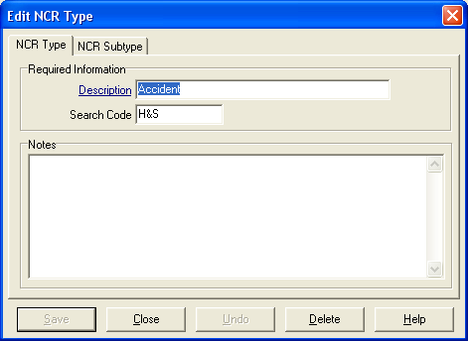
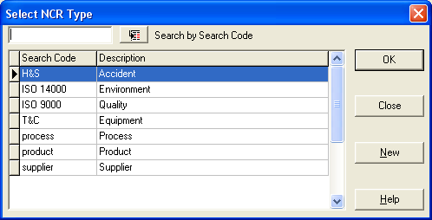

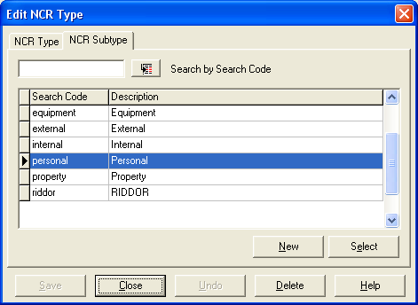
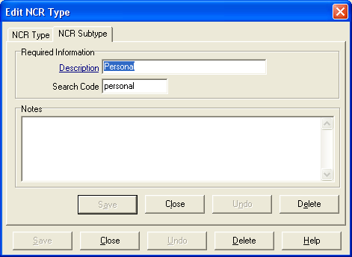

NCR Types can have Subtype settings allowing for a more detailed breakdown of the type of NCR reported, for instance:

An NCR Type of Accident can now be subdivided into Personnel, Near Miss, RIDDOR Reportable, Property, Vehicular etc.

The types of nonconformity settings will also enable you to break down the NCR’s for reporting, searching and setting up unique Business Rules.

NCR Severity Levels

Severity Levels can be ascribed to each NCR and then prioritised for resolution. In setting up Severity Levels, a unique weighting must be assigned to each level. Up to one hundred levels of severity can be created.

Examples of severity levels:
Critical 95
Major 75
Minor 40
Observation 20
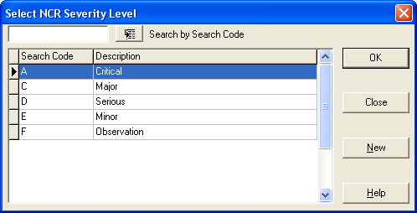

Severity Levels can be assigned within business rules, and when identified at the time the NCR is reported, can be used to trigger a given business rule so that a task or notification is sent out to the relevant people. This severity level can be re-assessed during the life of an NCR and the reassigned level will inform, via business rule settings, a different group or individual.
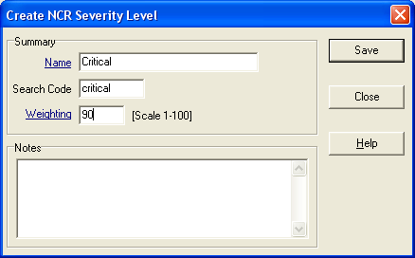

In the System Configuration Centre, Module Settings, Nonconformities, it is now possible to define that the Severity Level is a mandatory field.

NCR Sources

This area allows you to define the source of an NCR for later analysis and grouping determining either where in the business the activity being carried out when the problem originated.

In a typical company, there are a number of sources from where a problem can be highlighted.

These sources could include

Internal Audits
3rd Party Auditor
Customers
Suggestion Scheme
Accident
Health & Safety Executive
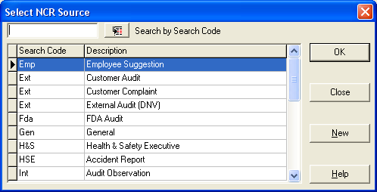

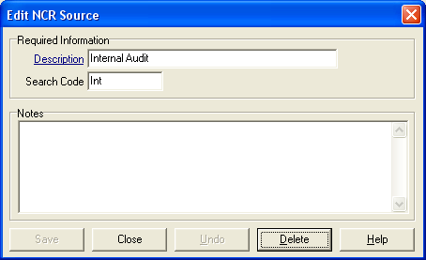

Corrective Action Types

Once an NCR has been reported and assessed, actions can be sent to individuals to resolve elements of the NCR. The terms for these actions can be pre-set, so that the person assigning the action can select from a drop down list to identify what type of action it is.

Examples of such actions could be

Investigate
Corrective
Preventive
Training
Refer to Supplier
Raise a credit note
Review procedures
Re-work to specification
Scrap
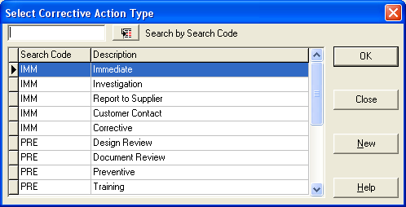

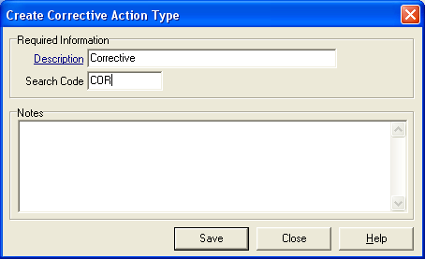

Recording of Suppliers and Products.

Suppliers of product or service to an organisation can be recorded and recalled through Workbench. Any discrepancies can be reported through the NCR module, and Audits to be carried out against a Supplier can be scheduled through the Audits module.

Setting up the suppliers is completed through the “Supplier|New” menu item under the “Settings” menu.
You can enter as much or as little information as is needed.
You will however be required to enter at least one contact in the “Contacts” section.

Information entered through the NCR module will become available anywhere in the software where supplier or product information is referenced.

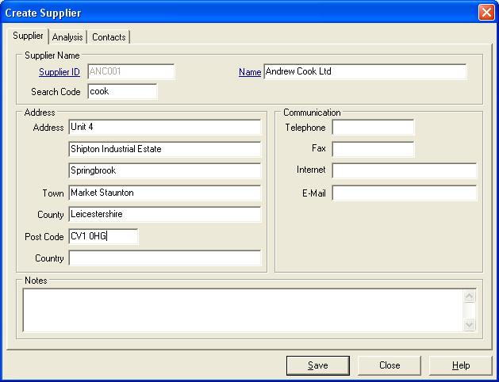

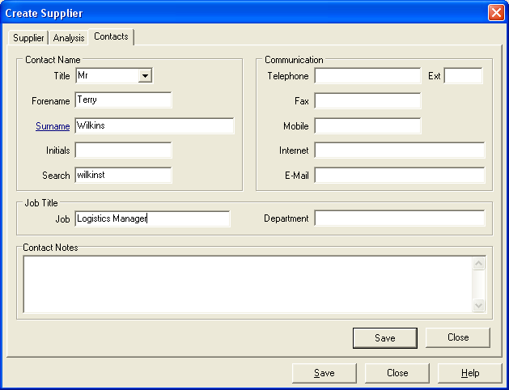
Product or Services.

Setting up Products or Services you supply uses a similar structure.
You can enter information about the product and whether it is manufactured in-house or bought in. If the product is manufactured in house, then a manufacturing cost can be associated with it.

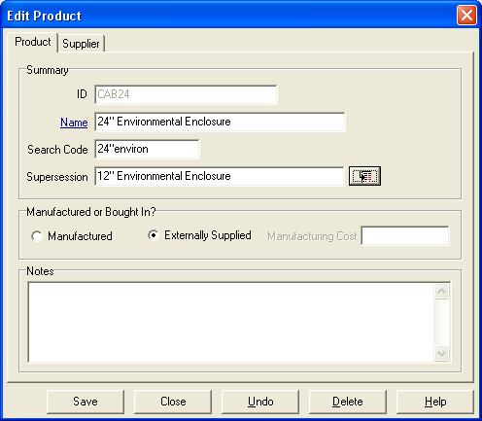

If the product is bought in then a link to the supplier can be assigned.
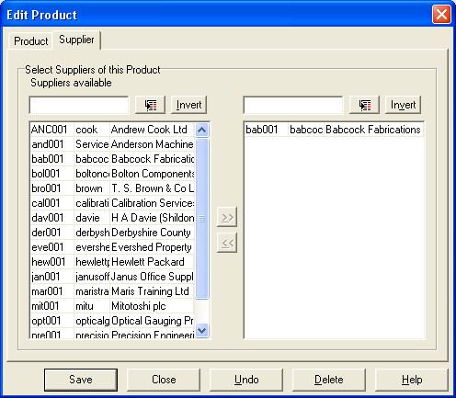

Customer Information

Customer Contact Management is carried out in this area.

Customer / Maintain

Details of Companies or Individuals are entered and updated in this section.
Customers can be Individuals (for Environmental Standard ISO 14001 these could be Stake Holders rather than true Customers) or Companies.

The details are separated into 4 parts

Company Details – name etc.
Notes
Analysis – How your company wants to see extra information
Contacts – Details on the contacts – with further Analysis and Contact Notes

Searching for a company can be done by search code or within Name, and filtering can be done on the type of customer as a company or as an individual.

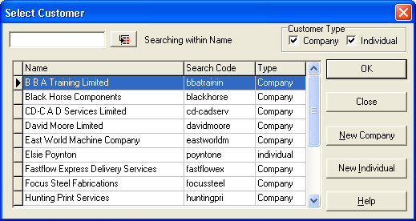

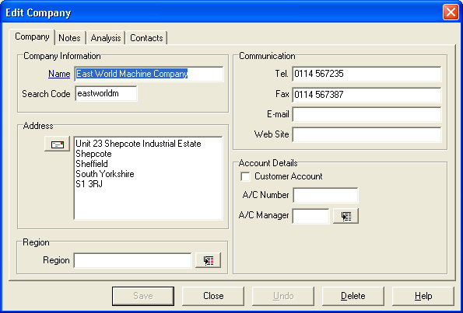

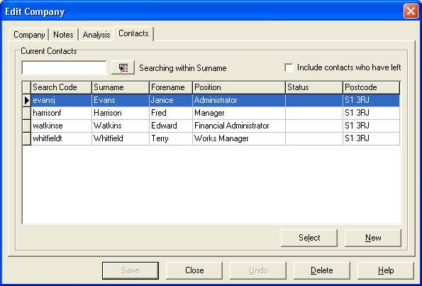

Customer / Search for Contact

Details of each contact on the database are held in the contact tables of the database and a search for contacts can be made from the “Search for Contact” screen. To make the search and viewing easier the presentation can be sorted in five different ways, and the search can then be made in two ways.

Examples of different criteria for ordering the display are:

by search code
by name
by company
by position in the company
by postcode

which can be selected by using the right mouse button on the “Order By...” button.

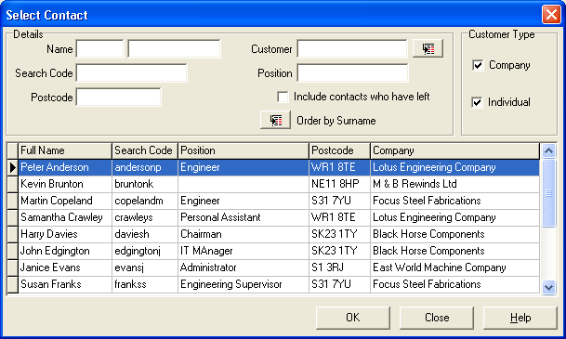

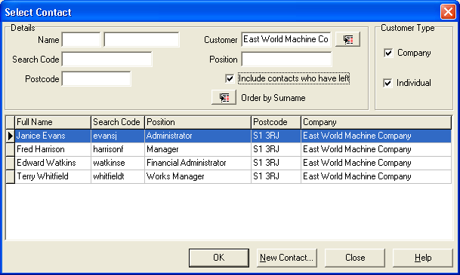

Sort the contacts by Company.

For instance
find the contacts for East World Machine Co. by selecting the customer search button.

Customer / Move Contact

Sometimes a contact from one of your customers moves job to another customer company or sets up in business on their own. You can transfer them to the new company or set them up as individual contacts.

Helpful hint

The source contact is not deleted but marked as left (read only).
Similarly, if the source was a private individual various amounts of information may be retained by use of the options button (as shown below).
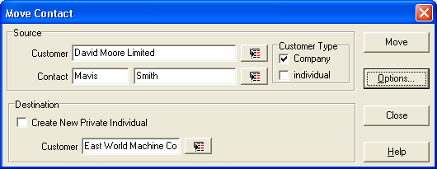

The Business Rules

The NCR module provides a sophisticated method of notifying and actioning NCR’s automatically.

Rules are turned on or off through the “Workflow Configuration Centre” in the System Manager Module.

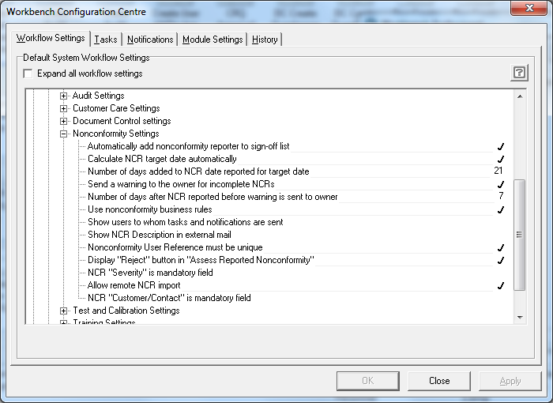
If you decide to use and implement Business Rules, then you can also decide if you want the end user to see the list of people to whom the Task and Notification messages will be sent. Switching off the tick will stop the end user from seeing the list of people who will be informed of the NCR.

If you do not select that Business Rules be used, you will still be able to direct the NCR to the correct people by completing the boxes manually when you log the NCR if the “Show users to whom tasks and notifications are sent” is selected in the Workflow Configuration Centre.

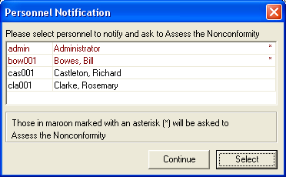

Default Business Rules

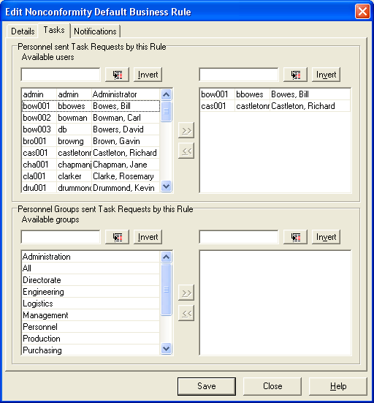
If you are using Business Rules, or using Quality Workbench, then it is important that you set up the “default” rules, so that in the event of an NCR being reported, and not falling into one of the prescribed Business Rules, then it will still be notified to someone.
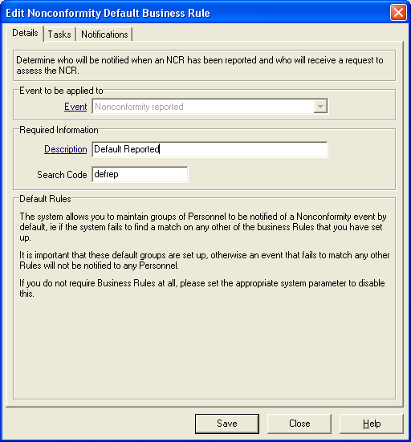

There are three stages to a Nonconformance.

Reported
The first stage requires that when an NCR is reported, (entered into the system) a task message will be sent to the defined individuals, and notification of the NCR to other individuals or groups. The people tasked will be asked to “Please Assess” the NCR.

Assessed
The second stage triggers a notification only message to be sent to the defined individuals when someone on the task list at the previous stage has assessed the NCR.

Sign Off
The third stage is triggered once all the required actions (there must be at least one action), have been completed and signed-off, the NCR has been reviewed and is ready to be signed off as complete. A task message will be sent to the person with responsibility to sign off NCR’s of that type and a notification message sent to those who need to know.

Setting up Multiple Business Rules (Licensed Area for Quality Workbench)

With the Business Rules switched on, you can set up a simple set of rules by creating and completing the three stages of a nonconformity.

Select “Rules|Business Rules”.

You will need to select an “Event”, give it a Description and select the various parameters that will apply.

The possible combinations will each require their own business rules, so a clear concept of the structure will help.

NCR Reported.

Select the parameters that, if entered in the NCR Reporting dialogue, will trigger this Business Rule.
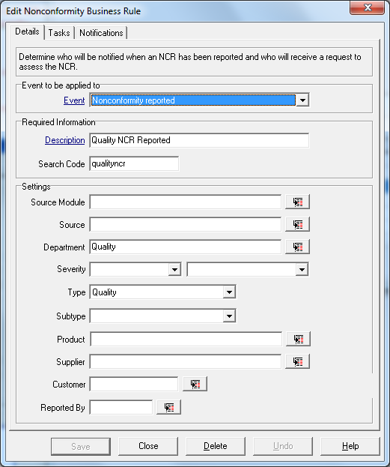

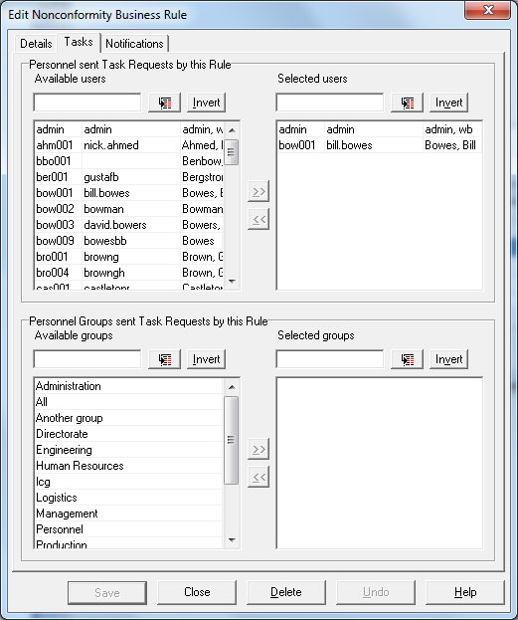

Decide who will need to act on the NCR, and be sent a task to “Assess” the NCR,
and in addition, who should be advised by a Notification, that it has been reported.

NCR Assessed

The next stage is to inform people when the NCR has been assessed. This area only has a notification section.

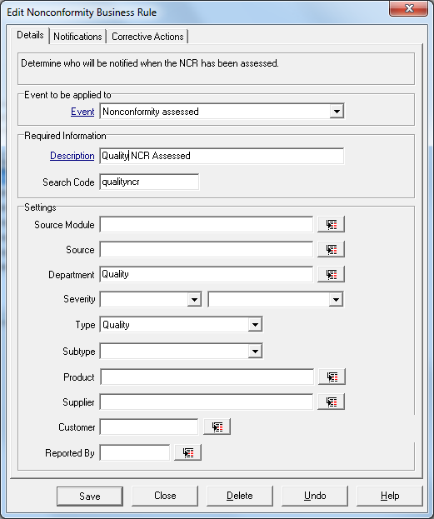

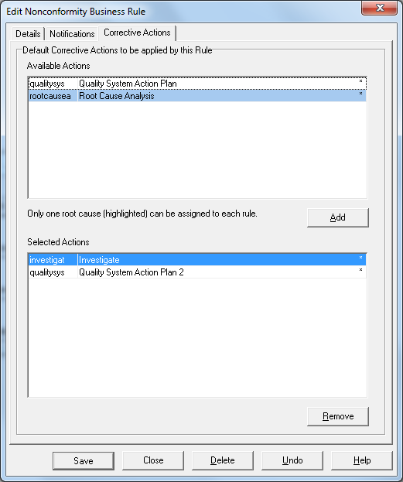

But at this stage it will also invoke the relevant Corrective Action Template giving a list of Corrective Actions that could and should be used if the type of event occurs.
Select as many as are required to resolve the issue, however, you will only be able to select ONE of the actions defined as a Root Cause to be associated with each NCR action plan rule.

NCR Sign Off

The third stage is at the end of the NCR cycle and you need to define who will sign off the NCR once the owner has finally reviewed it.
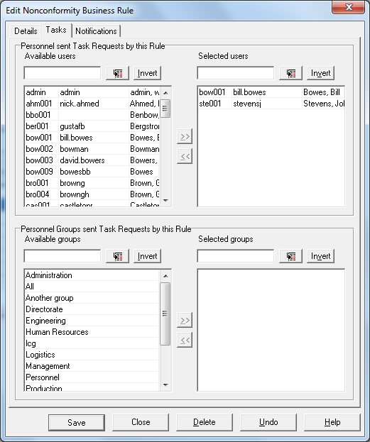
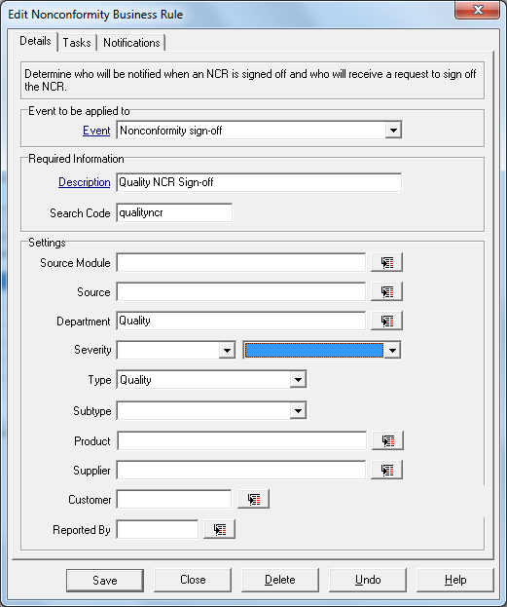

ALL people nominated as being required to sign off an NCR will have to sign before the NCR can be completed.

It is important to bear in mind that setting too many parameters for each rule will mean a complicated and confusing rule structure, and will necessitate the creation of a large number of rules to cover all eventualities.

As in all the set-up of Workbench, the golden rule is to
“Keep It Simple”.

User Defined Analysis (Licensed Area)

This is applicable throughout each module within Workbench, and creation and modification is the same with the exception of the NCR Module, where, for NCRs and the related corrective actions, additional functionality to make UDA fields mandatory are available.

The User Defined Analysis (UDA) facilities allow an unlimited number of fields to be created where extra information about the relevant NCR can be recorded for later analysis.
UDA’s can be created both for Nonconformities, Corrective Actions and Suppliers where required.

The analysis can, for instance, reflect areas of nonconformance related to the ISO standard, or Health and Safety. As nonconformances reflect many different issues within an organisation, some analysis may be needed to link this with, for example, customer or supplier problems.

Corrective Action Analysis could be used to ensure that certain elements of every CA are recorded before the Corrective Action can be processed.

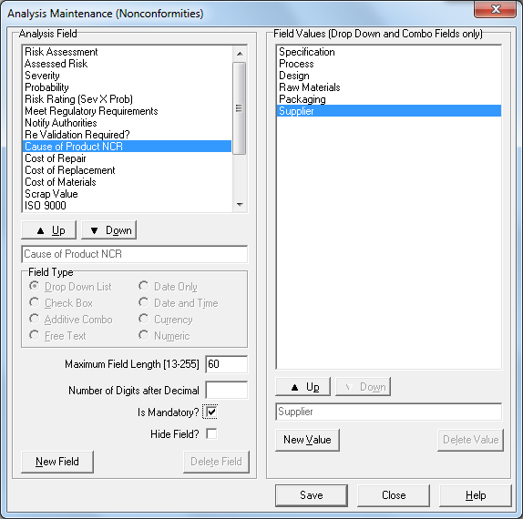
All User Defined Analysis applies to all areas in which it is defined, for example ALL Corrective Actions will have the same set of UDAs.

These fields can be created and populated within the UDA screen and for NCRs and NCR Corrective Actions, these can be made mandatory to force users to complete the information required, with the exception of a “Tick Box” field.

At present, there are eight types of field available for use in the UDA screen.

The Drop Down List box allows creation of a single selection drop down menu. This analysis type has to be set up and populated with information prior to creating an NCR.

The Check box allows any number of Tick boxes to be created.

The Additive Combo box allows end users to build a drop down list as they use the system. This is “on the fly” build-up of the drop down list.

The Free Text box allows users to type up to two hundred and fifty five characters of free text into the box.

The Date Only Field allows for date to be entered from a Calendar select button.

The Date and Time Field allows for date and time to be entered from a Calendar select button.

The Currency Field allows values to be entered, with up to 20 characters and to 9 decimal places.

The Numeric Field allows numbers to be entered, with up to 20 characters and to 9 decimal places.

The Nonconformity Life Cycle

The Corrective Action Life Cycle

For each corrective action the process is the same, the action is assigned to a user, who must accept or reject the action. Once accepted the user will carry out the task, report back into the Description box in the Action dialogue whatever information is needed, and then mark the task as complete.
The Owner of the NCR and/or any people identified as suitable will be asked to sign off the corrective action as completed.
Once all the Actions have been signed off, the NCR can then be reviewed and if all is correct, sent for sign-off.

Reporting a completed NCR into the database through the Wizard

There are two ways to enter an NCR into Workbench.
Using the Quick Wizard allows a completed and closed NCR to be entered as an historical event. The Wizard takes the process through each step and stage of the NCR up to completion and sign-off. It would normally be used for retrospective reporting. None of the Business Rules (if used) or messages will be invoked when using a Wizard entry.

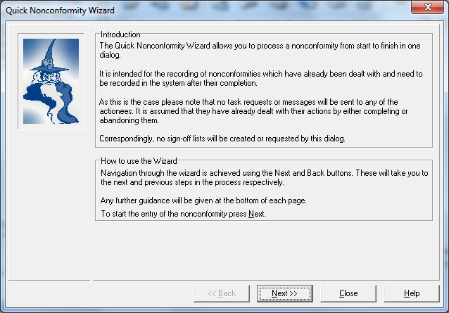
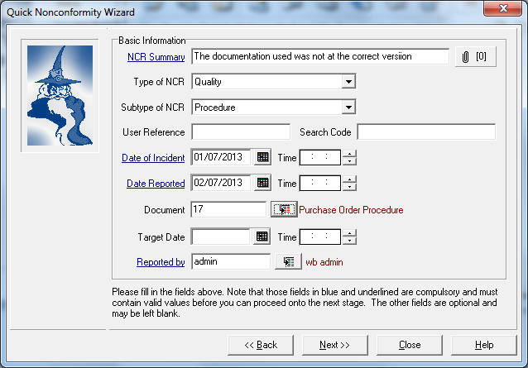

Enter a one line summary of the problem.

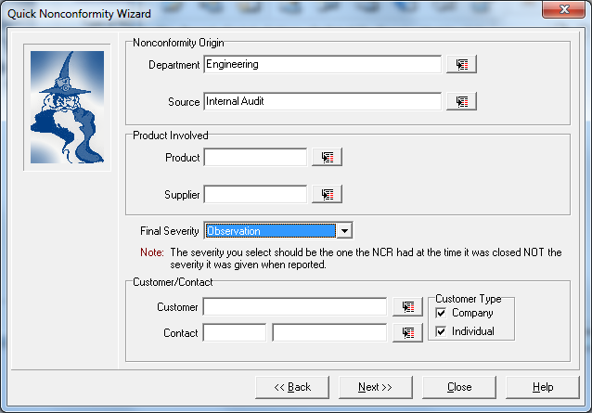

Fill In any of the relevant data fields for department, source,
Product, severity and customer as needed.

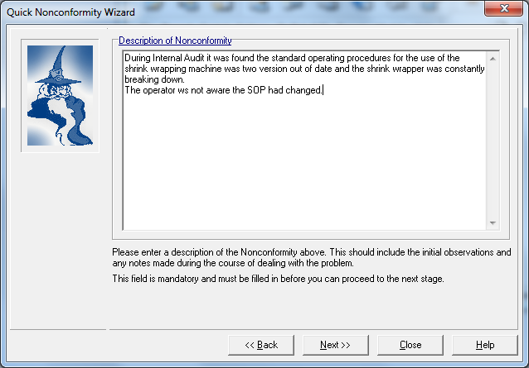

Complete the description field with a full explanation of the issue.
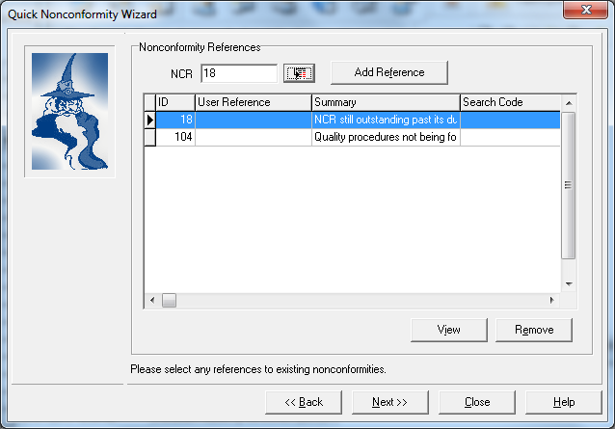

Add any other NCRs already in the system that are similar or associated with this NCR as cross references, so that they can be grouped together.

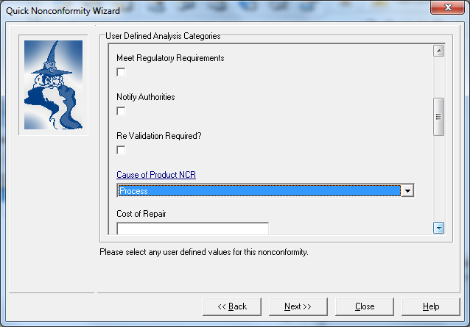

Complete any of the User Defined Analysis fields relevant to this NCR.
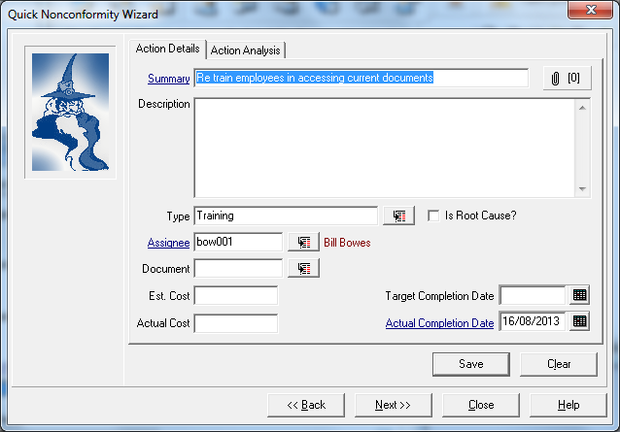

Enter any and all Corrective and Preventive Actions taken to rectify or resolve this issue, and complete any of the associated User Defined Analysis fields for the Actions.

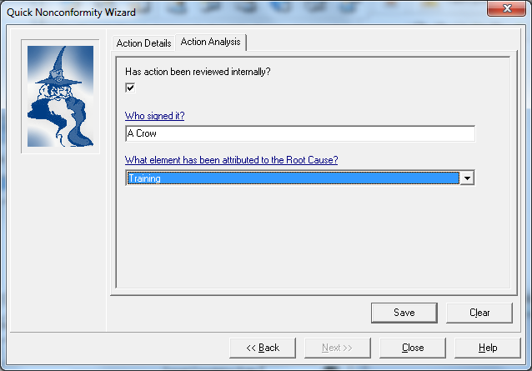
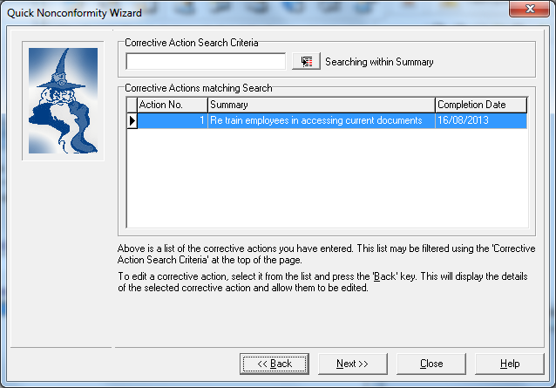

The Quick Wizard takes an NCR from start to finish, close out, and although entry of any number of actions can take place, once the final screen is closed then it is assumed that everything is finished and the NCR is marked as completed.

No further detail can be added from this point on.

The Wizard is used for the entry of historical NCR information for complete reporting purposes, and for those instances where an issue is highlighted and corrected all at the same time.

The method for reporting a new NCR

There are a number of data fields that are mandatory i.e. something must be entered (blue underlined field labels).

Enter summary details in the summary box (a short description of the incident).

Enter the date the incident actually occurred, (using the pop-up calendar).

You will need to enter data into the selection boxes for source, department, severity, customer and or product, for sorting and analysis.

If you are using business rules then the relevant fields should be filled in so that they invoke the correct rule.

The Severity of an NCR and the Customer Information can be made mandatory fields and these settings can be defined in the System Manager Configuration Centre. As these settings are system wide, ALL NCRs will have the severity and customer settings as Mandatory.
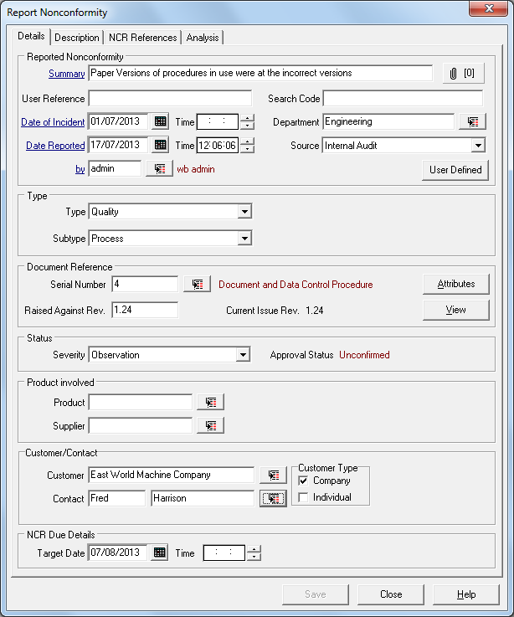

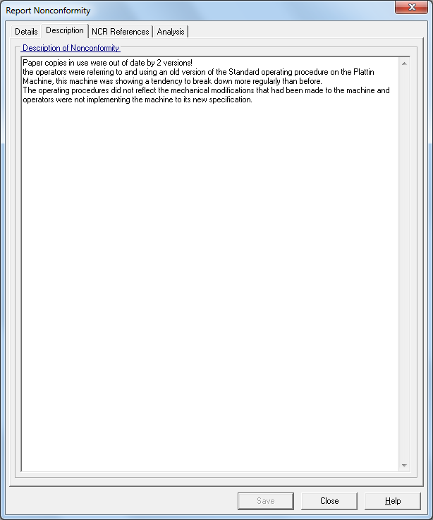

Select the “Description” tab and enter a more detailed description of the incidence.

If the Automatic Target Date has been set within System Manager module, then the target date will automatically be calculated, based on the value set, and filled in at the time the NCR is reported. A warning message may be sent to the NCR owner, or the user who reported the NCR, if it has not been assessed, that the NCR target date is approaching.

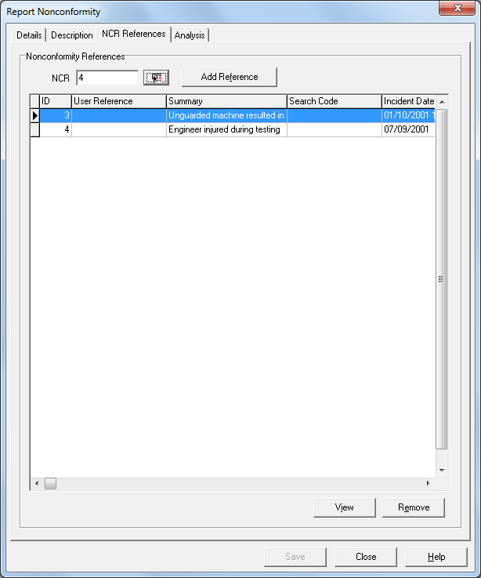
Reference to other NCRs already reported in the system can be made here thereby grouping similar problem together.

Select the referenced NCRs by using the search button

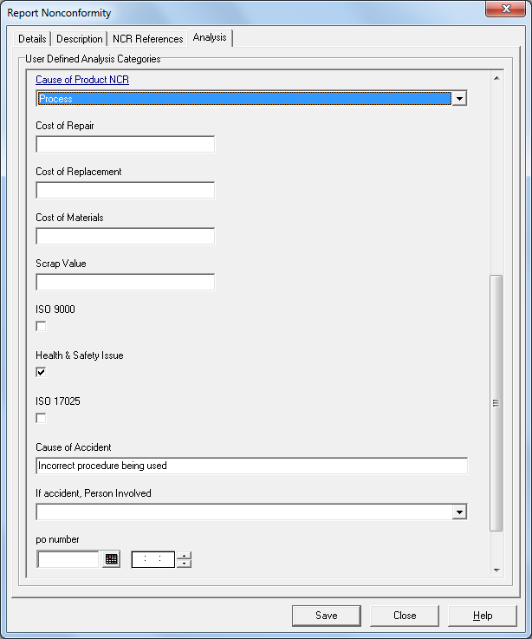

If the User Defined Analysis section has been set up then there may also be fields within that are which are mandatory and need to be completed. The Save button on the bottom of the dialogue screen will not be activated until ALL mandatory fields have been completed.

Adding an attachment to an NCR or Corrective Action (Licensed Area)

It may not be possible to enter all the information required in the description box when entering an NCR or Corrective Action. Actual evidence in the form of letters, e-mails, digital photographs etc. may be needed as part of the NCR. This information can be added to an NCR or action using the attachments capability.
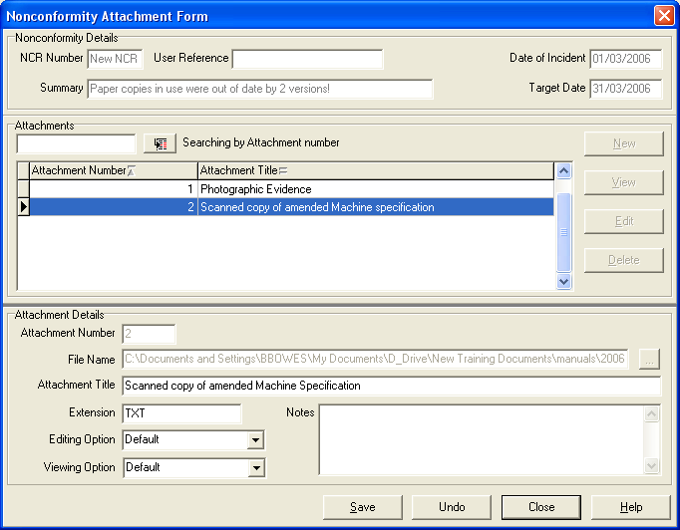

Attachments can be made at any-time during the processing of an NCR or action, up until the point the NCR or Action is closed.

To be able to add or amend an attachment during the life of an NCR or Action, the user must have edit rights to the NCR or Action.

Selecting the “New” button in the middle area of the screen activates the lower screen, where the attachment or file detail can be entered.

Search for the relevant file, give it a title, and select the save button. Repeat for each file to be attached to the NCR.

Personnel Notification

If the Default Business Rule (or Workbench Professional Multiple Business Rules) has been activated, and the “show users to whom tasks and notifications will be sent” has been activated, a box will appear confirming the personnel to whom the notification of assessment, and the task to assess will be sent. In both Quality Workbench and Workbench Professional additional personnel can be added to this list by selecting the “Add” button.
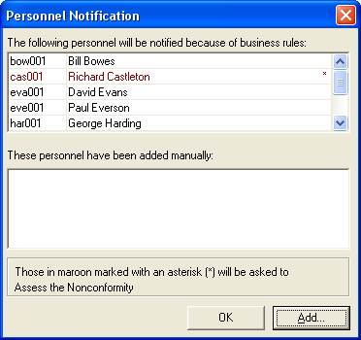

Once accepted a further list will appear showing those people who you have elected to be told that the NCR has been assessed.

If the Business Rules are switched off, but the check box allowing a manual selection of personnel was ticked, a similar selection box will appear, but will be not have any names inserted. Make your selection by selecting the “Add” button.

The people to whom a task to assess the NCR will be in Red with an asterisk next to their name, and those who will be notified will be in black.

Processing an NCR.

Once reported, an NCR must then be assessed.
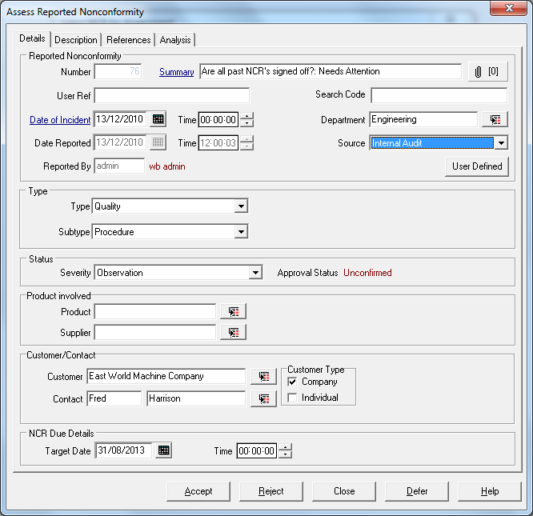
Assessment requires one of the people given the task, to either “Accept”, “Reject” or “Defer” the decision.

“Reject” an NCR means it goes no further in the NCR cycle and can be purged from the records. The “Reject Button” can be hidden or switched off by altering the settings in the Workbench Configuration manager.

“Defer” allows for an NCR to be reviewed without a decision being made but the fact that it has been reviewed is recorded in the history.

“Accepting” the NCR makes the assessor the owner of the NCR and decisions can be made as to the corrective actions needed. The owner of the NCR will be notified of an impending target date if that setting has been activated through the system manager Workflow Configuration Centre.

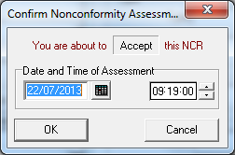
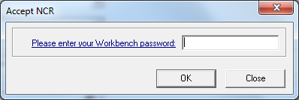
On completion of the decision a box appears with a time and date stamp confirming the decision made.

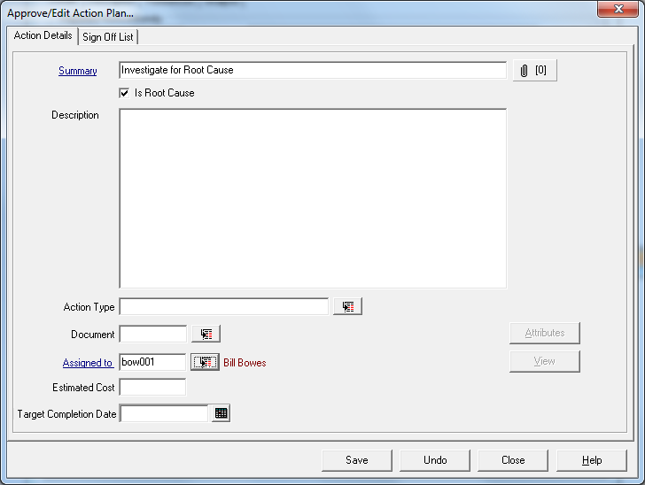
If the Corrective Action Templates have been used, the person accepting ownership of the NCR will be presented with the list of Corrective Action Templates, and if Corrective Action Templates have been defined in Business Rules, these actions will already be selected in the Selected Action Templates panel.
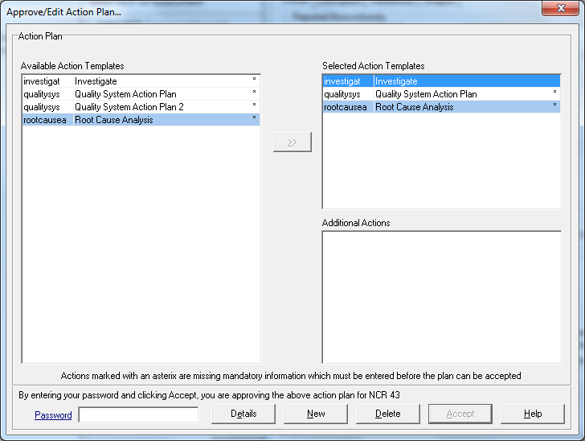

If the Action has an asterisk * showing next to it, that denotes that an actionee has not been identified to carry out the action and this will need to be done for all actions before the NCR can be accepted.

Individual Corrective Actions already identified can be removed from the selection list and others can be added from the Corrective Actions Template list, and totally new Corrective Actions can be defined as well, making the list of Actions specific for the NCR.

Only one Corrective Action can be defined as the Root Cause for each individual NCR.

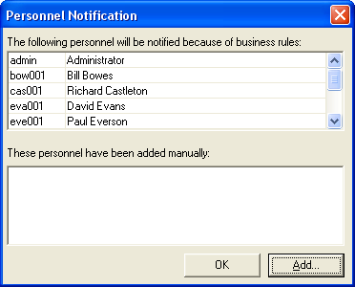
If the Default Business Rule (or the Multiple Business Rules) is active, a box will appear confirming the personnel to whom the notification of assessment will be sent. Additional personnel can be added to this list. Once accepted a further list will appear showing those people eligible to sign off the NCR once it has been completed and reviewed.
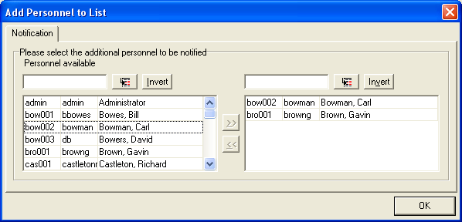

If the Business Rule is switched off, but the check box allowing a manual selection of personnel was ticked, a similar selection box will appear. Add the names of people by selecting from the personnel list provided.

Any other person who is highlighted on the task list for that NCR can do the assessment and acceptance of that NCR.

Any person with the correct access permission can perform the Assessment of an NCR (see “On Behalf of” menu).
The “On Behalf Of” menu (Licensed Area for Quality Workbench)

Many of the tasks in the NCR module may require that a task be undertaken by someone else.
This is addressed using the “On Behalf Of” menu items.
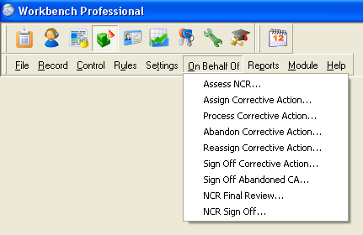

The tasks covered by the on behalf of menu are

Assess NCR
Assign Corrective Action
Process Corrective Action
Abandon Corrective Action
Reassign Corrective Action
Sign Off Corrective Action
Sign Off Abandoned CA
NCR Final Review
NCR Sign Off

An individual given the correct access permissions to the menu can carry all of the tasks out.

The history will show that the task was completed by “xxxx” on behalf of “yyyy”.

The “NCR and Corrective Action Sign-off Progress” menu (Licensed Area for Quality Workbench)

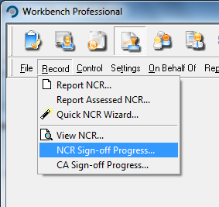
To monitor the sign-off progress of either a complete NCR or the individual Corrective Actions assigned
to that NCR, select the relevant menu item. This will then display all the relevant events, and enable the selection of the NCR or Action to be viewed. The view will then show which people have signed off the event or not.
Reassign Ownership of an NCR

This dialog is the only way a user can reassign ownership of an NCR once it has been reported.
NCR ownership may be re-assigned by any user with full access rights to the menu item.

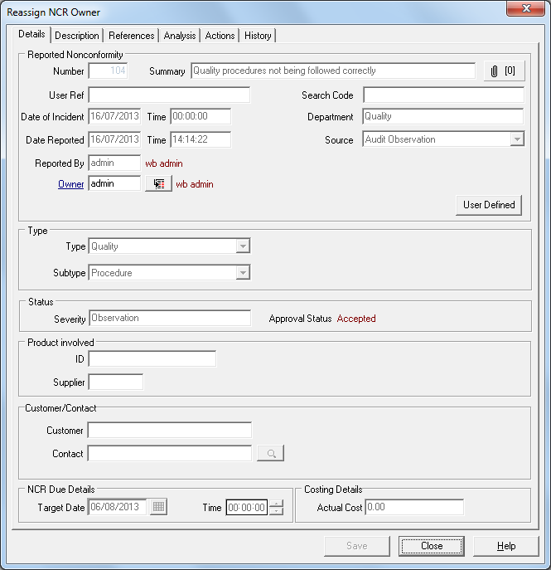
You may reassign ownership of any NCR that has been assessed (even if it has had all its corrective actions signed off) up until the time that it has been marked ready for sign-off.

Messages will be sent to the original owner telling them that they are no longer responsible for the NCR, and to the new owner informing them that the NCR has now been assigned to them.

Changing Target Date of an NCR

During the progress of an NCR, the target date originally set at the time the NCR was accepted may need to be changed. Additionally the target dates set for the Actions associated with the NCR may also need to be changed. The owner of the NCR can change the target date, anytime up to the point of final review, for an NCR or any actions associated with it.

A reason MUST be given in the mandatory box for changing the NCR date.
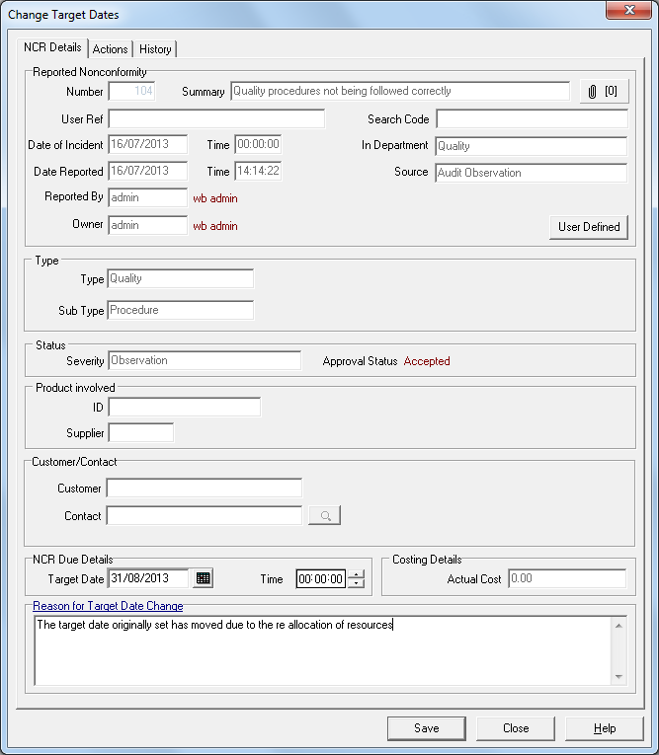

Changes to Target Dates can only be made through the menu item “Change NCR Details” menu item.

Assign Additional Corrective Actions

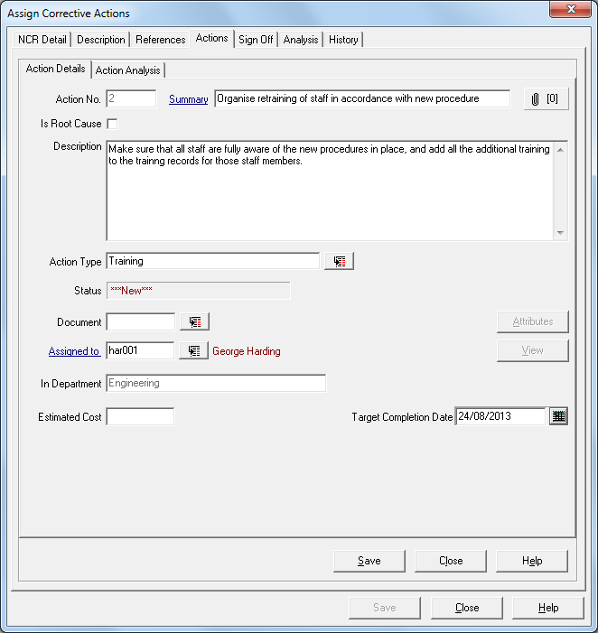
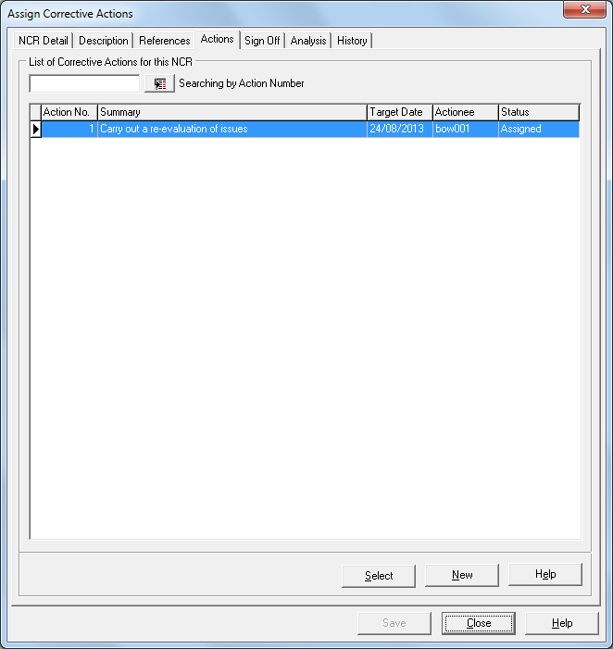
been assessed and accepted Corrective Actions will have been assigned at the accept Assessment stage, but at any time during the NCR process, the owner can then decide what additional actions need to be taken and can allocate those actions to individuals in exactly the same way. A list of the currently assigned actions will be shown.
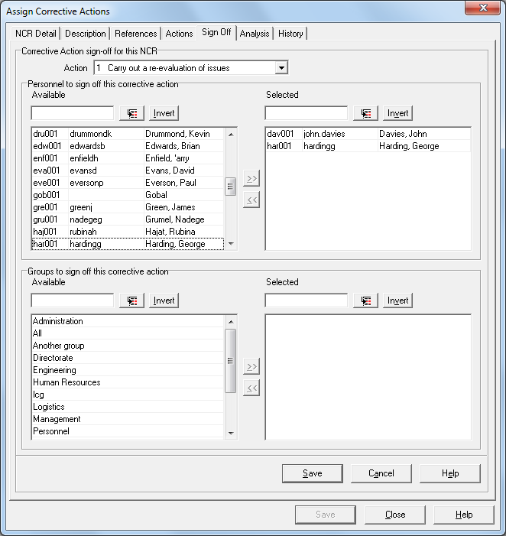
Any number of Corrective Actions can be raised for any particular NCR.

Each Action will require to be signed off before it can be considered closed.
An entry in the NCR history is made at this point, and a right mouse click on that entry will show those required to sign off the Corrective action.

If there is no one assigned to sign off the NCR then the task will be sent to the NCR Owner to sign off the Action.

Processing a corrective action

This task can be actioned from one of four different areas: - directly from an e-mail if the e-mail system is in use, directly from the relevant drop down menu, from the Workload Manager if that has been installed, or from the task screen in Workbench.
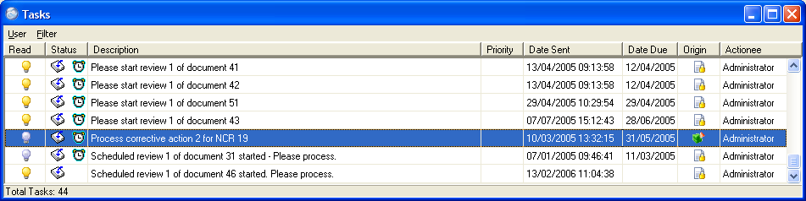

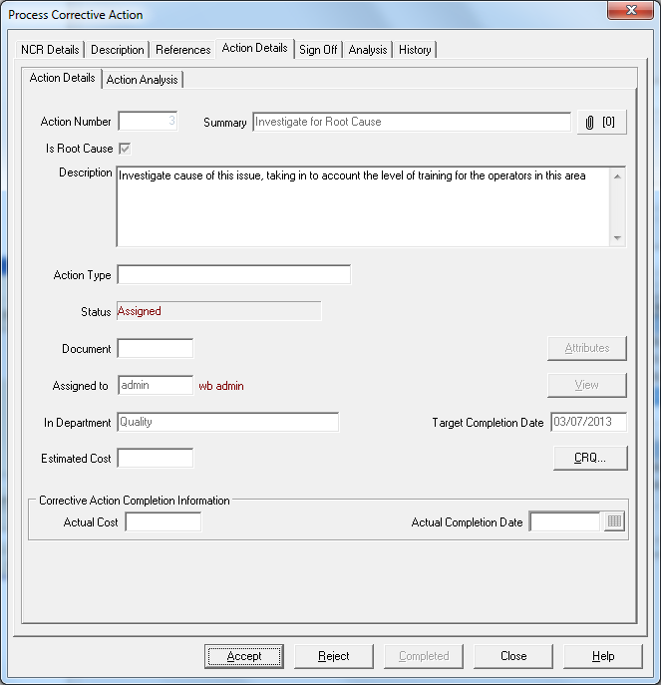
The person who has been nominated as the actionee for this corrective action will be requested to accept or reject the corrective action.

When the action is either accepted or rejected then a message will be sent to the owner of the NCR.

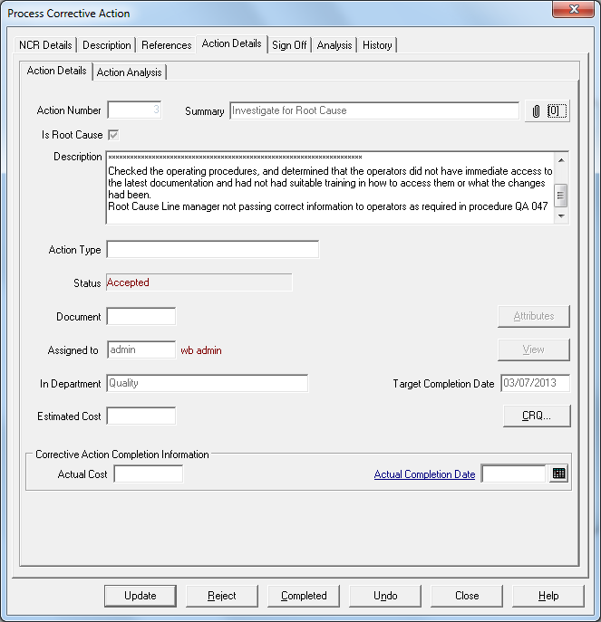
Once accepted, the actionee can process the action as instructed, by recording the detail of any actions in the description field.

Many stages can be recorded at this point and the actionee can update the notes by selecting the appropriate Update button.

Once the actionee has done everything required the task can be marked as completed. A date must be entered in the “Actual Completed Date” field.

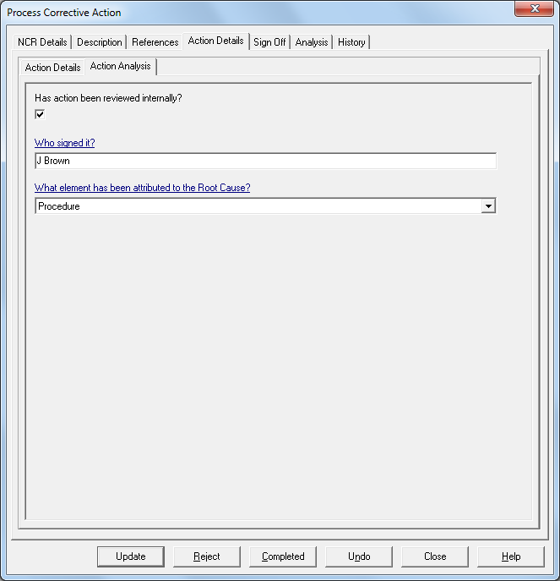

If the Action Analysis has been configured, then this must be completed and any mandatory Analysis fields filled in before the Action can be marked as completed.

Selecting the Completed radio button will inform the NCR owner and those required to sign off the task.

Should the task not be completed by the target date, an e-mail will automatically be sent to the actionee, that this task is overdue.

Changing Target Date of Actions

During the progress of an NCR, the target date originally set at the time the Corrective Action was accepted may need to be changed.

The owner of the NCR can change the target date for the action anytime up to the point of final review.
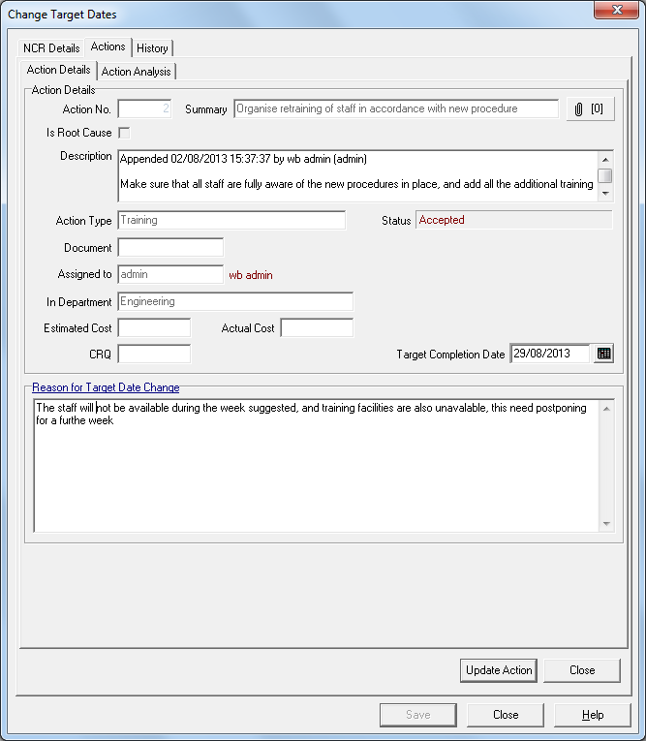
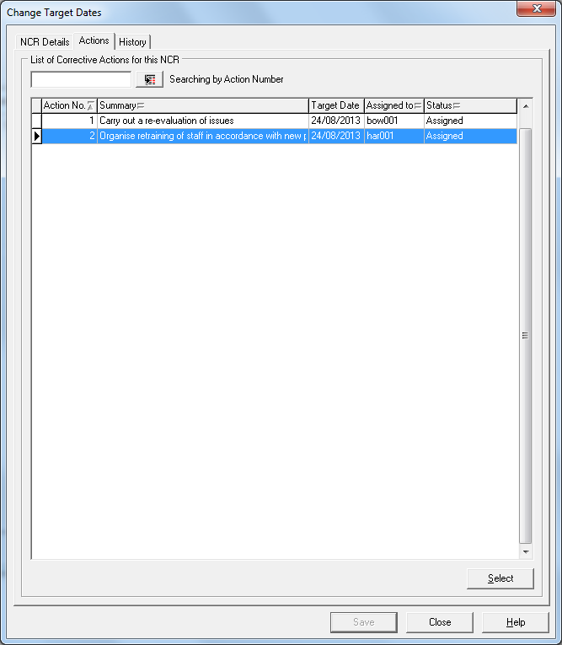

A reason MUST be given for changing the Corrective Action Target Date if the Action has been accepted by the actionee and a signature will be required to verify the change of target date.

Selection of Change of target date for Corrective Actions can only be made through the “Change NCR Details” menu item, by first selecting the NCR and then selecting the Actions Tab.

Change User Reference and Search Code

Changes to the Users Reference and Search Code can be made using the Change NCR Details menu item.

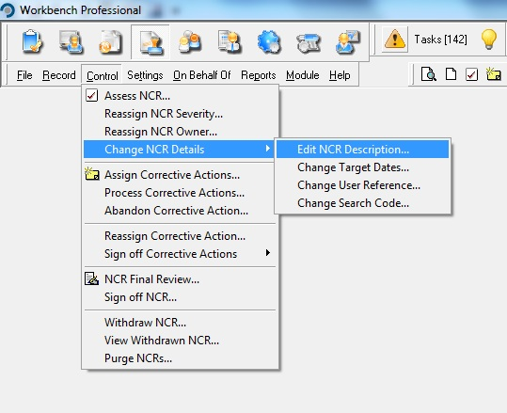

Unlike changes to target dates a reason for change is not required for changes made to NCR Description, User Reference or Search Code, but a history entry will be made when the changes are made.

Sign off Corrective Actions

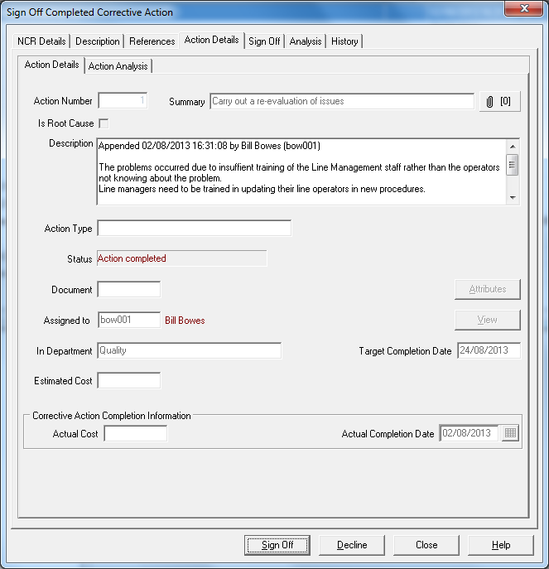
Once a corrective action has been submitted as complete then the assigned signatories will be requested to sign off the corrective action. If the sign off is declined then a reason must be given and this will be transmitted to the actionee.

If more than one person is on the sign off list then all those on the sign off list must sign off the Action before it is returned to the owner as complete.

If no-one is defined to sign off the Corrective Action, then the NCR owner will be the default signatory.

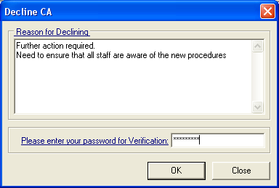
If the Corrective action has not been completed to the satisfaction of those required to sign it off, then they should “Decline” sign off, but a reason is required which will be sent as a task the original Actionee.

Reassign Corrective Actions

If the actionee of an NCR action or the owner of the NCR needs to ask another user to complete a task, for whatever reason, this is accomplished through the re-assign corrective action menu item.

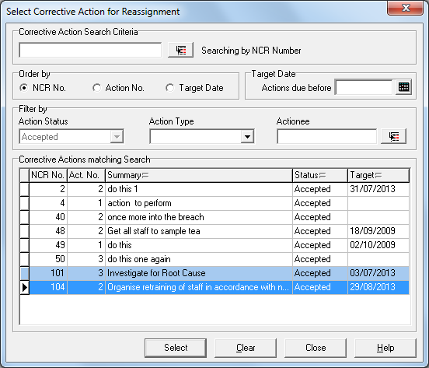
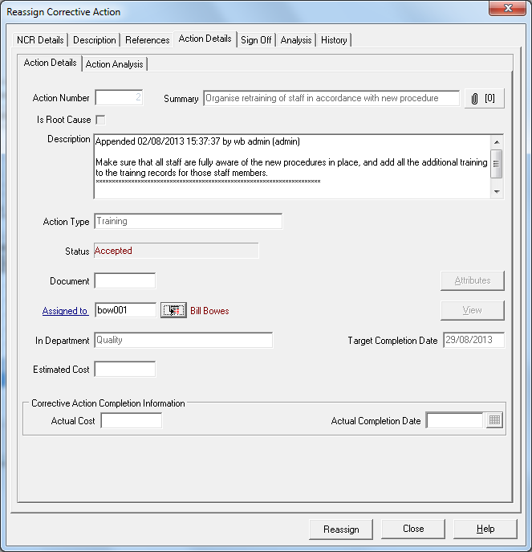
The task must have been accepted by the original actionee. The owner of the overall NCR, or the actionee of the action, can pass ownership to anyone else with access to the process corrective actions menu item. Ownership of the action will stay with the original actionee until the new actionee has accepted the task.

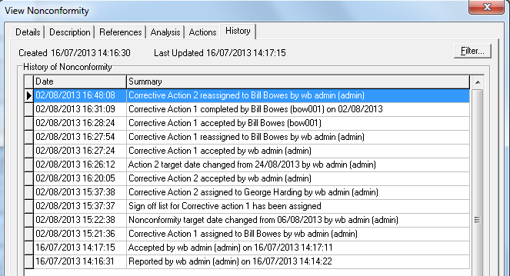
A history entry will be made in the NCR history and a task will be sent to the new actionee that they should accept and process the corrective action.
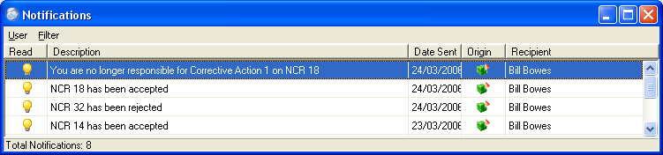
The previous actionee will be advised they are no longer responsible for the task.

NCR Final Review

Once all the actions have been signed off then a message is sent to the Owner that all actions have been signed off and the NCR passes to the NCR final Review stage.

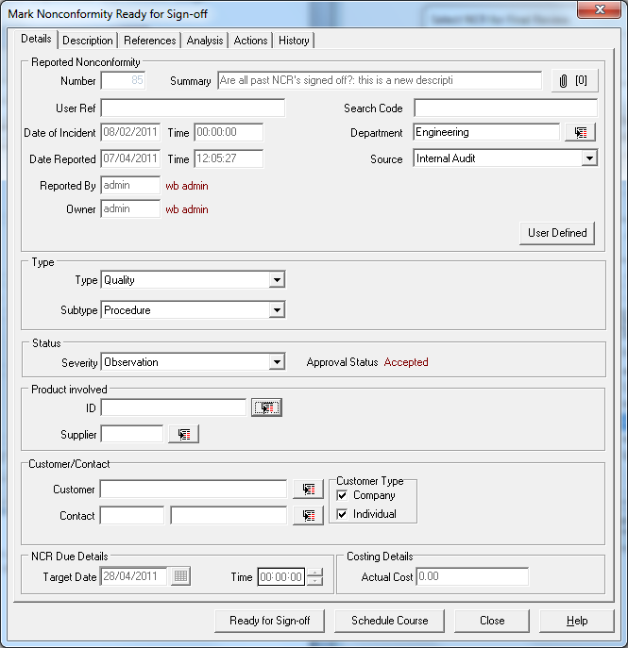
Further actions can still be created at this stage and these will supersede the Review stage until they too have been signed off.

The owner of the NCR will then review the NCR and all the actions raised, ensuring the original issue has been addressed, and further occurrences should not arise, (corrective and preventive actions), and then mark the NCR Ready for Sign-off.

At this stage it is possible to amend the following fields:-

Department
Type and subtype
Product
Search Code
User Reference
Source
Severity

It is also possible to add notes to the description field and make any additional changes to the User Defined Analysis fields

NCR Final Review with No Corrective Actions

If the NCR did not require any Corrective Actions assigned to it, it can be marked for Final Review and closed out, but a reason why no actions were assigned will be a mandatory requirement.

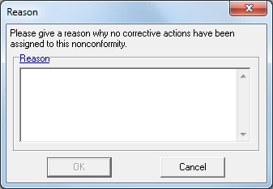
Sign off Completed NCR

Once the final review has been completed then the NCR is ready for completed sign off. At this stage the sign off can be declined, actions can be re-opened and further actions taken to ensure the NCR is complete.

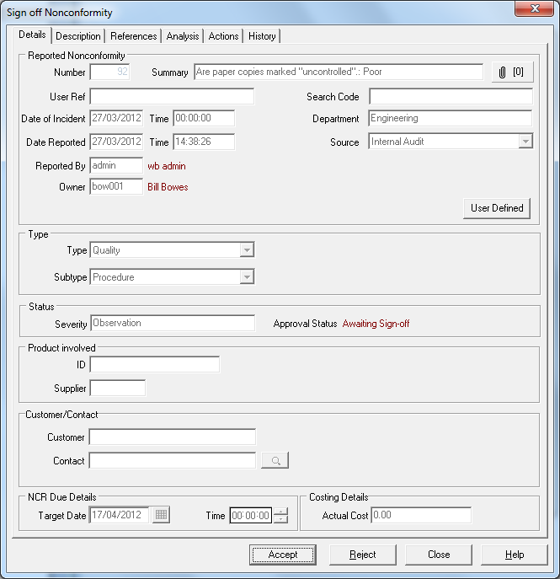

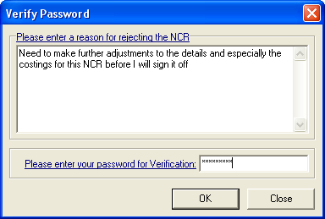
At this stage in the workflow, it is not possible to make any amendments to the main NCR fields, but it is possible to append to the description and to add further attachments.

Should any other amendments be needed the NCR sign-off must be rejected and reasons made clear in the mandatory rejection dialogue screen.

View an NCR

Once reported into Workbench an NCR can be viewed to monitor its status and progress up to completion and sign-off. Filters are available to refine the choice available for selection.

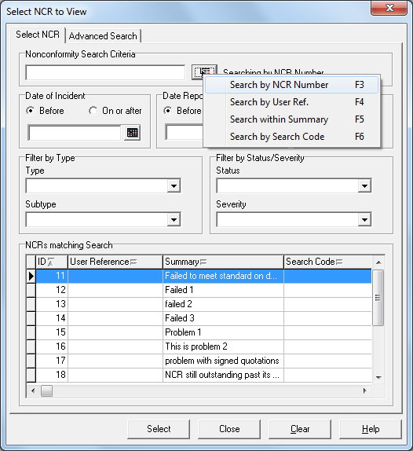

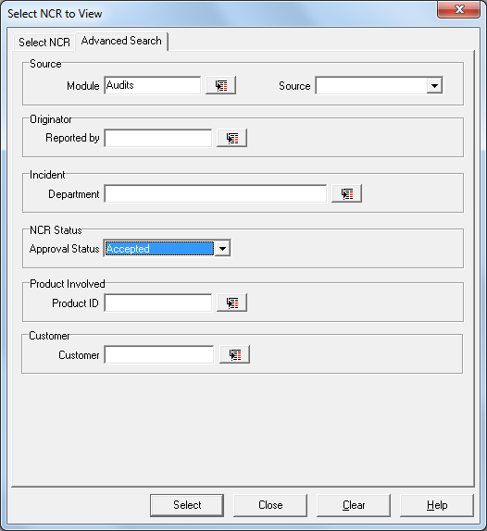
In the Search Criteria box at the top, type in an NCR Number, Users Reference, words from the summary, or NCR Search code to find a particular NCR.
To decide which criteria you wish to use, right mouse click on the search button next to the Search Criteria box.

The selections can be filtered by the Date of Incident, Date Reported, NCR Type, NCR Subtype, Status and Severity, and can be ordered by NCR Number, User Reference Number, Search Code and Summary.

Advanced Searching fields can include Originator, Date of Incident, Product, Source, Department, Date Reported, and Module.

Once you have made the selection you require, then you can view the NCR by highlighting and selecting it either with a double mouse click or by the “Select” button at the bottom of the page.
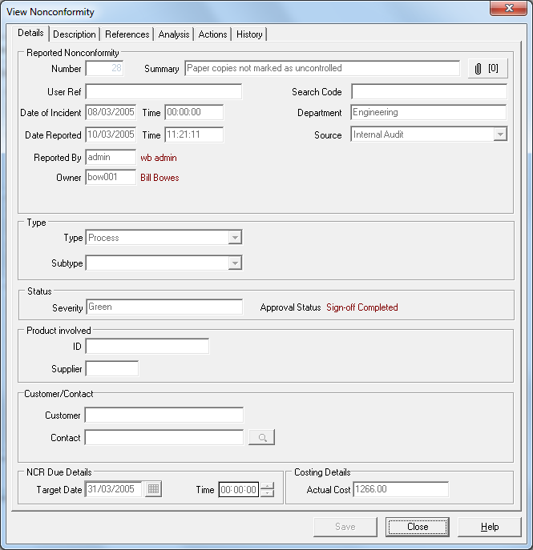
Once selected all the information you would need is visible through the tab screens. The Reference tab indicates any cross-reference to other modules within Workbench, such as the association with a Document in the Document Control Module or to the origin of an NCR such as resulting from an issue highlighted during an audit.

Reference to other NCRs already reported into the system will also be visible from the References tab.

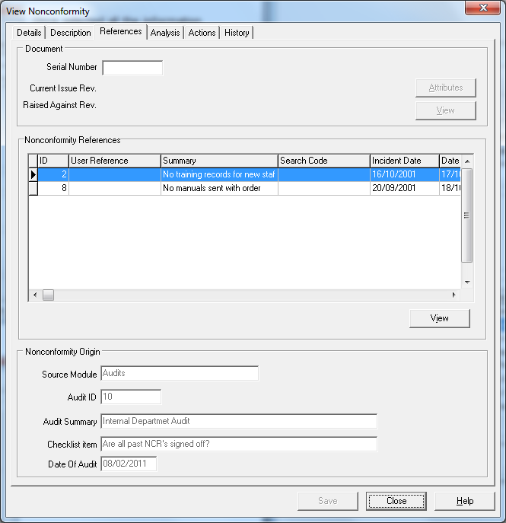

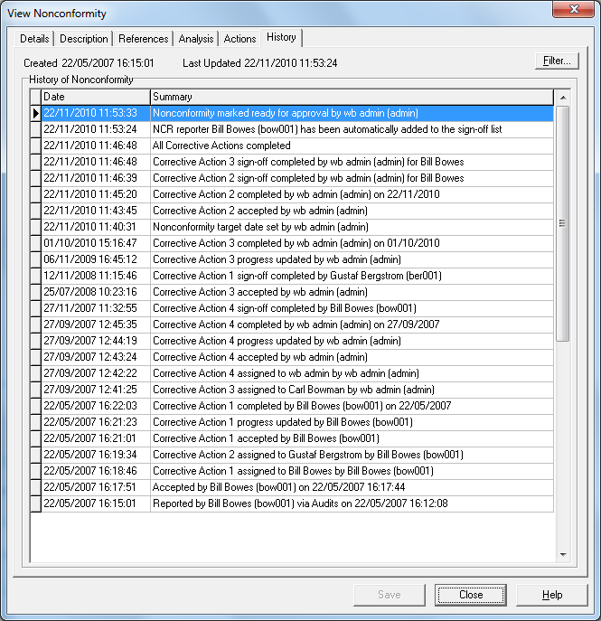

The history for the whole NCR and the individual Corrective Actions assigned to it are available to view on the History and Actions.

Withdraw Completed NCR’s

Once signed off, the NCR can be withdrawn from view, but is still available for statistical analysis, and data can be used in the relevant reports.

Notes can be added to the description field at this point, allowing reasons for withdrawing the NCR to be added.
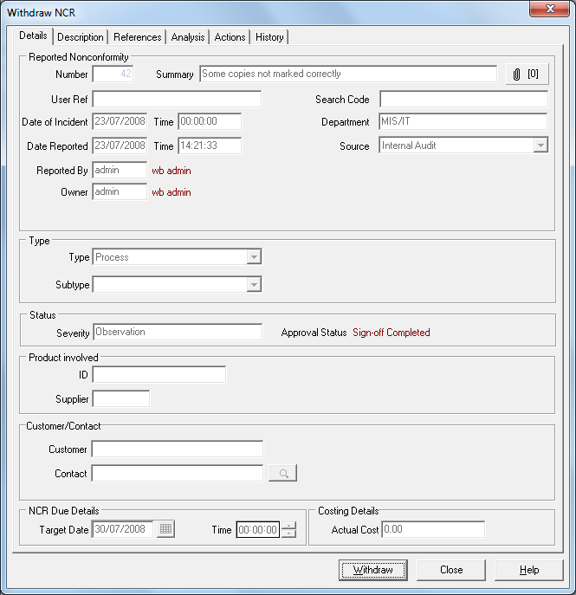
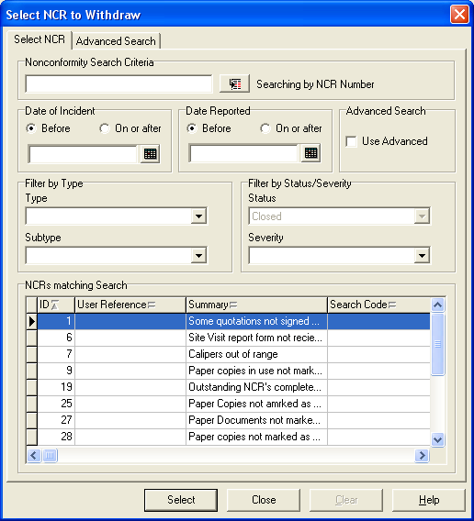

Nonconformities that have been withdrawn no longer appear in View NCR but can be viewed in the “View Withdrawn NCR” menu item by users with appropriate access.

Purge Completed NCR’s

Once signed off, the NCR can be purged from the system, as can all rejected NCR’s. Purging is normally limited to the administrator and the NCR owner.

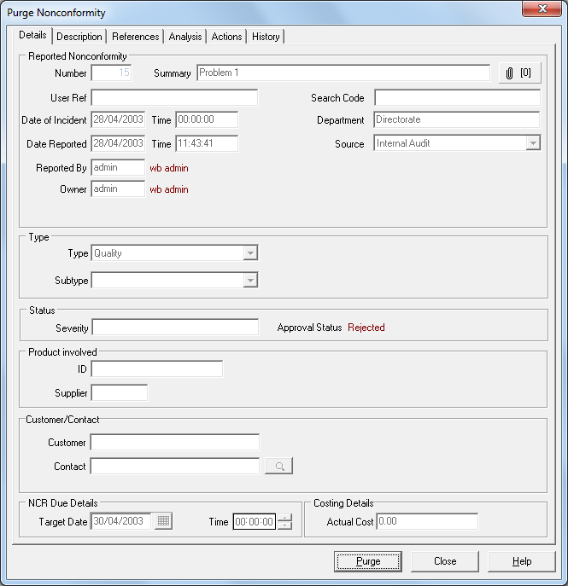

(This function removes all trace of the NCR and should therefore be strictly controlled.)

Reports

There are a number of reports available in Workbench and it is important to recognise the level of information presented.

NCR Graph Wizard

NCR Report Form

NCR Summary
NCR Detail
Corrective Action Summary
Corrective Action Detail
Target Date History

Viewing reports

The Graph Wizard allows a quick graphical overview of the NCR’s recorded.
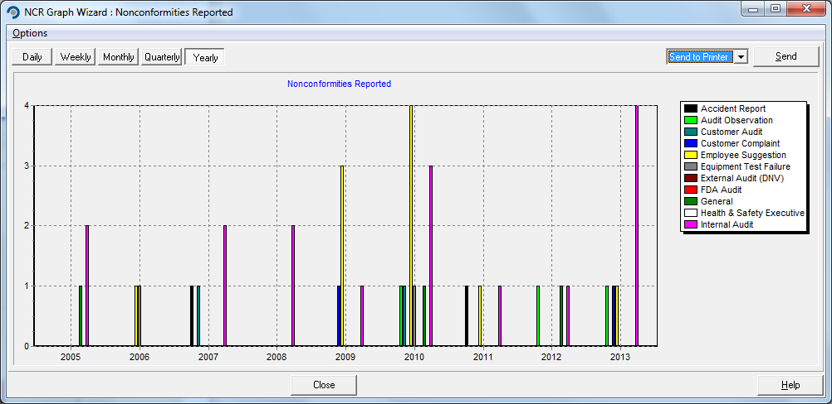
Information can be initially filtered by Source, Product, Severity, Status or Department, and broken

down into time periods.

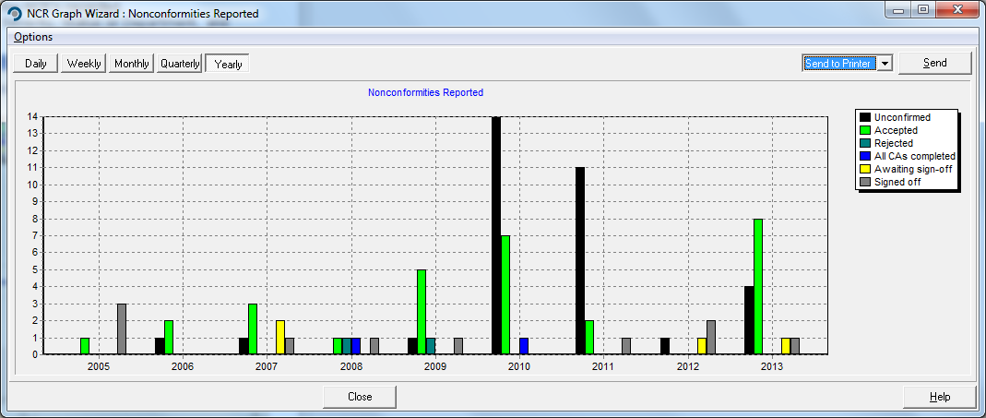

Other reports are text based and allow filtering to produce the required information.
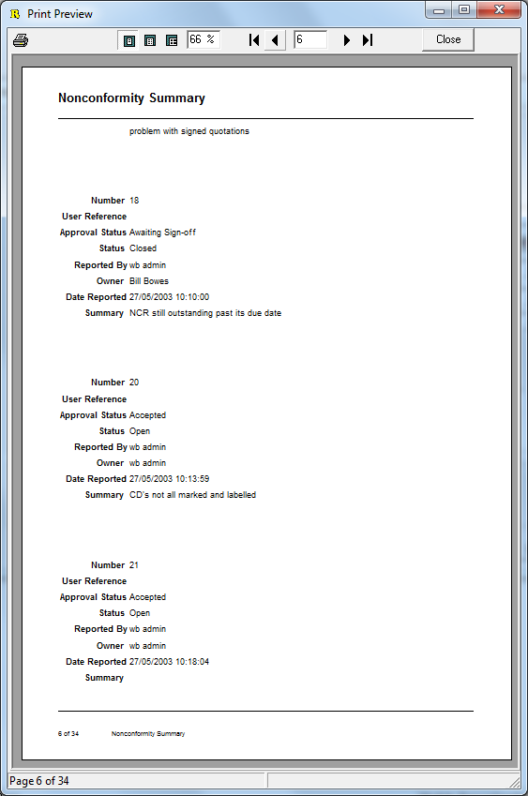
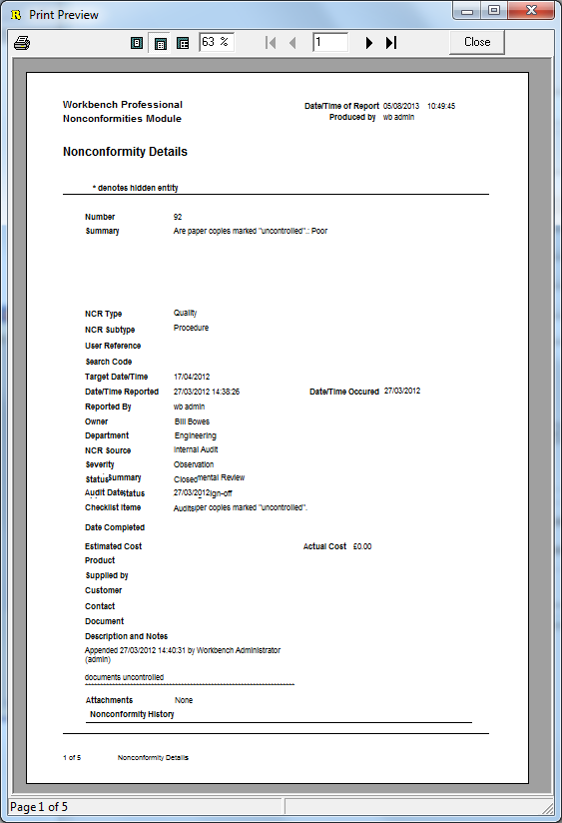
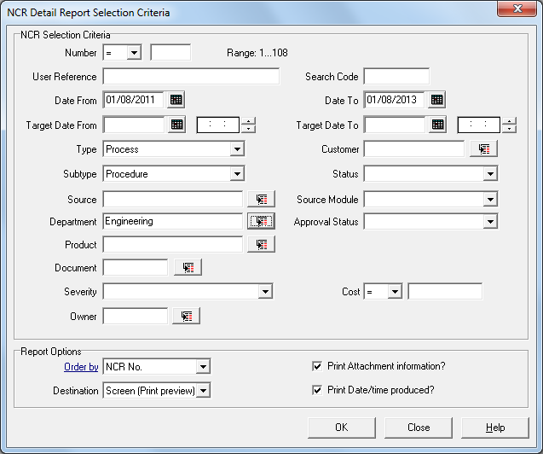

Further reports can be generated through the addition of the ReportQuest Module.

Index

A
Abandon Corrective Action 53
Accept 50
acceptance 52
accepted 56, 57
Accepting 50
access permissions 53
access rights 54
Action 56
actionee 57, 58, 62
Actions 67
Additive Combo 38
Alt Key 5
Assess 53
Assess Reported Nonconformity 19
assessed 26, 33, 49, 50, 56
Assessed 22
assessment 52
Assessment 50
Assign Corrective Action 53
Assign Corrective Actions 56
attachment 48
Audits 27
B
Business Rule 22, 49
business rules 19, 24
Business Rules 18, 23, 32, 34, 51
C
Change Target Date 55
Change User Reference 60
Changing Target Date 55, 59
Check box 38
Companies 29
completed 33, 58
completed NCR 41
Configuration Centre 19
Contact 20, 30
Contacts 27
Conventions used in Workbench Professional/Quality Workbench. 5
corrective action 57, 61
Corrective Action 26, 40, 48, 53
Corrective Action Templates 21, 51
Corrective Action Types 26
corrective actions 50
Corrective Actions 53, 67
Currency 38
Customer 20, 30, 46
Customer / Maintain 29
Customer Information 29
D
Date 38
Date and Time 38
Date of Incident 66
Date or Calendar Fields 5
Date Reported 66
declined 61
Default Business Rules 33
Defer 50
Delegates 14
Department 23, 66
Description 34, 46
Display Web page in Workbench 15
Document Control Module 67
Drop Down List 38
E
electronic form 20
e-mail 57
Esc Key 5
Event 34
evidence 48
external e-mail 13, 19
F
File 10, 11
Filters 66
final review 65
Final Review 63
Free Text 38
G
Graph Wizard 70
H
Help 10
history 53, 56, 62
History 67
I
Individuals 29
L
Life Cycle 39, 40
life cycle of a nonconformity 18
light bulb 6
Limited Access 8
Log on to Workbench 7
Logging on to Workbench 7
Login to Database 7, 11
M
mail attachments 13
Main screen View 9
mandatory 46, 47, 55, 65
Mandatory 46
mandatory field 20
mandatory fields 46
Mandatory Fields 5
manufactured 28
manufacturing cost 28
marked ready for sign-off 54
Menu 6
Module 6, 23, 66
Module Icon Bar 9
Module Icons 6
Module Menu Bar 9
Modules 10
Move Contact 31
Multiple Business Rules 34
N
Navigation around Workbench 9
NCR 19, 37, 48, 53
NCR Final Review 53, 64
NCR Number 66
NCR ownership 54
NCR record 18
NCR Settings 21
NCR Sign Off 53
NCR target date 47
NCR Types 23
No Corrective Actions 64
Nonconformances 37
Nonconformities 17
Nonconformities Module 17
NOTE for Quality Workbench Users 6
Notification 32
notification of assessment 52
Notifications 6
NOTIFICATIONS 18
Numeric 38
O
On Behalf Of 53
Order By 30
Originator 66
outstanding tasks 15
overdue 58
owner 50
P
Password Constraints 12
Personnel Notification 49
Please Assess 33
Process Corrective Action 53
Processing 50
processing cycle 17
Product 28, 66
Products 27
Purge Completed 69
Q
Quick Launch 15
Quick NCR Wizard 17
Quick Wizard 41
R
Ready for Sign-off 63
Reassign Corrective Action 53
Reassign Corrective Actions 62
reassign ownership 54
Reassign Ownership 54
Reference tab 67
Reference to other NCRs 47
referenced NCRs 47
Reject 19, 50
Reject Button 50
rejected 57
rejection 65
reminder 19
remote NCR import 20
reported 33
reporting a new NCR 46
Reports 70
Right Mouse Button 6
Root Cause 51
Root Cause Analysis 22
S
Search 66
Search Buttons 5
Search code 66
Search Code 60
Services 28
Setting up 19
Severity 20, 24, 46, 66
Severity Levels 24
Shortcut Keys 6
sign off 61
Sign off 61, 65
Sign Off Abandoned CA 53
Sign Off Corrective Action 53
signed off 33
signed-off 33
sign-off 19
sign-off progress 53
Sign-off Progress” 53
Source 66
source contact 31
Sources 25
Speed Buttons 6
status 66
Status 66
Subtype 23
summary 46
Summary 66
super user 7
Supplier 27
Suppliers 27, 37
T
Tab Key 5
target date 19, 58
Target Date 47
target dates 55
Task 32
Task and Notification Icons 6
Task Bar 9
tasks 6, 8, 9, 11
Tasks 6, 13
TASKS 18
tick symbol 5
Type 66
U
User Defined Analysis 37
User Preferences 12
User Reference 19, 66
Users Reference 66
V
View 66
View Issued Documents 11
View Withdrawn NCR 68
Viewing reports 70
W
Web Page Address 15
Web Page settings 16
weighting 24
Where Am I?” 11
Who Am I?” 11
Windows NT authentication 7
Withdraw 68
Workbench Configuration Centre 16
Workbench Icon 7
Workflow Configuration Centre 32, 50
Workflow Settings 15
Workgroup License 8
Workload manager 13
Workload Manager 57
Workstation Settings 11

