Workbench Getting Started Guide

Table of Contents

Table of Contents 2
Getting started with Workbench 4
Introduction 4
This manual is applicable for Quality Workbench users and does not give details about the additional functionality available with Workbench Professional, although all the information is applicable to both applications.Step by step 4
System Manager Steps 5
Document Control Steps 6
NCR Module Steps 7
Audits Module Steps 8
Basic data needed for the implementation of Workbench 9
Department Information 9
Personnel Information 9
Access and Security 10
How to section 12
Create Departments 12
Define Workflow Settings 13
Create a User in Personnel Module. 14
Setting Access for a User 15
Change a Users forgotten password 16
Marking a User as left 17
Document Control Module 18
Setting Category and Type Filters 20
Document Review Settings 21
Review Reason 21
Review Subjects and Topics 21
Creating a doclist 22
Creating a document in Workbench 23
Adding documents to a DocList 24
Marking for approval after creating document 24
Approving Documents 25
Issuing a document 26
Acknowledging Receipt of an Issued Document 27
Viewing Documents 28
Viewing Documents using DocLists 29
Selecting your document 30
Raising a change request 31
Approve/Rejecting a Change Request 32
Assigning change requests and editing documents 33
View CRQ’s whilst editing, and Stay on Top 33
Edit Complete 34
Requesting a Document Review 35
Starting a Review 36
Responding to a review 38
Closing the review 39
Complete a Review 40
Withdraw a document 41
Checking In and Checking Out of Documents 42
NCR Module 43
Setting up the NCR Module 44
NCR Types 45
NCR Severity Levels 45
NCR Sources 47
Corrective Action Types 48
Suppliers and Products. 49
Product or Services 50
Customer Information 51
Customer / Maintain 51
Customer / Search for Contact 52
Customer / Move Contact 53
Helpful hint 53
Reporting a new NCR 54
Personnel Notification 55
View an NCR 56
Processing an NCR 58
Assign Corrective Actions 60
Processing a corrective action 61
Sign off Corrective Actions 62
Reassign Corrective Actions 63
NCR Final Review 64
Sign off Completed NCR 65
Audits Module 66
Setting up the Audit Module 66
Audit Types 66
Assessors 67
Result Description 68
Customer and Clients 69
Suppliers 70
Categories and Checklist Library 71
Create a Template 72
Access to Individual Audits 73
Compiling Category and Checklist items in an Audit 74
Scheduling an audit 75
Editing an audit 76
Running an audit 77
Completing an Audit 82
Audit Reports 83

Getting started with Workbench

Introduction

Workbench is a highly flexible and configurable solution to the ever increasing world of compliance management, and the overall business requirements of management, control and completion of all business processes.
It is not intended to replace the need for ISO9000 or any other compliance system and it will not remove the requirement to create the documentation. It will however give a controlled, disciplined environment in which to hold and manage that documentation. Further, it will give you a configurable platform to store and distribute that documentation in a paperless environment. In addition, it allows for the recording, managing and resolution of all and any events that need an element of control.
You will be able to decide what workflow is required for any event within the organization, be it a document process, an NCR, Complaint or Audit, and the software will ensure that the event follows your defined workflow route, with all the main actions recorded as part of an historical audit trail.
The software consists of a number of modules aimed at giving businesses the ability, with one software solution, to manage all their company documentation, record, manage problems and issues, audit, and follow through suggestions and recommendations, and all with a detailed configurable workflow and audit trail.
This getting started guide is designed to help System Administrators with the initial setup of Quality Workbench, and to give simple steps to perform each task.
The important thing to bear in mind is the collection and collation of all the relevant data BEFORE starting to input the data into Quality Workbench.
The initial steps are followed by more detailed explanations of what all the configuration elements mean and the decisions you will need to make to implement them correctly.
This manual is applicable for Quality Workbench users and does not give details about the additional functionality available with Workbench Professional, although all the information is applicable to both applications.

Step by step

Collect all the basic data required for all relevant fields before entering anything into Quality Workbench!

System Manager Steps

- Create departments in System Manager Module
- Set default settings in Workbench Configuration Centre
- System Workflow New Users settings
- System Workflow for System Wide settings
- System Workflow for Module settings
- System Workflow for Default New Document Workflow settings
- Create Personnel Titles ( Mr., Mrs. etc.) in Personnel Module
- Enter people in Personnel Module
- Create Personnel Access Templates
- Give access individually or add people to Access Templates
- Change a user’s forgotten password
- Marking a user as left

Document Control Steps

- Create Master Templates in Document Control module (where needed)
- Create Document Category settings
- Create Document Type settings
- Create Review Reasons Settings
- Create Doclists
- Import Document, classify and associate with relevant Doclists
- Set Document Workflow
- Decide which users should be on the relevant Document Access Lists
- Mark Ready for Approval
- Approve Document
- Issue Document
- Acknowledge Receipt
- Raise Change Request
- Approve Change Request
- Edit Document
- Request a Review
- Start a Review
- Respond to Review
- Stop a Review
- Complete a Review
- Withdraw a Document

NCR Module Steps

- Setting up the NCR Module
- Create NCR Type settings
- Create NCR Severity settings
- Create NCR Source settings
- Create NCR Action Type settings
- Suppliers and Products
- Customers and Clients
- Report an NCR
- View an NCR
- Assess an NCR
- Assign Corrective Actions
- Accept Action
- Process Action
- Sign off Actions
- Review NCR
- Sign Off NCR

Audits Module Steps

- Create Audit Types setting
- Create Assessors
- Create Results Description setting
- Create Customer and Clients
- Create Suppliers
- Create Category and Checklist Library
- Create Audit Template
- Assign Access to Audit
- Schedule an Audit
- Editing an Audit
- Run an Audit
- Complete an Audit

Basic data needed for the implementation of Workbench

This document is to enable a company to collate the necessary information needed to set up Workbench. It will necessitate entering each module a number of times to input the data in a logical order.

Department Information

These are the business areas within the company.
What company or organisation structure do you have?
How are people or business functions grouped, i.e. function or department etc.?
This is a global setting and data entered in this area will be available in every module.

Personnel Information

The following information is needed for your implementation;
A unique Personnel IDcode *
User Login
Password
Title (Mr., Mrs.…)
Surname *
Forename
Initials
Department
Date started
Job Title
Reports To
Mail Profile
Mail Address

Those with an * are mandatory fields.

If you want to keep records of all staff, even if they do not have access to a computer but have a paper copy of a document issued to them, then they should be included in the personnel list. You do not need to give them a user login to Workbench.
Personnel ID MUST be unique and can never be used again as the history for that person is linked to the unique ID field and kept in the system, even after the person has been marked as left the company.
Suggestions for Personnel ID format

First three characters of surname plus 3 digit numeric - bow001
HR Reference or “clock” number - 876632
Network ID or login - bbowman
Surname plus first character of forename - bowmanb

Access and Security

Now that a company structure and personnel structure are in place, we can determine who can perform tasks within Workbench.
To determine who can perform specific functions within Workbench, the setting of users’ access will allow each user to have their own customised menu structure.
Access can be controlled down to each individual menu item, and in some cases the dialogue box resulting from a menu item.
The modules
The menu header
The menu item
The dialogue with options (R, C, U, and D)
You need to give access at each level for the user to be able to access at each sub level.
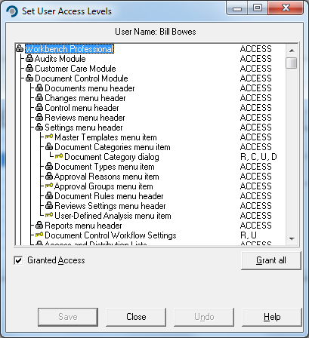
REMEMBER - a user can be in only have access set individually.

Information needed at the time of importing a document.

The following information is needed for each document you import:

Document Title*
User Reference
Revision (Version) Number *
Author*
Owner (This is the important one)*
Review Responsibility*
Category
Department
Type
Keywords (optional)
References (optional)

Those with an * are mandatory fields.

This is the information needed for EACH document for the Document Access List.

Approvers
Change Approvers
Distribution List
Editors
Issuer
Reviewers
Viewers

“How to” section

This section will enable you to follow in detail the main points of setting up a basic configuration of Workbench.

Create Departments

Open System Manager, select Configuration menu and Departments menu item.

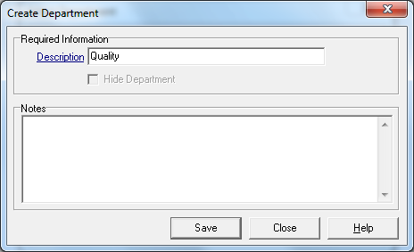
Select New and in the dialogue box…

…type in the name of the department in the description box.

Save and then add more departments as required.

If the department is no longer needed, but has been used, it cannot be deleted. The department no longer needed can be hidden from users.

Define Workflow Settings

It is VERY important that the decisions regarding these settings are taken before starting to build a new database. Collect the information as suggested in the Basic Data required section above.
To activate or switch on an item required as a function, then highlight the line and either double mouse click or select the “Use this workflow setting” box at the bottom of the dialogue screen. This will add a () in the box and also against the item line in the main screen.
Remove the tick () from the column on the right will de-activate the selected item. This can be accomplished either by double clicking the item line or deselecting the box at the bottom of the dialogue screen.
Where a value is required, type this in the box that appears at the bottom of the dialogue screen.
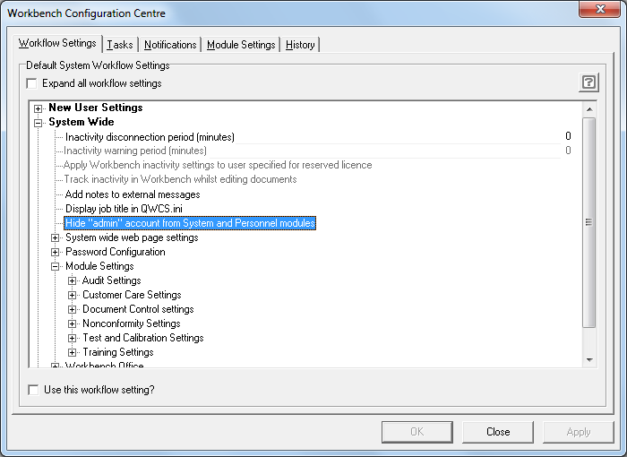
To view all the settings, select the “Expand all workflow settings” at the top left of the Workflow Settings screen.
Where there are sub sections for an item in the settings they will be indicated with a plus sign.
To expand a section of the settings grid, click on the plus sign symbol.

Create a User in Personnel Module.
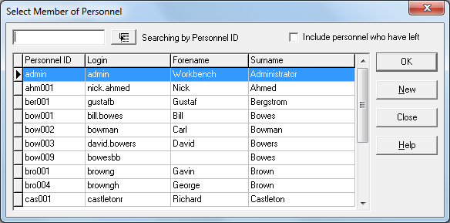
From the Record Menu select Personnel, then New.

In the next screen, there are two mandatory fields to be completed for each member of personnel. Surname and Personnel ID must be completed. Enter a Login ID and allocate a password if the person is to have any access to Quality Workbench and IntraVista.
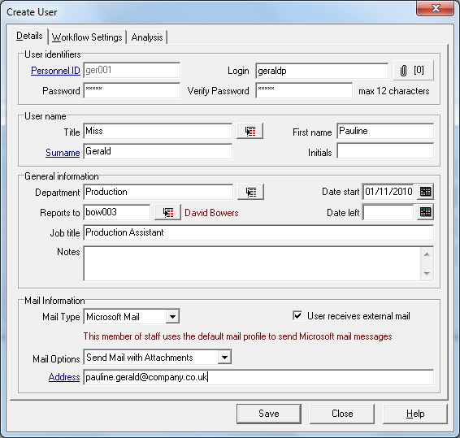
If you wish to use external mail for the communication of messages to individuals, the “Mail Information” must be completed.
The e-mail data relevant to each individual should be obtained from your IT department.
Note: E-mail must be configured on the server before it can be used.

Setting Access for a User

Select a member of personnel from the list and double click.
This will present you with the screen showing the tree of levels of Quality Workbench menu items. The default is NO ACCESS. Double click on the padlock icon at the left-hand side and the display expands to: -
The modules
The header
The menu
The dialogue with options (R, C, U, and D)
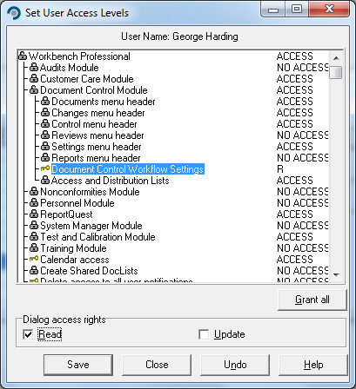

Expand each module by double clicking on the padlock, and select which menu items you wish the user to have. You must grant permission at the higher level before you can grant permission at a lower level, so follow the tree structure until the “Granted Access” tick box becomes available.
Where a “padlock” is showing, there is another level below that one. The Key symbol shows the lowest level.
R,C,U and D represent Read access, Create access, Update access and Delete access.

Change a User’s forgotten password

Select “User Logins” menu item, from the System Manager menu.
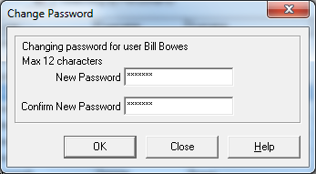
Change User Password enables you to allocate a new password where a user has forgotten their password.

You do NOT need to know what their old password was, and you cannot find it in the database.

Marking a User as left

When a user leaves the company, there will be many responsibilities and tasks that will need to be transferred to other users. Select the individual to mark as left from the Personnel module.
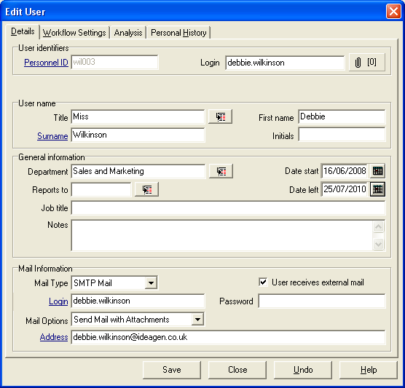
Enter the leaving date in the date left box. This must be a date in the past.
This invokes the Reassign Responsibility Dialogue box.
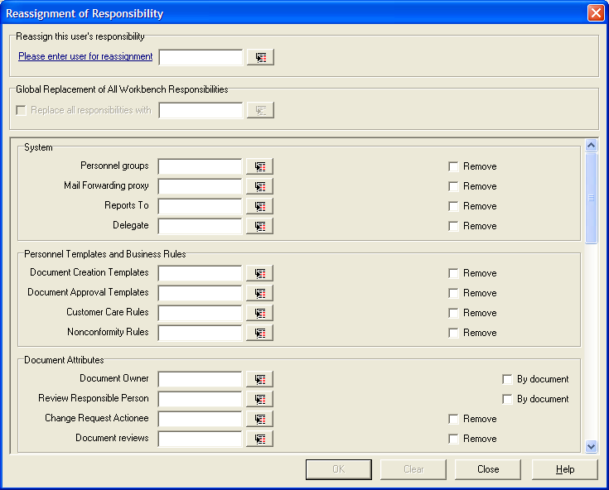
The name of the individual you have marked as leaving will be entered in the Reassign this user’s responsibility box.

Quality Workbench will then show all the areas where the selected users name has associations within Quality Workbench. You will be allowed to remove them or re-allocate the responsibilities to another user depending on the users responsibilities. There are certain areas where you cannot leave the element without a name in place, for instance: documents cannot be left without an owner, so you will have to re-assign responsibility to another user.
Document Control Module

This is the typical Document Workflow and Lifecycle.
Raise Change Request
Create or Import Document
Define Attributes
Issue Document
Approve Change Request
Edit Document
Mark for Approval or Review
Request a Review
Start a Review
Respond to Review
Close and complete Review
Approve Document

Master Templates

Master Templates used for the creation of documents are stored within Quality Workbench.
As a user creates a new document in Quality Workbench, then a pre-defined format or “template” will be invoked.
At least one document (blank or “template”) for each application required must be stored if NEW documents are to be created within Quality Workbench.
You will need to create a document by opening the application, for example MSWord, and then saving this to your local disk to use as the template master. This Master will hold formatting information, style and layout, wording and content details as required.
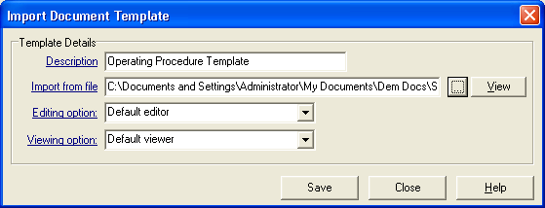
From the “Settings” menu, select Master Templates|New, give the template a name, then navigate to and select the document you have just created to use as a template.
HOWEVER, unlike MSWord templates, these templates should NOT be of the .dot or .dotx extension.

Setting Category and Type Filters

Because of the way Quality Workbench stores documents inside the database, you should create some way of easily retrieving those documents.
These areas enable you to define the terminology used to classify the documents.
Some suggested ways of achieving this: -

Categories | or Projects | Or Site
Quality | Prometheus | Matlock
Environmental | New Building | Sheffield
Health and Safety | New Product | USA
Corporate |  | Europe

Types
Manual | Letter
Forms | Contract
Work Instruction | Specification
Procedure | Drawing
Drawing | Design Brief
Contract | e-Mail

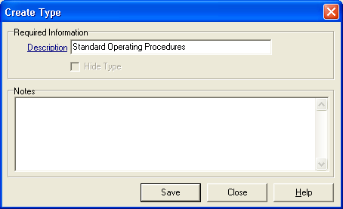
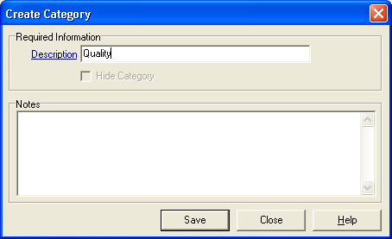

Note: Department settings are global and are already available as a possible filter.

Document Review Settings

The Settings menu incorporates a ‘Document Review Settings’ walk-right menu.

Review Reason
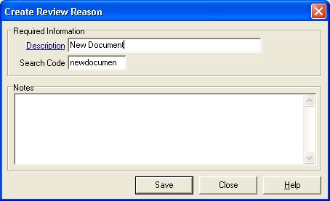
Reason for Review is a mandatory field when setting an unscheduled review; therefore, a Reason for Review must be created.

Review Subjects and Topics
To create or amend a subject or topic, select the “Review Subjects” menu item and “New”.
Type in to the “Description” field the definition of your subject.
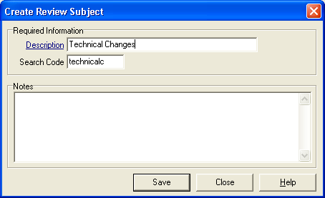
Do the same for Review Topics.

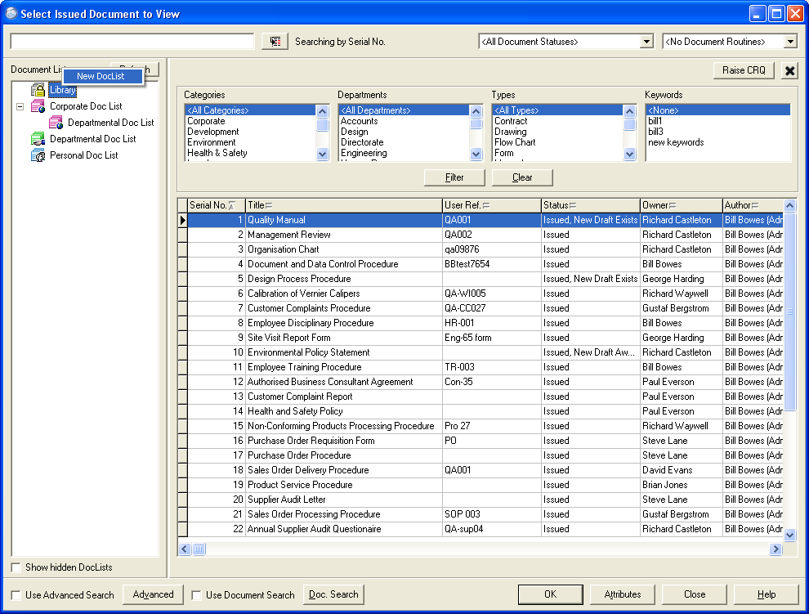
Creating a doclist

To create these areas select the “Library” label and right mouse click. This will present a new label called “New DocList”. Selecting this will then request a name for the new folder.
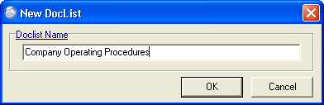
Once created, Right Clicking on the folder will give a number of options:
Cut Doclist removes it and allows it to be pasted elsewhere.
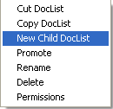
Copy Doclist copies it and allows it to be pasted elsewhere.
New Child DocList allows for creation of a new DocList under the current one.
Promote allows the doclist and all its sub-lists to be promoted to a Global DocList.
Rename allows it to be renamed.
Delete allows for the deletion of the DocList and all its sub or child lists.
Permissions allows the identification of users or groups to be allowed to see the lists and its child lists.

Creating a document in Workbench

Assuming that you have successfully created a Master Template; category, department and types have been set up and that a policy on the approval and distribution of documents exists, you can create a new document in the database.
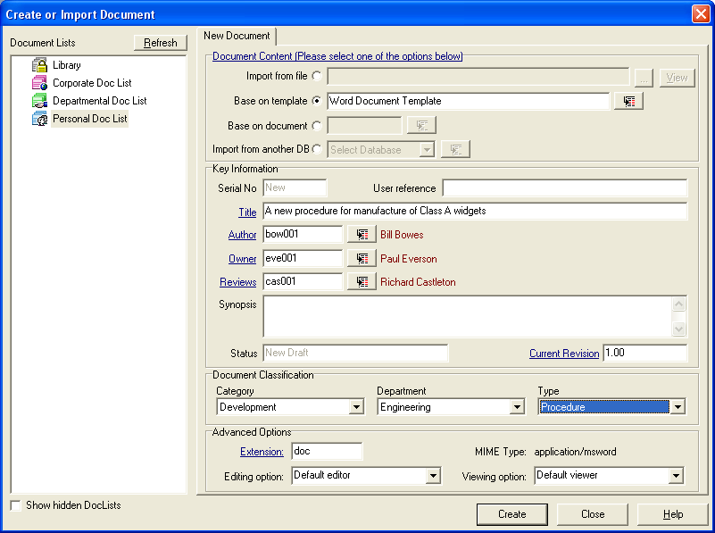
Complete the form for a new document.
Note the Mandatory fields, the only one of which you will need to fill in will be the Title field; the other mandatory fields will be filled in as default settings.
The Owner of a document is the person who will be responsible for its maintenance. The Owner will receive a task or notification of the events and actions associated with the document.
The Author is the person who created or imported the document.
The Author and the Owner can be the same person.
Reviews is the person responsible for starting and stopping the documents reviews. By default, this person will normally be the person nominated as the document owner, the person creating or importing the document.
Change the names in the relevant fields to suit the correct people involved.
Do not forget that the correct Document Classification will help you find the document more easily.

Adding documents to a DocList

Select the documents you want to appear in the folder in the Document Lists, and drag the document from the list of documents in the main search screen on to the folder name. The titles of the documents will then appear under that folder list.
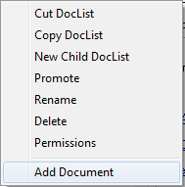
To add a document whilst creating a new document, right click on the folder and select the Add document menu.
Alternatively, once the document is imported into the database, highlight the document in the main screen and right mouse click. This will give the option to copy document to the selected DocList on the Doclists pane.

Documents can only be added to a Global DocList by the DocList Owner without changing the DocList status.
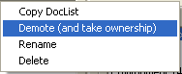
Otherwise, a DocList that has been “Promoted” to a Global DocList has to be taken back under Ownership of a user with the permissions to change it, before documents can be added.

A document can be added to any number of DocLists at the time of creation or import, by selecting the doclist before moving on to the Workflow and Access screens. The DocLists in to which the document will be added at creation will be highlighted in Bold.

Marking for approval after creating document
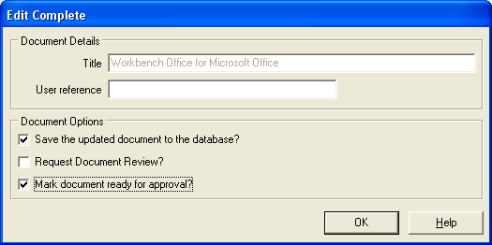
Once created or imported, the next stage will be to mark the document ready for approval. This is done at the end of an editing session or from the Control menu.

Approving Documents
As soon as the document is marked ready for approval, you will not be able to make any editorial changes to it.
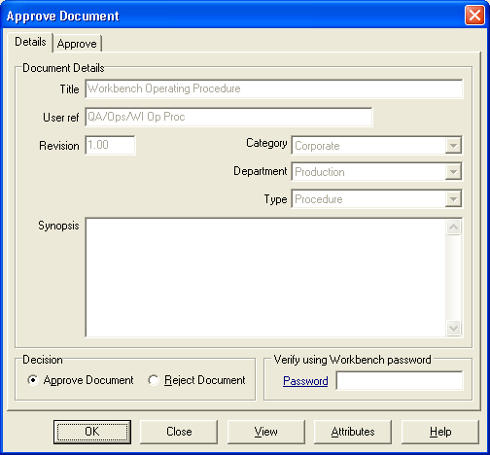
Everyone on the approval list must approve the document before it can be issued.
From the menu, select Approve Document, or open the Task from your task box.
Select the document and you will be presented with the “Approve Document” screen.
Type your password in to the “Password” box.

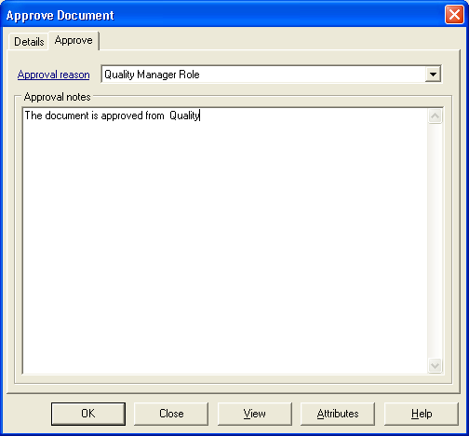
If the Approval Reason is activated in the document attributes, then you will have a second Tab to complete requiring you to give a reason for approving the document. The reasons will be available from a drop down menu.

Issuing a document

Once the document has been fully approved by everyone on the approval list, a document can be issued.
From the menu, select “Issue Document” to give a list of documents available for you to issue.
After selecting the appropriate document, the following screen will be displayed:
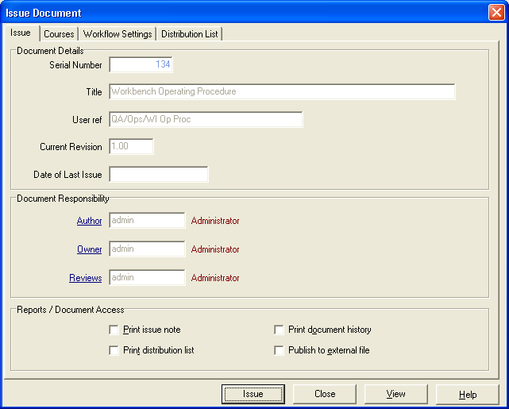
Simply select the issue button and the document will become “Issued”, and be available to be viewed from the “View Issued Documents” menu.

Acknowledging Receipt of an Issued Document
All the individuals on the distribution list for a document will be advised of the issue of that document and would normally be required to Acknowledge Receipt.
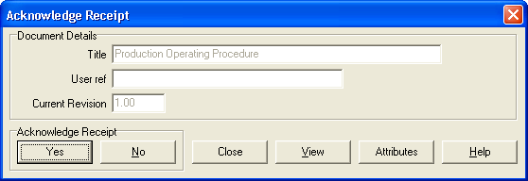
If users are required to Acknowledge Receipt of a document, they will be expected to read that document before they confirm receipt.

Viewing Documents

There are two different ways you may view a document. The standard document select screen and the Doclists screen.
The Doclists screen functionality will depend on the settings in the system manager module, or in the individual user preference settings.
First, there must be documents in the database.
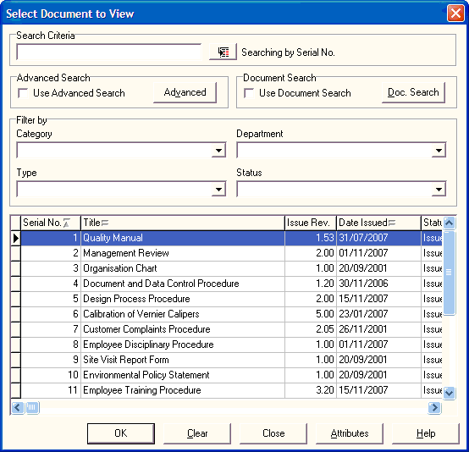
Scroll down using the scroll bar on the right to find the document you want.
Use the Category, Department and Type filters to reduce the list to a manageable list.
Right Click on the Search box next to Search Criteria and select by Options offered.

Viewing Documents using DocLists

There is an alternative dialogue screen for document searching.
DocLists uses a format similar to that found in IntraVista Pro, and all the features found in IVPro are repeated in DocList.
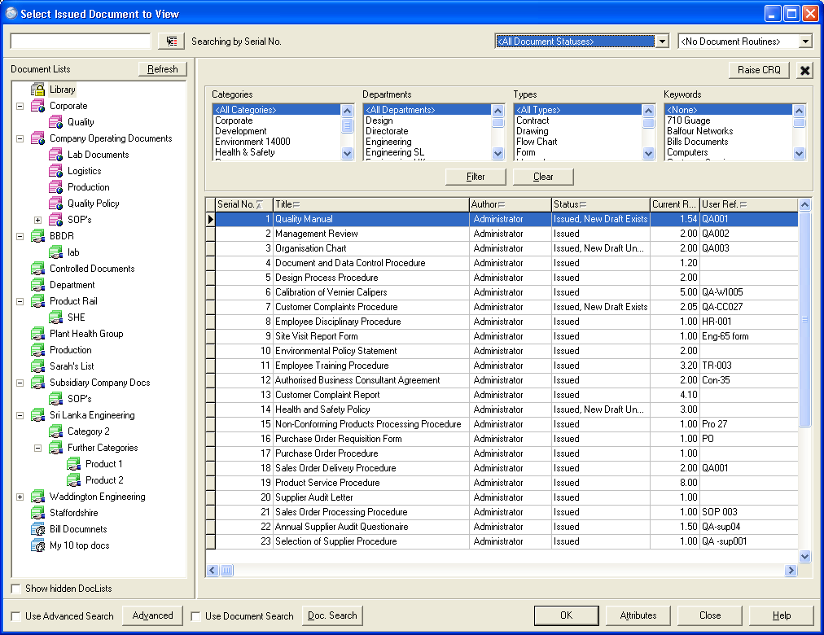
To be able to access the full functionality that the new DocLists provides, users will need to have access to the “View Documents” menu in the Document Control Module.

Selecting your document

There are a variety of different methods and combinations of criteria by which you can select your document.
Filtering
Select the Category and/or Department and/or Type and the Status of the document you wish to find. Within the DocLists view, use the Shift or Ctrl keys, to select multiple Category, Department and Type fields as well as Keywords as this will help in the search.
Ordering
In the Standard Document search screen, you can order the lists of documents by selecting the required column header and changing the order from Ascending to Descending using the mouse. The sort order uses the ASCII settings so order may seem a little unusual, but lower case letter “a” will follow upper case letter “Z”.
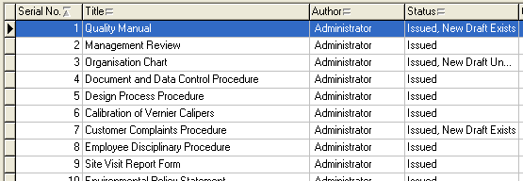
Within the Doclist dialogue screen, all the columns are always available, and the order of view can be changed by clicking on the column header of the column.

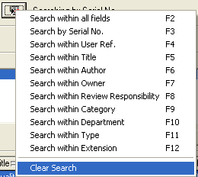
Using Search Criteria
A Right Mouse Click on the search button will allow a user to Search by Serial Number, User Reference or Words within the Title.

Raising a change request

Raise a change request by selecting “Raise Change Request” from the Changes menu in
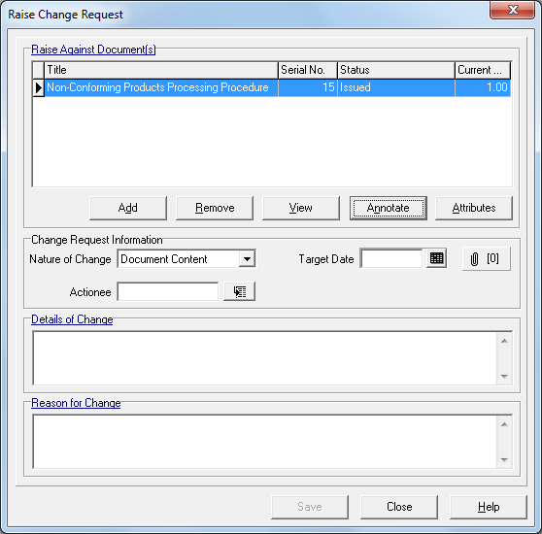
Document Control, or by right mouse click on the document in the DocLists view.

Select the document you want to change by using the “Add” button, which will present a list of all the documents in the system.
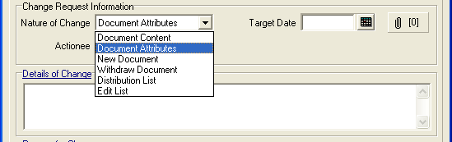
Select Document Content from the Nature of Change menu.
Withdraw Document and Document Content are the only Actions that cannot be made without a change request.
There are two mandatory fields to be completed.
These are the Details of Change and the Reason for Change, or what needs changing and why does it need changing.
It is possible to cut and paste into these boxes from the document to be changed, but it does NOT carry across any formatting into these boxes. It is also possible, when editing the document, to cut and paste from these boxes directly into the document, so saving a great deal of re-typing.

Approve/Rejecting a Change Request

The Change Request Approval screen is in two parts: -

The first part shows the details of the document and the Change Request itself,
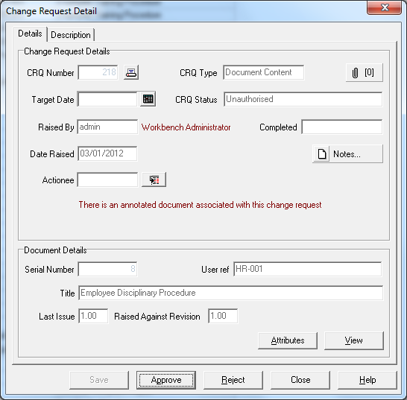
and the second shows the Change Request description and reason for the change.

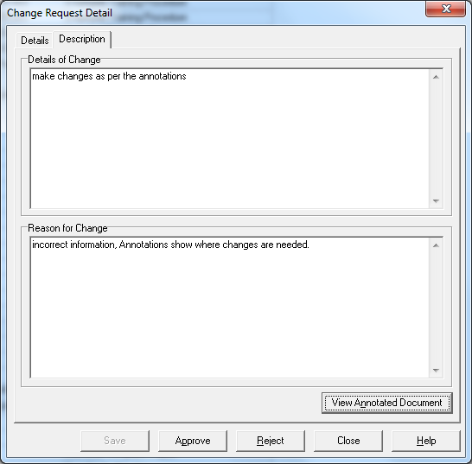

At this stage you may have the option to either Approve or Reject the change request.

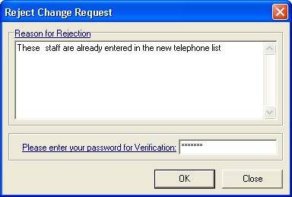
If you reject the change request, you will be asked for a reason.
This reason for the change request being rejected will also be recorded in the document history log detail.

Assigning change requests and editing documents

When a change request has been approved then the document subject to that change request can be edited.
Select “Document” menu and “Edit” from the drop down list and select the required document.
Increase the revision level and assign the change request.
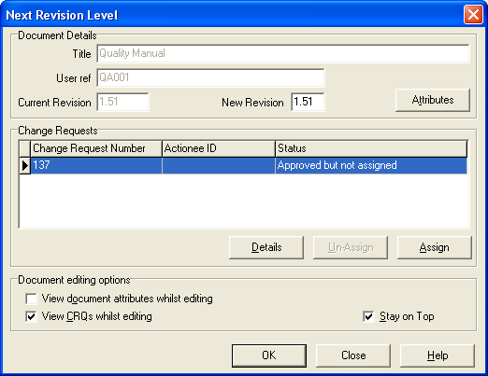
Note that there is no need to increase the revision level of the document again if re-editing the document between issues.

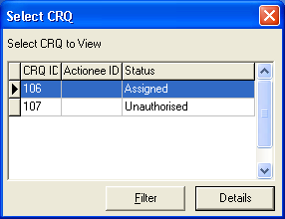
View CRQ’s whilst editing, and Stay on Top
It is possible, whilst editing a document, to have the relevant change request(s) available to view whilst editing the document in the editing application.
The list of approved change requests can be set to appear as a “floating box” over the document being edited so that reference can be made to it.
This facility can be switched off if required.

Edit Complete
Once the editing is complete, CLOSE the application, and return to Workbench.
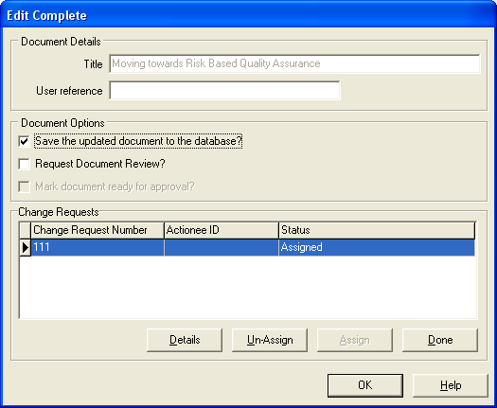

If editing of the document is complete and no further changes are required, then mark the Change request as “Done”.
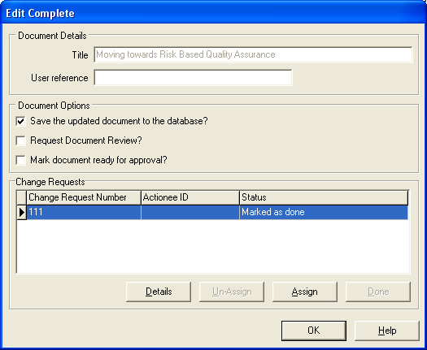
This will then activate the “Mark document ready for approval” field, tick the box and then select OK.

The document will now proceed round the Approval cycle as before (see Approving Documents).

The Approval and Issue process is exactly the same as when approving and issuing a document after initial creation.

Requesting a Document Review
Unscheduled reviews originate from two points:
- When the user finishes editing a document and checks the ‘Request Document Review’ check box. In this case, the version to be reviewed will automatically be the ‘draft’ version
- By selecting the ‘Request Review’ menu item, a request can be submitted to review any document. This can be either the draft or issued version.
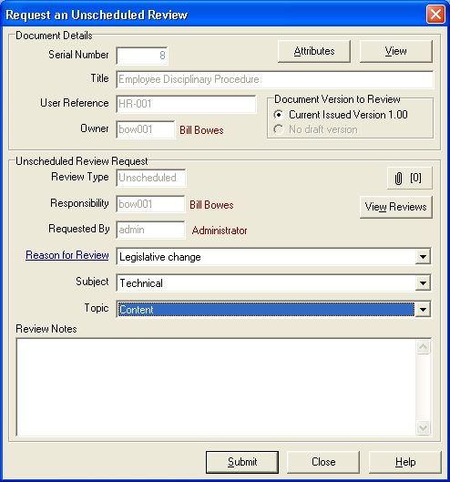
The Review Request will be sent to the person responsible for the document’s review, who will be able to either start the review, or reject the review if it is an unscheduled review.

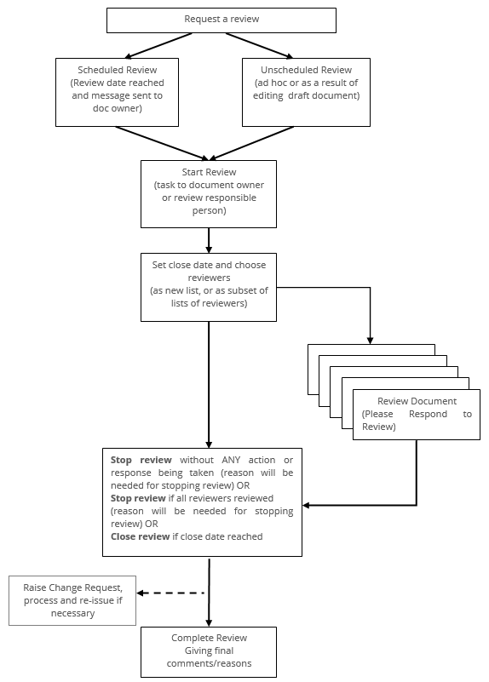

Starting a Review
Open up the Maintain Review document screen with the option to start the review.
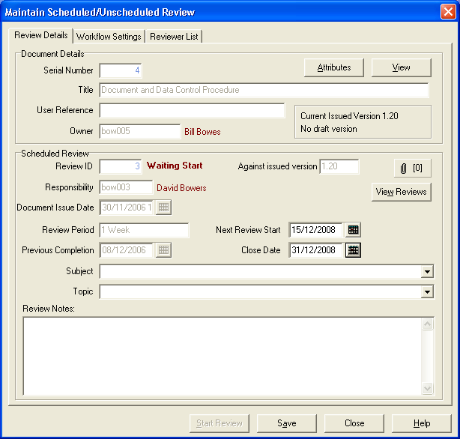
Although not mandatory, it is advisable to enter a close date for the review, but do not alter the start date.
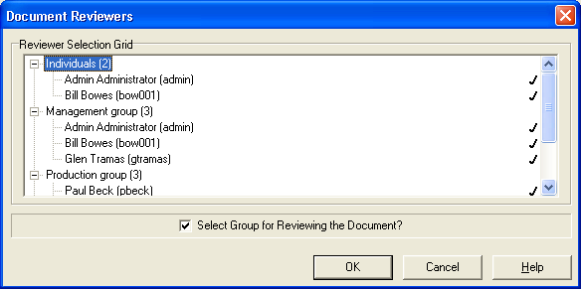
Select the people who you want to review the document and Start the Review.

Responding to a review
Once the Review has been started, all the people on the review list or subset will be tasked with carrying out the review of the document.
The screen will ask the reviewer to respond to the review and will give details on the first page of the document under review and the reason for the review.
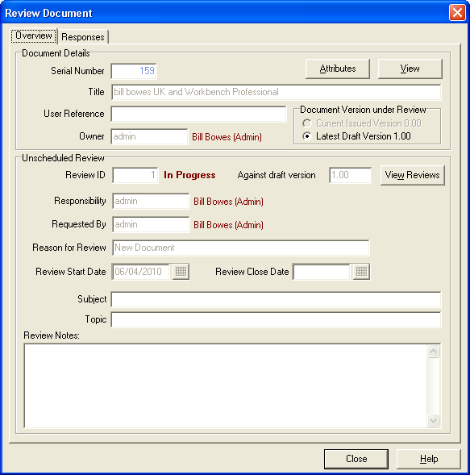
The person reviewing the document should then select the Responses tab to be able to enter details of their review.

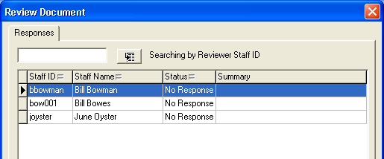
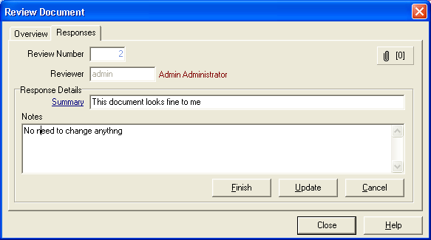
The Summary line is the only mandatory field required for a response.
Mark as Finished, when all the review notes have been entered.

Closing the review
Once all the reviewers have responded, and/or the close date has been reached, the person responsible for the review can the close the review. (The review can be closed at any time regardless of whether the close date has been reached or not, but a reason will have to be given).
This will unlock the document so that further changes, if necessary, can be made, change requests approved and assigned, and work done to the document.
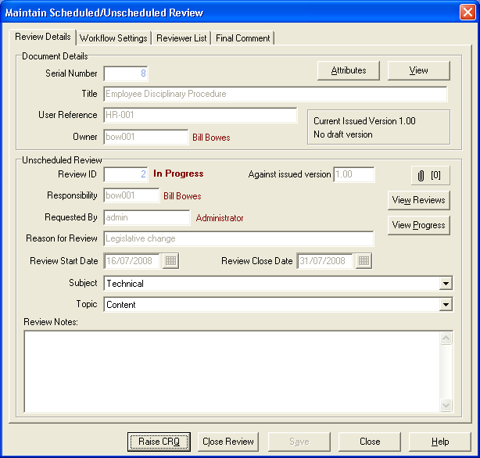
If any of the review responses suggest a change to the document, then a formal change request can be raised from this screen.
Whilst a document is undergoing review Change requests can still be raised against the document but CRQ’s cannot be approved or actioned.

Complete a Review
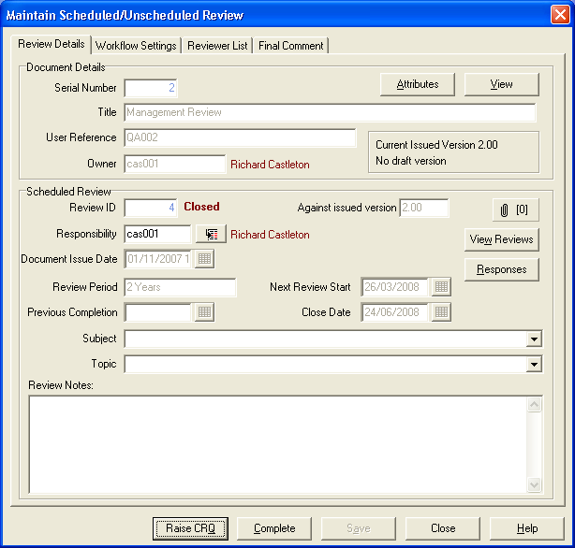
To complete and close out a review, final mandatory comments must be entered in the Final Review Comments dialogue box, and the person responsible for the review must enter their password to complete the review.
Once completed, no changes can be made to the review at all.
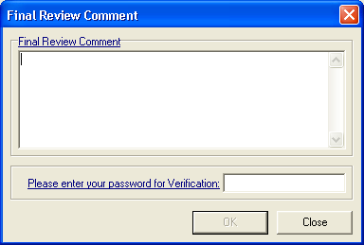

Withdraw a document
To withdraw a document from use, (remove the last issued version from view) there must be a change request raised and approved for this to happen.
Raise a Change Request from the Changes menu and select the document to withdraw. Change the Nature of Change from Document Content to Withdraw document, and then complete the Detail of Change and the Reason for Change boxes.
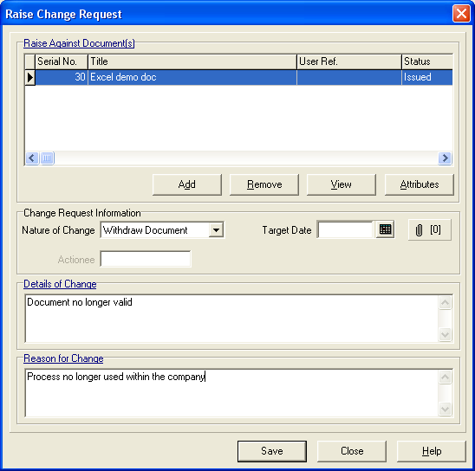
Once this has been approved, an instruction will go to the document owner to Please Withdraw the document.
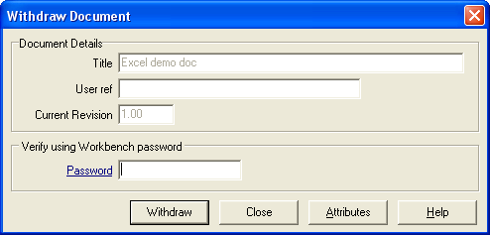
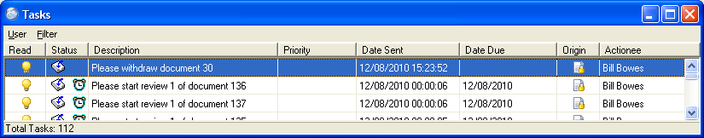
Withdraw the document by entering the correct password and selecting the “Withdraw” button.

Checking In and Checking Out of Documents
This allows documents to be worked on “off-line”, i.e. whilst away from the network, or where working on a document will hold a user license for an inappropriate length of time, such as when editing a drawing.
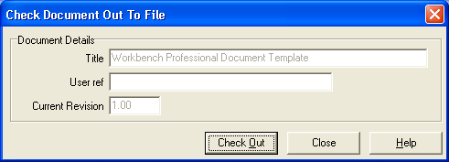
Checking a document out of the system can only be carried out on “Draft” documents where an approved change request is assigned to that document or the document has never been issued.
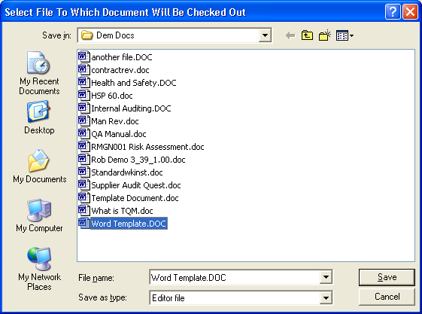
Select “Check out to File” from the Documents menu and then select the document to check out from the available list. When requested, create a file name for the document and select “Save”.
To check a document back in, select “Check in from File” which will show the documents currently checked out. Select the document to check in and select the “Check in” button to keep the changes made, or the “Uncheckout” button to revert to the previous document.
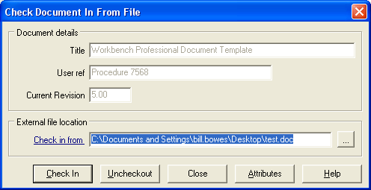

NCR Module
An overview of the workflow

Setting up the NCR Module
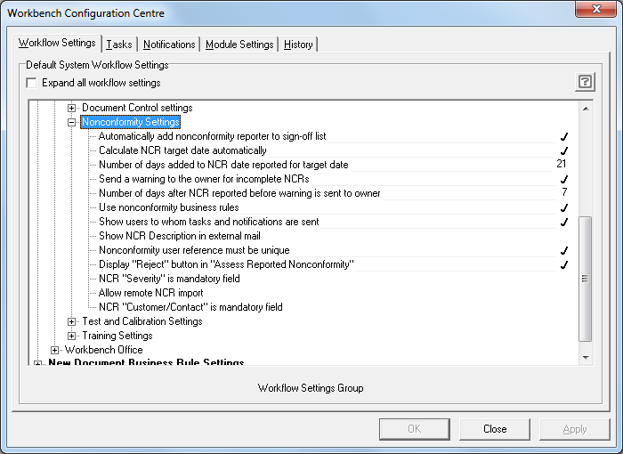
There are certain settings in the System Manager Workflow Configuration Centre that need to be set before starting on the settings in the NCR Module itself.
In the Configuration Centre, the default elements of the NCR Module enable the system to: -
- Automatically add nonconformity Reporter to the sign-off list.
- Calculate the target date automatically.
- Number of days added to NCR date reported for target date.
- Send a warning to the owner for incomplete NCRs.
- Number of days after NCR reported before warning is sent to owner.
- Use Nonconformity business rules.
- Show users to whom tasks will be sent.
- Show NCR description in external mail.
- Nonconformity user reference must be unique.
- Display “Reject” button in “Assess Reported Nonconformity”.
- NCR “Severity” is mandatory field.
- Allow remote NCR import.
- NCR “Customer/Contact” is mandatory field.
Once these settings are decided then it is necessary to customise the specific settings in the NCR module itself.
Customising the NCR module will allow you to reflect your organisations terminology for: -
- NCR types,
- Severity levels,
- NCR Sources,
- Corrective Action Types,
- Product,
- Supplier,
- Customers.

NCR Types
These settings will allow for the searching, sorting and grouping of NCR’s, and for a unique set of Business Rules to be applied to any Nonconformity so that it can automatically notify the correct people. Other settings, which are already part of Workbench, such as Department and Module, can also be used as parameters for the business rules.
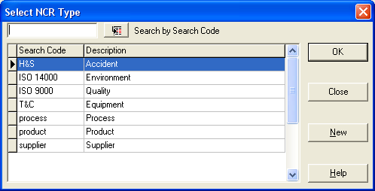

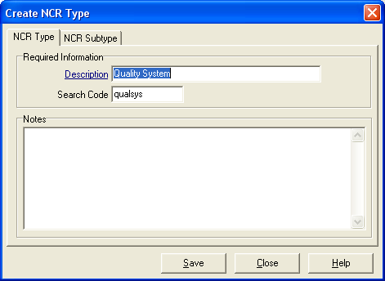
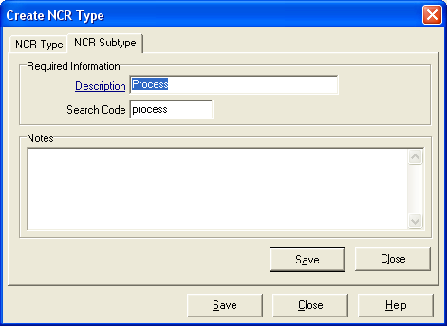
The types of nonconformity settings will enable you to break down the NCR’s for reporting, searching and setting up unique Business Rules. These can be broken down into sub types, specific to the type of NCR.

NCR Severity Levels
Severity Levels can be ascribed to each NCR and then prioritised for resolution. In setting up Severity Levels, a unique weighting MUST be assigned to each level. Up to one hundred levels of severity can be created.
Severity Levels can also be made mandatory.
Examples of severity levels:
Critical 95
Major 75
Minor 40
Observation 20
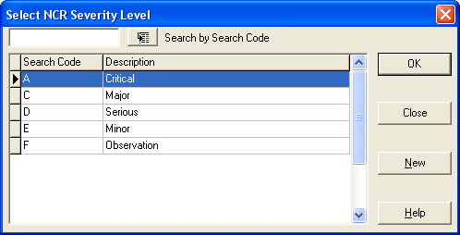
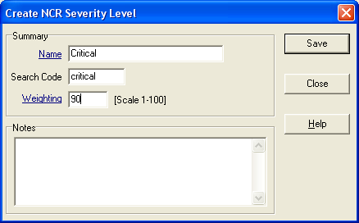

NCR Sources
This area allows you to define the source of an NCR for later analysis and grouping. In a typical company, there are a number of sources from where a problem can be highlighted.
These sources could include:
- Internal Audits
- 3rd Party Auditor
- Customers
- Suggestion Scheme
- Accident
- Health & Safety Executive
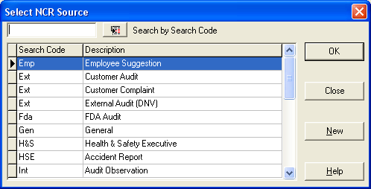
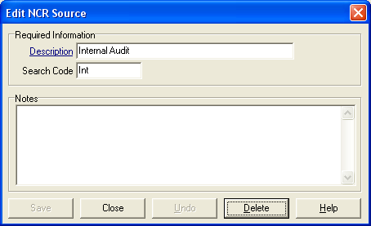

Corrective Action Types
Once an NCR has been reported and assessed, actions can be sent to individuals to resolve elements of the NCR. The terms for these actions can be pre-set, so that the person assigning the action can select from a drop down list to identify what type of action it is.
Examples of such actions could be:
- Investigate
- Corrective
- Preventive
- Training
- Refer to Supplier
- Raise a credit note
- Review procedures
- Re-work to specification
- Scrap
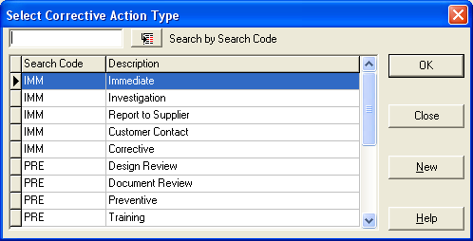

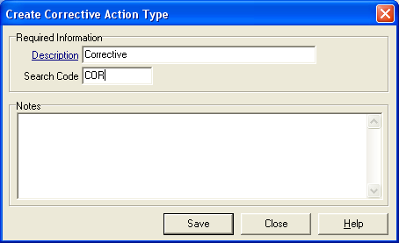

Suppliers and Products.
Suppliers of product or service to an organisation can be recorded and recalled through Workbench. Any discrepancies can be reported through the NCR module, and Audits to be carried out against a Supplier can be scheduled through the Audits module.
Setting up the suppliers is completed through the “Supplier|New” menu item under the “Settings” menu.
You can enter as much or as little information as is needed.
You will however be required to enter at least one contact in the “Contacts” section.
Information entered through the NCR module will become available anywhere in the software where supplier or product information is referenced.
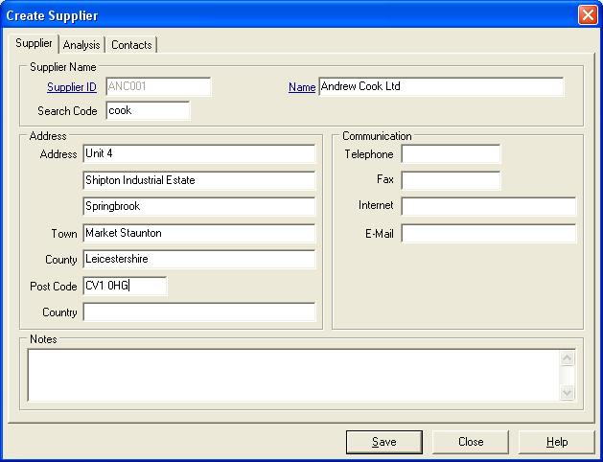

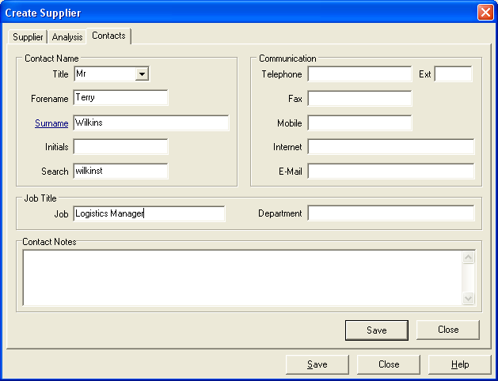

Product or Services
Setting up Products or Services you supply uses a similar structure.
You can enter information about the product, and whether it is manufactured in-house, or bought in.
If the product is manufactured in-house, then a manufacturing cost can be associated with it.
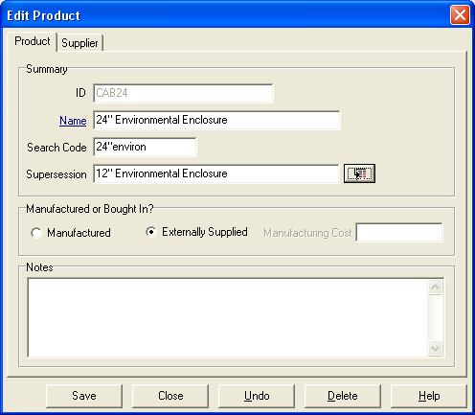

If the product is bought in, then a link to the supplier can be assigned.
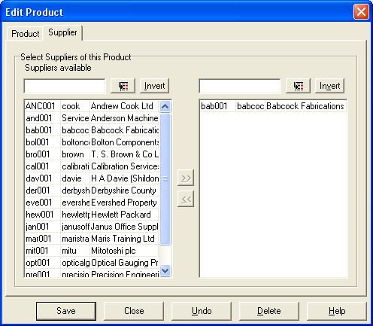

Customer Information
Customer Contact Management is carried out in this area.

Customer / Maintain
Details of Companies or Individuals are entered and updated in this section.
Customers can be Individuals (for Environmental Standard ISO 14001 these could be Stake Holders rather than true Customers) or Companies.

The details are separated into 3 parts:
- Company Details – name etc.
- Notes
- Contacts – Details on the contacts – with further Analysis and Contact Notes
Searching for a company can be done by search code or within Name, and filtering can be done on the type of customer as a company or as an individual.
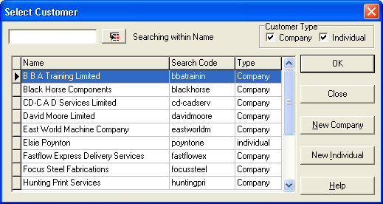

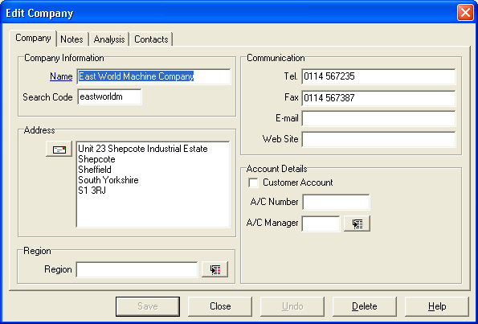

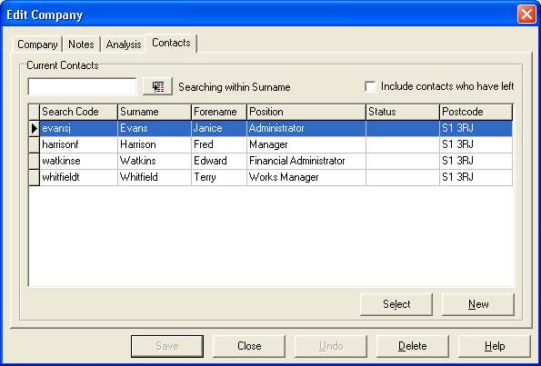

Customer / Search for Contact
Details of each contact on the database are held in the contact tables of the database and a search for contacts can be made from the “Search for Contact” screen. To make the search and viewing easier the presentation can be sorted in five different ways, and the search can then be made in two ways.
Examples of different criteria for ordering the display are:
- by search code
- by name
- by company
- by position in the company
- by postcode

which can be selected by using the right mouse button on the “Order by…” button.
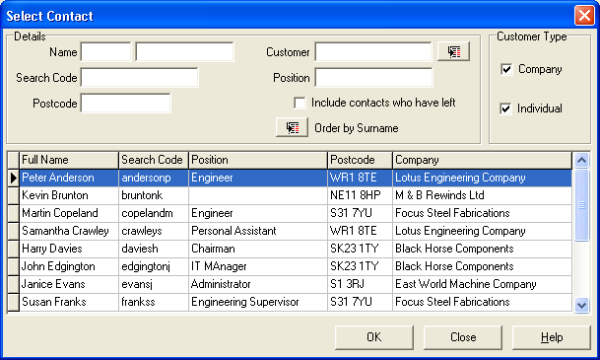

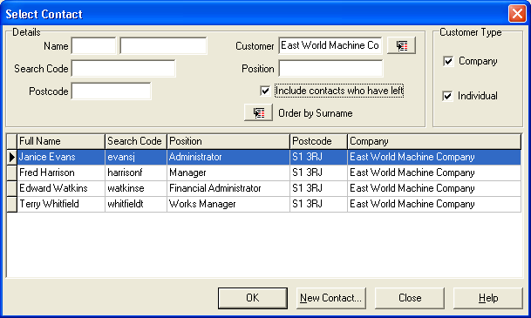
Sort the contacts by Company; For instance, find the contacts for East World Machine Co. by selecting the customer search button.

Customer / Move Contact
Sometimes a contact from one of your customers moves job to another customer company or sets up in business on their own. You can transfer them to the new company or set them up as individual contacts.

Helpful hint: The source contact is not deleted but marked as left (read only).
Similarly, if the source was a private individual various amounts of information may be retained by use of the options button (as shown below).
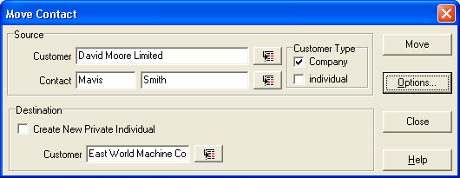

Reporting a new NCR
There are a number of data fields that are mandatory i.e. something must be entered (blue underlined field labels).
Enter summary details in the summary box (a short description of the incident).
Enter the date the incident actually occurred, (using the pop-up calendar).
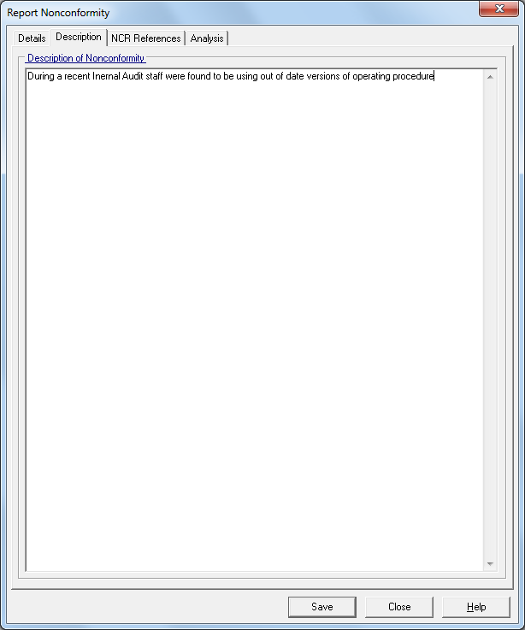
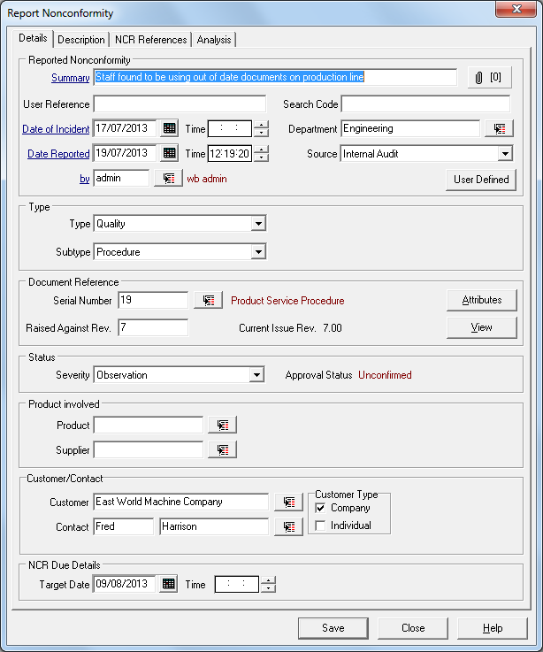
Enter data into the selection boxes for source, department, severity or product for sorting and analysis later.

Select the “Description” tab and enter a more detailed description of the incidence.

Personnel Notification
If the Default Business Rule has been activated, and the “show users to whom tasks and notifications will be sent” has been activated, a box will appear confirming the personnel to whom the notification of assessment and the task to assess will be sent.
Additional personnel can be added to this list by selecting the “Add” button.
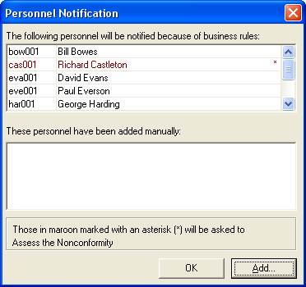

Once accepted a further list will appear showing those people who you have elected to be told that the NCR has been assessed.
If the Default Business Rule is switched off, but the check box allowing a manual selection of personnel was ticked, a similar selection box will appear, but will be not have any names inserted. Make your selection by selecting the “Add” button.
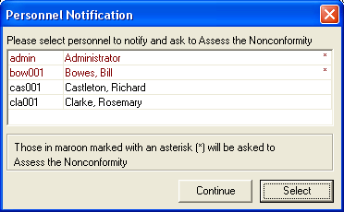
The people to whom a task to assess the NCR will be in Red with an asterisk next to their name, and those who will be notified will be in black.

View an NCR
Once reported into Workbench an NCR can be viewed to monitor its status and progress up to completion and sign-off. Filters are available to refine the choice available for selection.
In the Search Criteria box at the top, type in an NCR Number, Users Reference, words from the summary or NCR Search code to find a particular NCR.
To decide which criteria you wish to use, right mouse click on the search button next to the Search Criteria box.
The selections can be filtered by the Date of Incident, Date Reported, NCR Type, Status and Severity, and can be ordered by NCR Number, User Reference Number and Summary.
Advanced Searching fields can include Originator, Date of Incident, Product, Source, Department, Date Reported, and Module
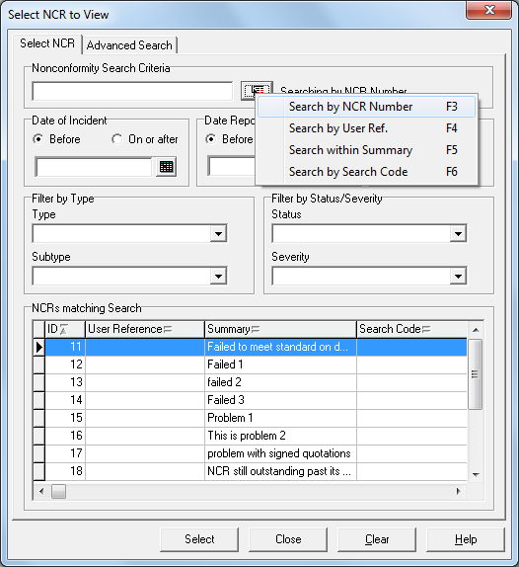
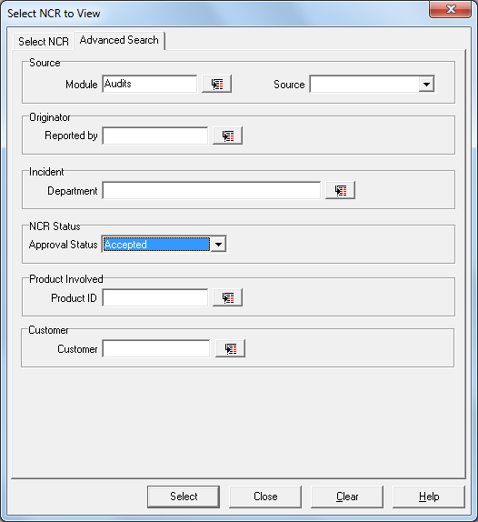

Once selected all the information you would need is visible through the tab screens.
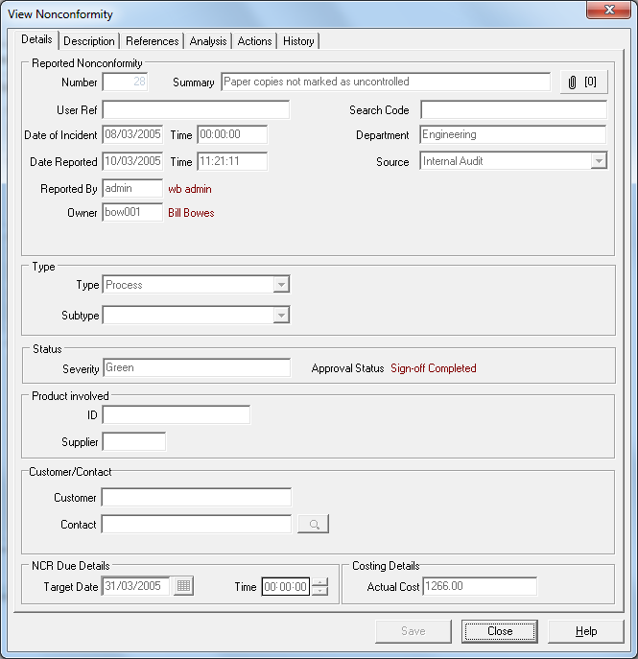
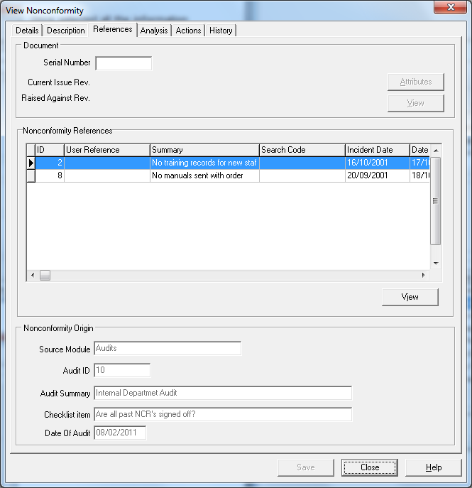
The Reference tab indicates any cross-reference to other modules within Workbench, such as the association with a Document in the Document Control Module or to the origin of an NCR such as resulting from an issue highlighted during an audit.

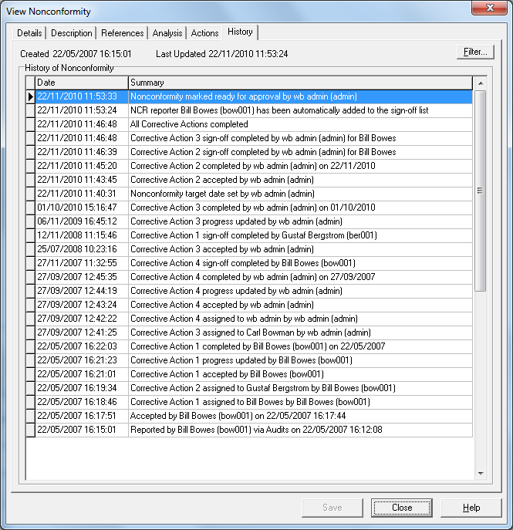
The history for the whole NCR and the individual Corrective Actions assigned to it are available to view on the History and Actions.

Processing an NCR
Once reported, an NCR must be assessed.
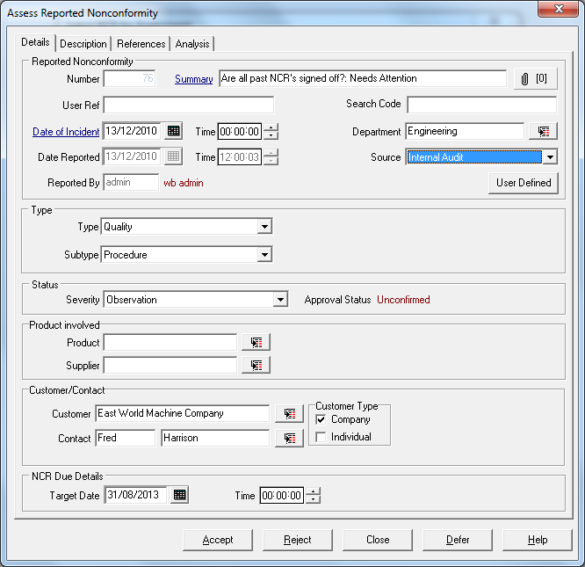
Assessment requires one of the people given the task, to either “Accept”, Reject” or “Defer” the decision.
“Reject” an NCR means it goes no further in the NCR cycle and can be purged from the records. The “Reject Button” can be hidden or switched off by altering the settings in the Workbench Configuration Manager.
“Defer” allows for an NCR to be reviewed without a decision being made but the fact that it has been reviewed is recorded in the history.
“Accept” the NCR makes the assessor the owner of the NCR and decisions can be made as to the corrective actions needed. The owner of the NCR will be notified of an impending target date if that setting has been activated through the System Manager Workflow Configuration Centre.

On completion of the decision, a box appears with a time and date stamp confirming the decision made.
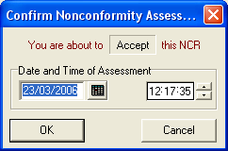
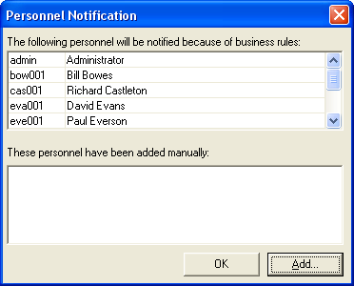
If the Default Business Rule is active, a box will appear confirming the personnel to whom the notification of assessment will be sent. Additional personnel can be added to this list. Once accepted a further list will appear showing those people eligible to sign off the NCR once it has been completed and reviewed.
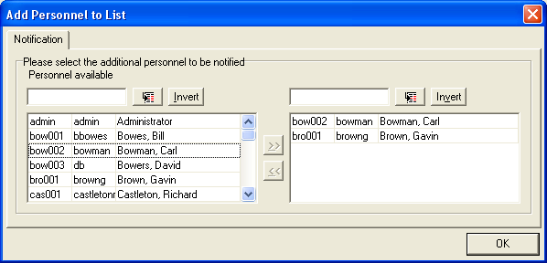
If the Business Rule is switched off, but the check box allowing a manual selection of personnel was ticked, a similar selection box will appear. Add the names of people by selecting from the personnel list provided.
Any other person who is highlighted on the task list for that NCR can do the assessment and acceptance of that NCR.

Assign Corrective Actions
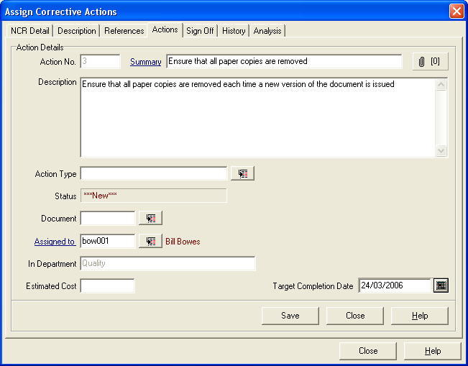
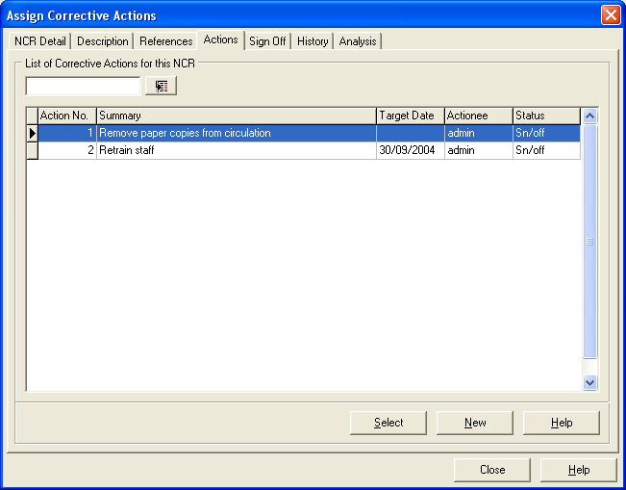
Once the NCR has been assessed and accepted, the owner can then decide what actions need to be taken and can allocate those actions to individuals.

Any number of Actions can be raised for a particular NCR.
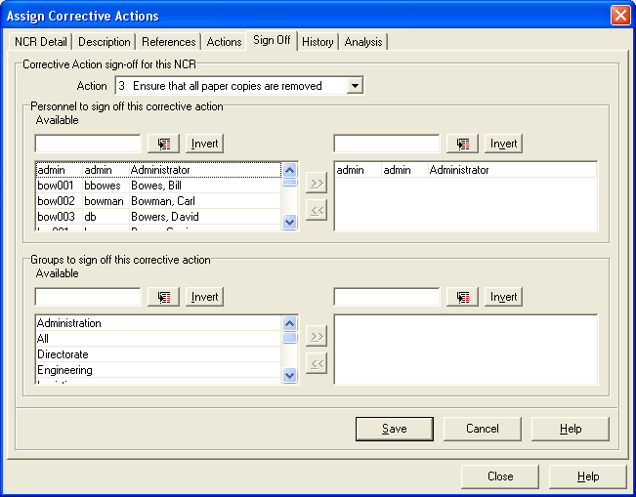
Each Action will require to be signed off before it can be considered closed.
An entry in the NCR history is made at this point, and a right mouse click on that entry will show those required to sign off the Corrective action.

Processing a Corrective Action
This task can be actioned from one of four different areas: - directly from an e-mail if the e-mail system is in use, directly from the relevant drop down menu, from the Workload Manager if that has been installed, or from the task screen in Workbench.
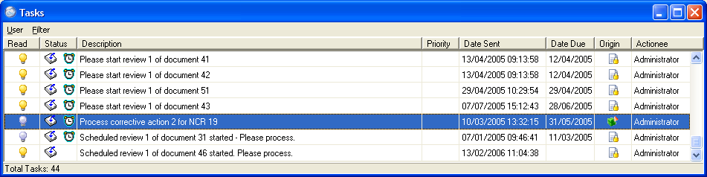
The person who has been nominated as the actionee for this corrective action will be requested to accept or reject the corrective action.
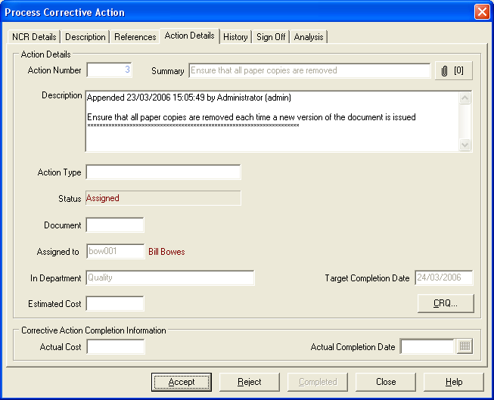
If the action is accepted or rejected then a message will be sent to the owner of the NCR.

Once accepted, the actionee can process the action as instructed, by recording the detail of any actions in the description field.
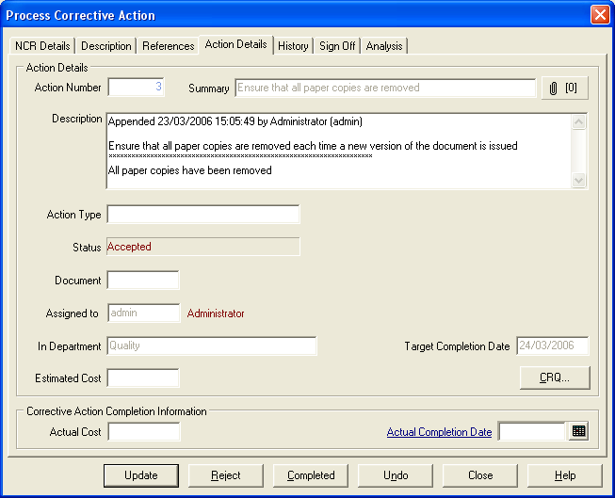
Many stages can be recorded at this point and the actionee can update the notes by selecting the appropriate button.
Once the actionee has done everything required the task can be marked as completed. A date must be entered in the “Actual Completed Date” field. Selecting the Completed radio button will inform the NCR owner and those required to sign off the task Should the task not be completed by the target date, an e-mail will automatically be sent to the actionee, that this task is overdue.

Sign off Corrective Actions
Once a corrective action has been submitted as complete then the assigned signatory will be requested to sign off the corrective action. If the sign off is declined, then a reason must be given and this will be transmitted to the actionee.
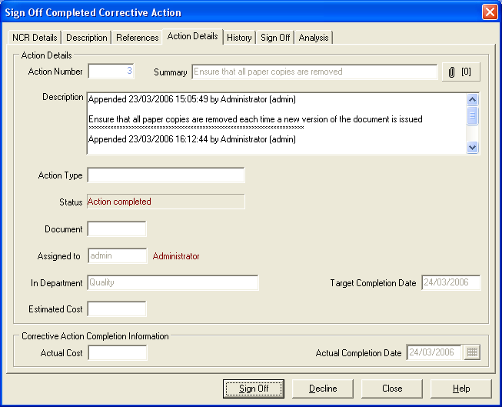

If more than one person is on the sign off list, then all those on the sign off list must sign off the Action before it is returned to the owner as complete.
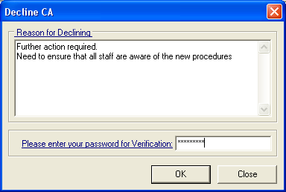

Reassign Corrective Actions
If the actionee of an NCR action or the owner of the NCR needs to ask another user to complete a task, for whatever reason, this is accomplished through the re-assign corrective action menu item.
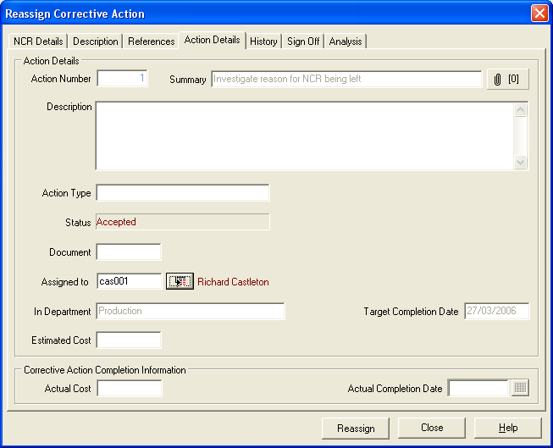
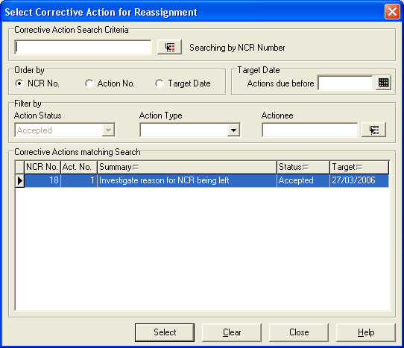
The task must have been accepted by the original actionee. The owner of the overall NCR, or the actionee of the action, can pass ownership to anyone else with access to the process corrective actions menu item. Ownership of the action will stay with the original actionee until the new actionee has accepted the task.
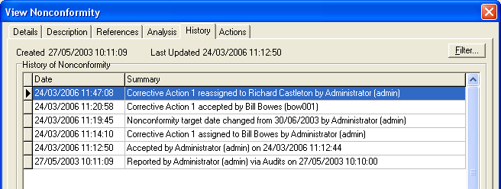
A history entry will be made in the NCR history and a task will be sent to the new actionee that they should accept and process the corrective action.
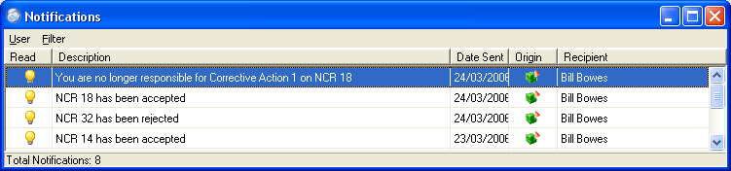
The previous actionee will be advised they are no longer responsible for the task.

NCR Final Review
Once all the actions have been signed off then a message is sent to the Owner that all actions have been signed off and the NCR passes to the NCR final Review stage.
Further actions can still be created at this stage and these will supersede the Review stage until they too have been signed off.
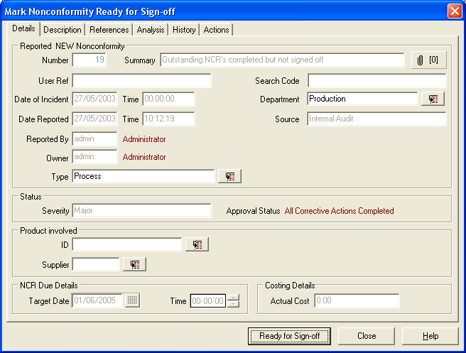
The owner of the NCR will then review the NCR and all the actions raised, ensuring the original issue has been addressed, and further occurrences should not arise, (corrective and preventive actions), and then mark the NCR Ready for Sign-off.
At this stage it is possible to amend the Department, NCR Type and Product fields, add notes to the description field and make any additional changes to the User Defined Analysis fields.

Sign off Completed NCR
Once the final review has been completed then the NCR is ready for completed sign off. At this stage the sign off can be declined, actions can be re-opened and further actions taken to ensure the NCR is complete.
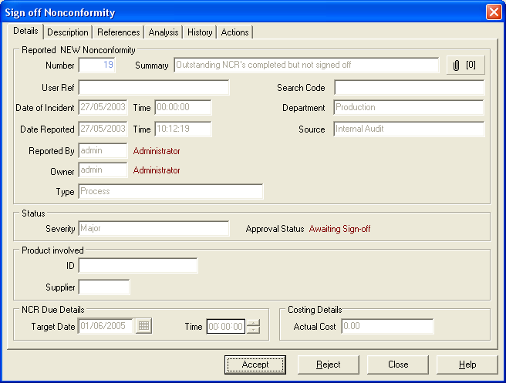
At this stage in the workflow, it is not possible to make any amendments to the main NCR fields, but it is possible to append to the description. Should any other amendments be needed the NCR sign-off must be rejected and reasons made clear in the mandatory rejection dialogue screen.
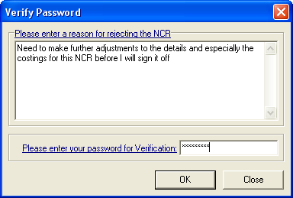

Audits Module

Setting up the Audit Module
Setting up your information for audit types, results descriptions and other relevant information is accomplished through the “Settings” menu.
All this information can be input into the software and used to plan an overall auditing schedule.

Audit Types
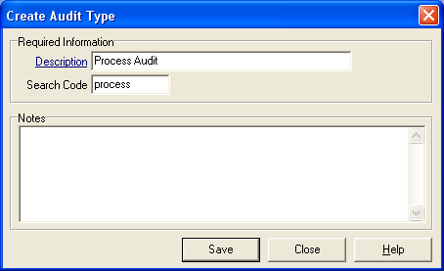
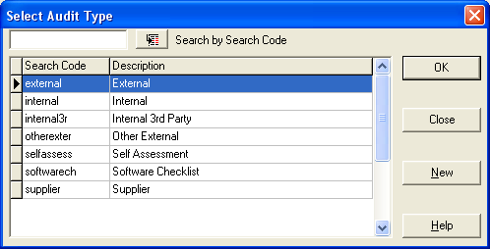
Although these settings are not mandatory, they will help in speeding input of information and retrieval of data in reports.

Assessors
If, as part of the overall audit plan of the organisation, external audits are to be included, as well as internal audits, then the relevant details about the assessment bodies can be entered in the Assessors.
Auditing by a number of organisations, from ISO 9000, Health and Safety, Environmental as well as more industry specific assessments can be included.
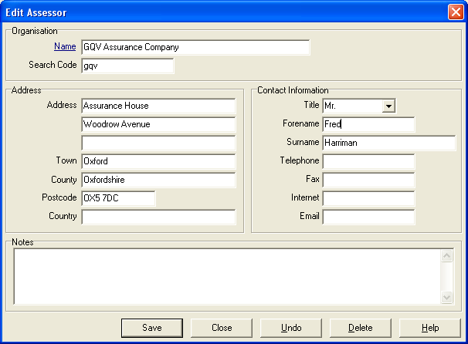
Enter the details for the assessment body responsible for ISO 9001-2000.

Result Description
To enable standardisation in the response to audit questions, there is a facility to create a drop down list of standard or common “Result Description” terms.
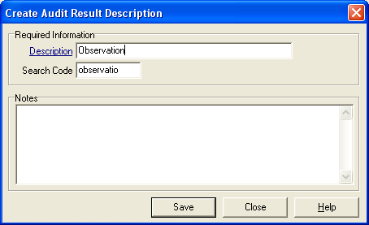
This should aid the understanding and qualification of answers given in an audit.
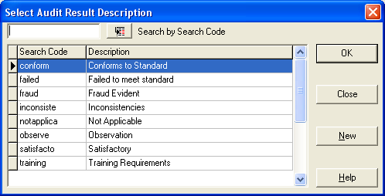

Customer and Clients
Customer/Client Contact Management is carried out in this area. If either the Customer Care Module or the NCR Module is in use, this information will already be in place.
Details of Companies or Individuals are entered and updated in this section.
Customers can be Individuals (for Environmental Standard ISO 14001 these could be Stake Holders rather than true Customers) or Companies.
The details are separated into 4 parts: -
- Company Details – name etc.
- Notes
- Analysis – How your company wants to see extra information
- Contacts – Details on the contacts – with further Analysis and Contact Notes
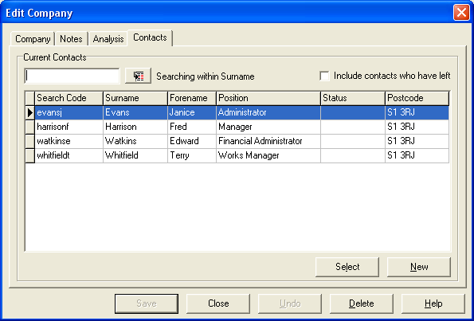
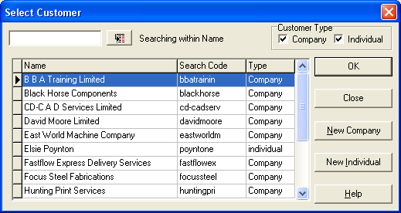
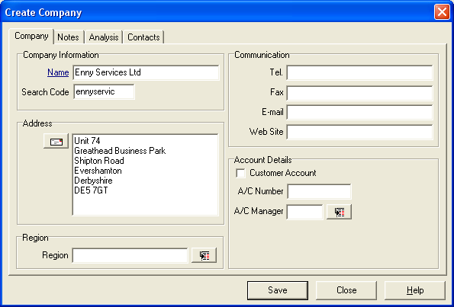
Searching for a company can be done by search code or within Name, and filtering can be done on the type of customer as a company or as an individual.

Suppliers
It is possible to plan and schedule audits on external suppliers and include them as part of the overall audit plan.
Suppliers of product or service to an organisation can be recorded and recalled through Workbench. Any discrepancies can be reported through the NCR module, and Audits to be carried out against a Supplier can be scheduled through the Audits module.
Setting up the suppliers is completed through the “Supplier|New” menu item.
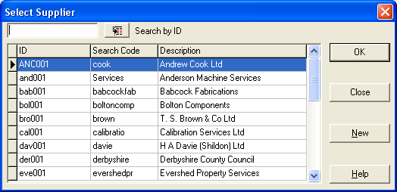

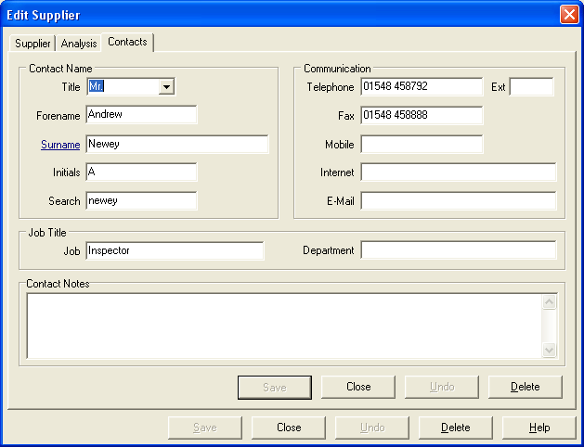
You can enter as much or as little information as is needed.

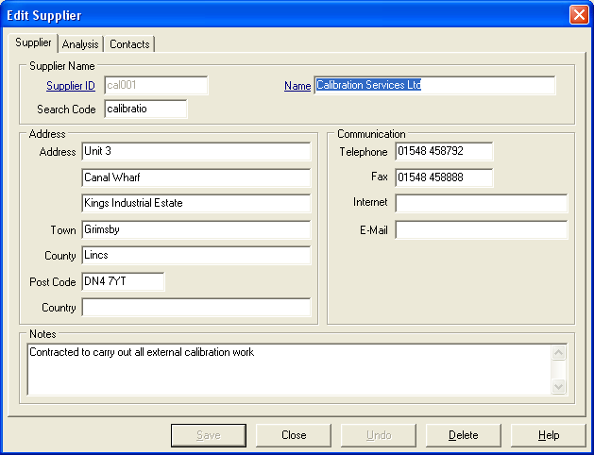
You will however be required to enter at least one contact in the “Contacts” section.

Categories and Checklist Library
When creating an audit template Workbench Audit module will allow for the creation of categories and checklist items in a library so that they may be used in many different audits.
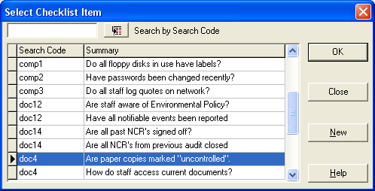
These elements are stored in a library of Categories and Checklist items available to auditors at the time of compiling templates, and when editing or running audits.
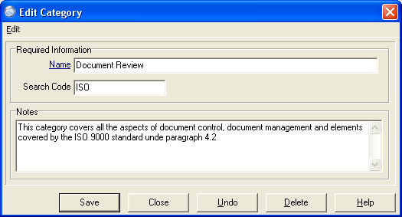
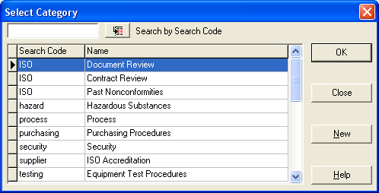

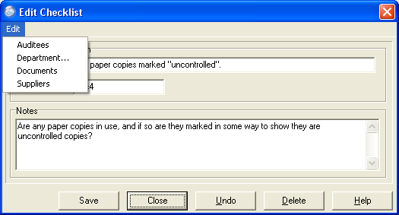

From the “Edit” menu on the add category or checklist dialogue …
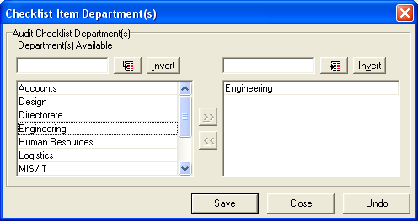

… more specific details about the department, auditee, supplier and related documents can be added so that the information will be included when the item is selected for inclusion in the relevant audit.

Create a Template
Select Audit menu item and Templates from the drop down list.
This lists all the current Audit templates in the system and allows creation of new templates.
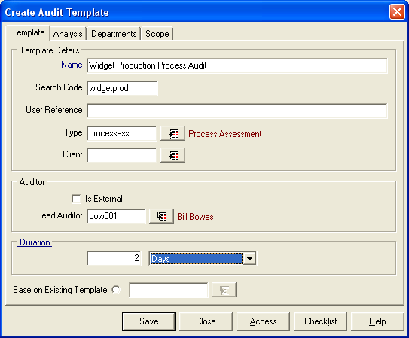
Selecting “New” allows you to create a new template.

Note the Mandatory fields are the “Name” Field and the “Duration” Field.

The Title (Name) will have to be unique.
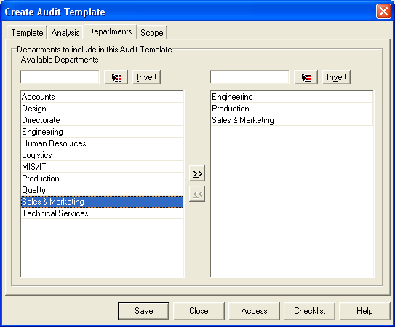

On the Departments tab select the departments to be audited, and on the Scope tab define the scope and detail of the audit.

To save time and unnecessary repetition it is possible to create a template based upon an audit template already in the system.

Access to Individual Audits
Access to be able to view and modify an audit can be strictly controlled, over and above the controls applied under the Access menu in the System Manager module.
Access to an audit is best determined at the template stage, but can be modified for each individual audit. The ability to edit an audit, i.e. add new questions or modify questions at any stage of the audit will need to be given at this stage. The person nominated as lead auditor will have this facility by default.
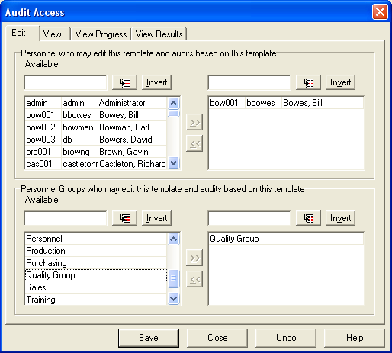
Any subsequent auditor assigned to a particular question will also need edit rights and needs to be added to the “Edit” Access.

Compiling Category and Checklist items in an Audit
This is the area where questions or checklist items can be entered to build up a complete audit.
Sub headings, or categories, can help to give a more regulated audit.
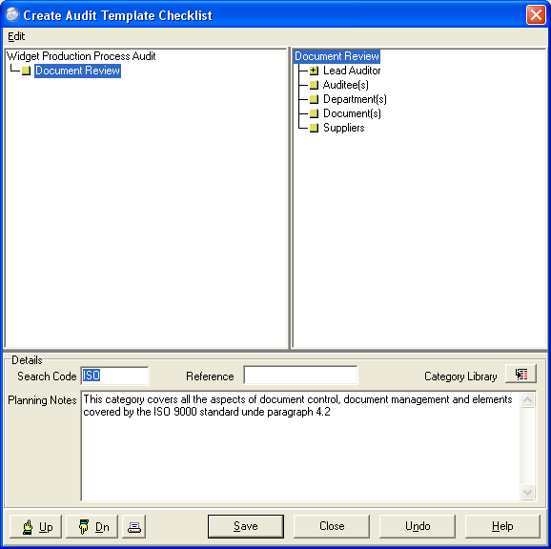

An audit can be created and scheduled without any checklist items, allowing freedom for the auditors to generate their own questions at any time before or during the audit.

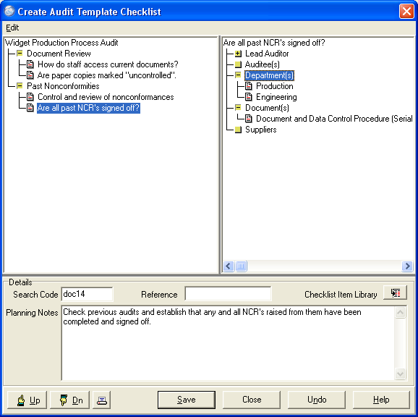

Additional categories and/or checklist items can be added to the audit, either by selecting the “edit” menu item in the audit screen or by using the right mouse button.

This will bring up a dialogue box where, for each Category and Checklist item, details such as Lead Auditor, Auditees, Departments, Document(s), and Suppliers can be specified.

Scheduling an audit
Once created, an audit template can be scheduled to run any number of times over a planned period.
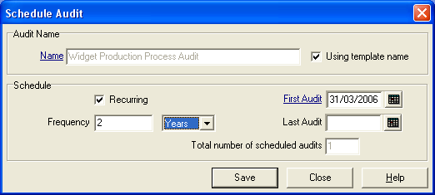
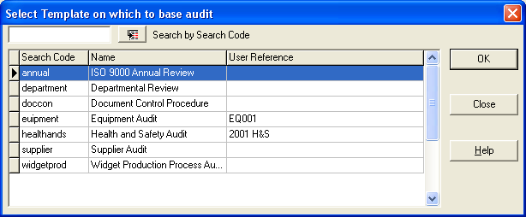

Select the date of the FIRST of the audits to be run, and if it is an audit that is carried out at regular intervals then select the Recurring tick box. Select the frequency of the audits, for instance 6 monthly, annually or every 2 years.
This will activate the “Last Audit” calendar box and select the date on which the last of this audit sequence being planned will be carried out.
If you select a date which does not match exactly with the frequency specified, then you will be offered the nearest date before the date you specified.
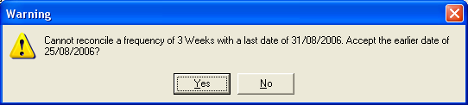
Underneath the “Last Audit” date will show the number of audits this will produce in the sequence. Each audit will be given a unique sequential number.
There is also an option to change the name of the actual audits being created from the template.
For example: - the template may be a generic departmental audit, but the plan is to schedule to audit the Engineering Department using that template. Change the name by de-selecting the box next to “Using Template Name”, and type in the name you wish to use.
All scheduled audits whether planned, running or complete will appear in the working calendar.

Editing an audit
Once the audit is scheduled, the auditor will be notified that there is an audit to be run on the day the audit is due.
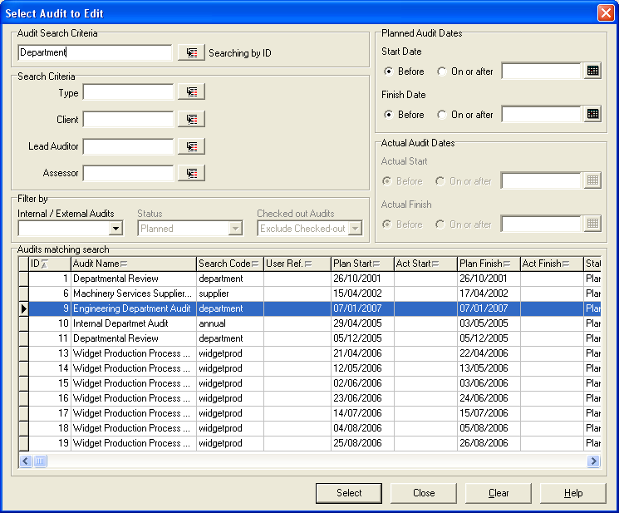
It is possible from any of the “Edit”, “Run”, “Check Audit out…” and “View” menu items to see a list of all the audits in the system and to filter the list to present the audits required.

Searching to get to the audit required can be in a combination of any of the fields in the top half of the screen.
Some elements will be predefined by default and cannot be changed, such as the status, if searching for audits to edit, as this will be set to Planned audits only, i.e. only a planned audit can be edited.
Most Searches will exclude “Checked Out Audits”.
The auditor must be given edit rights to the audit to be able to make any changes to the audit.
The auditor will be able to edit the audit, change the Checklist items and Categories, either adding to them or deleting them, in order to customize the particular audit.
More importantly, the auditor will be able to specify the auditees, if known.

In addition, the auditor may want to inform the auditees as to when the audit will take place.
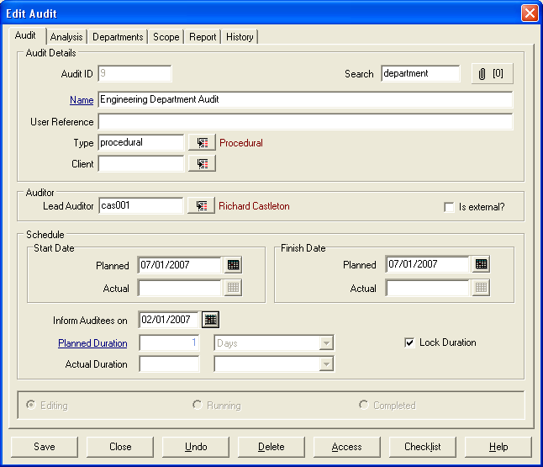
Inform auditees
All these changes will be registered in the audit history.
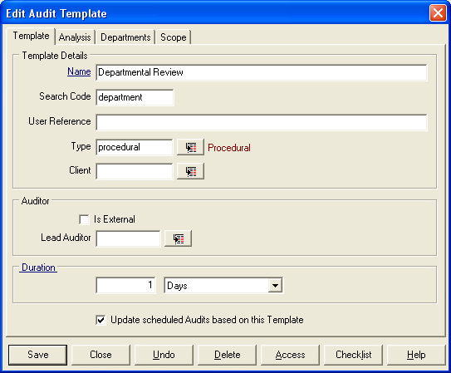
Any changes made to this audit will not affect the audit template or any other audits based on the template.
If any changes need to be made to all the audits based on the original template, then the changes must be made in the template itself and the “Update scheduled audits based on this template” box must be ticked.

Any audits already running or checked out will not be affected by changes made to the template.
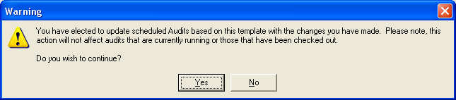

Running an audit
Audits can be run, either from the Run menu item, from the e-mail/task bar, or from the Calendar.
Select the Calendar Icon from the Icon Bar near the top of the screen. In the monthly view, selecting the day and show day details gives all the events for the chosen day.
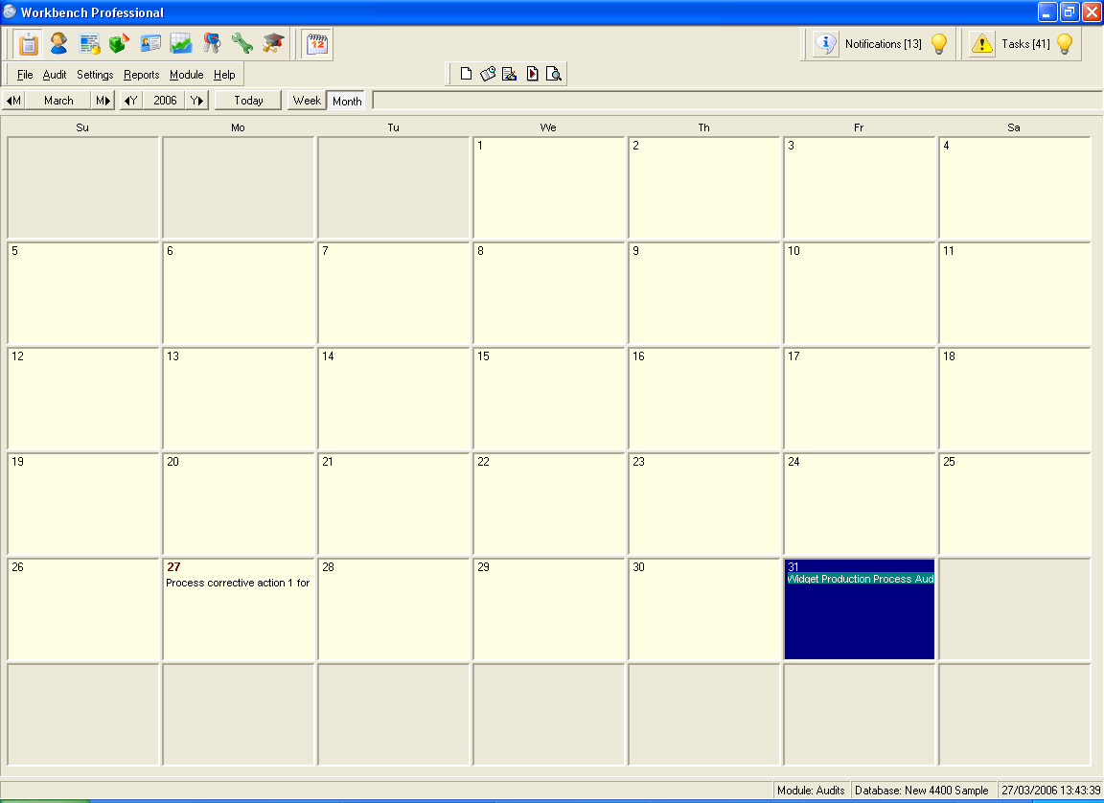

Double clicking on the desired item allows access to the screen where you can begin to input information and complete this particular audit.

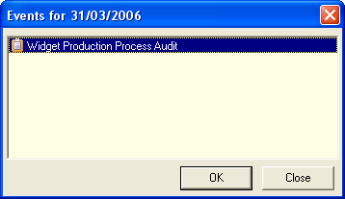

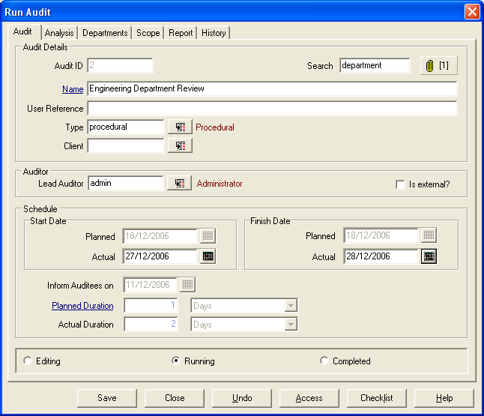
This brings up the audit details.
In the Auditor section on the Audit tab screen check to ensure that the Lead Auditor’s name entered is correct.
Enter today’s date in the Start Date “Actual” field in the schedule page.

Select the Checklist button at the bottom of the screen to bring up a list of the questions.
This will show you a screen similar to the template screen with the addition of the Results section.
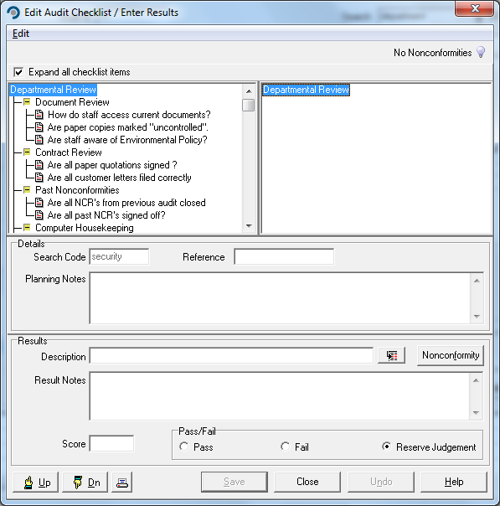
The physical aspects of the auditing can be undertaken by printing a copy of the checklist items and doing a “clipboard” or manual audit.

Select “Print” button from the bottom of the audit screen to print out questions.

Carry out the audit.
Select the audit to run and select a question to answer.
The evidence of your questioning can be entered in the relevant results notes box.
The Results Notes field provides a free text area.
Decide on a Pass, Fail, or Reserve Judgment for the question.
Selecting the Nonconformity… button invokes the Nonconformities Module.
Further questions can be added at any time by selecting either the title of the audit or any category, and either using the mouse right click button or selecting the edit menu item and “Add Checklist Item” or “Add Checklist item from Library” from the dialogue box.

From the right hand screen, or from the dialogue box, it is also possible to identify the auditee for this question, the department involved, and the specific procedures being audited.
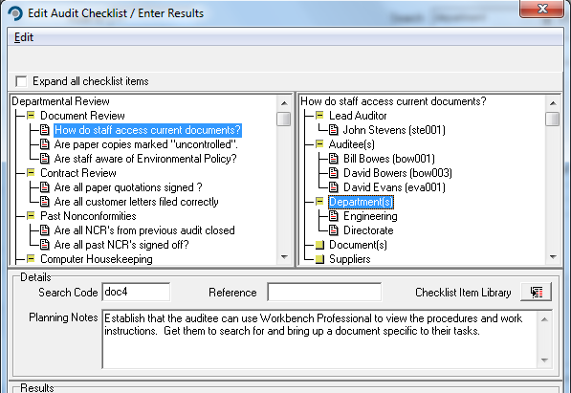
The Auditor/Lead Auditor can also be changed at this point.
NOTE: If changes are made to the audit, and then the “Undo” button is used, a warning that ALL the changes since the last save will be undone. It is recommended that the audit be saved regularly.

Completing an Audit
If required, a composite text document, or Audit Final Report, can be entered into the “Report” tab. This needs to be done BEFORE marking the audit as complete.
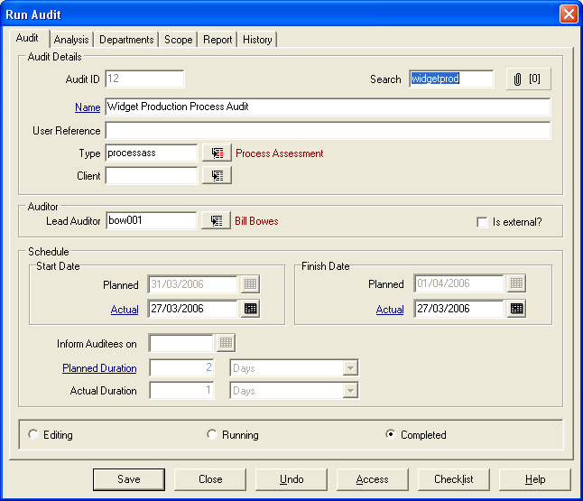

Once the required checklist items have been answered, the audit can be closed or “completed”.

This does not require that any Nonconformities raised be closed out.

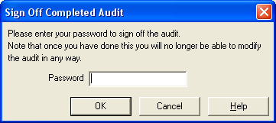

It will require your password as a signature and once completed the audit becomes view only.

Any Nonconformity raised will be visible from the audit checklist results screen by selecting the title of the audit, and the number of Nonconformities raised against an audit will be highlighted in the top right hand corner of the Checklist screen.
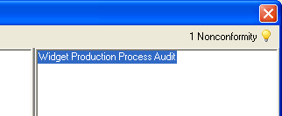
If there are any Nonconformities that are still open then the light bulb indicator will be yellow. When the NCR has been completed and closed off, the light bulb will turn white.

Audit Reports
There are a number of reports where the Planned Audits, Running and Completed Audits can be reported on, as well as a graphical view of the Audits planned in the system.
