Applying Workbench V11 Service Pack 1 Patch 10

Important: You must read the following section

It is essential you ensure that all your data / systems / databases are fully backed up before following any procedure or advice provided. Ideagen Gael Ltd accept no liability whatsoever for any data loss / corruption / system downtime / business or monetary loss caused either directly or indirectly from the use of the information or utilities provided. Ensure all users are off the system before commencing.

Pre-requisites

Please make sure you have a complete backup of your Workbench server before undergoing this process.

You must be running version 11 SP 1 or above of Workbench in order to apply Patch 10.

Please make sure all users are logged out of Workbench, and that applications such as Workbench Licence Manager are not running on the server or client machines.

The server will need to be restarted at the end of this process.

Workbench Office add-ins for Microsoft Office 2013

Please note that if you are upgrading from SP 1 or any of the previous patches, any of your users that are on Microsoft Office 2013 and want to use the Workbench add-ins for Word, Excel and PowerPoint, the add-ins will need to be re-installed as there are new versions that work with Office 2013 UNLESS they are already on v11.1.8.100 of the add-ins.

If you also have IntraVista Professional, you need to stop access to it before upgrading Workbench. This prevents the upgrade to Workbench being compromised by users trying to view documents in IVPro. To disable IVPro, start by running the WebObjects monitor from the desktop icon on the IVPro server, or alternatively open Internet Explorer and go to http://localhost:56789. Click the [Detail View] button.

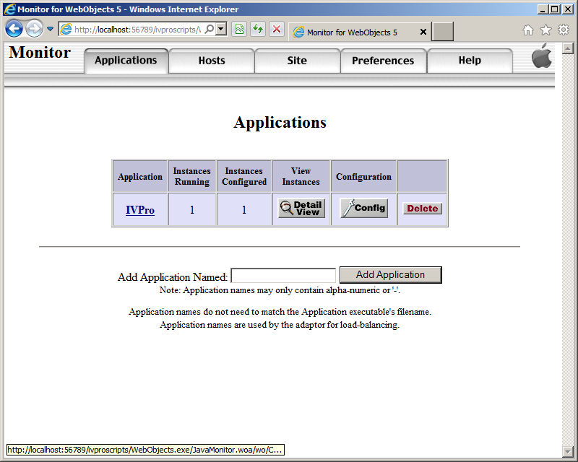
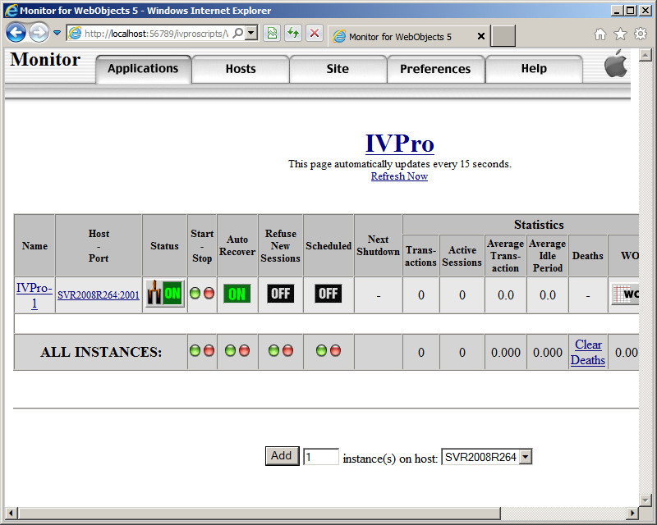

Under Auto Recover, click on the Green ‘ON’ icon and this should turn to a White ‘OFF’. Under Start – Stop, click on the Red LED and then press [F5] to refresh the page. The Status will now show as ‘OFF’ (in Red, see below). You can now close Internet Explorer.

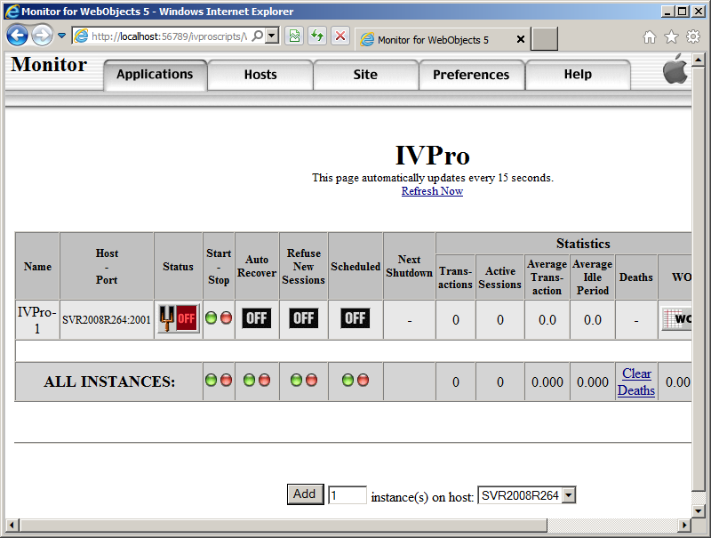
If you have IntraVista, to prevent users accessing the database all you need to do is rename the QwbCgi.exe or Qwb.Cgi.dll file to (QwbCgi.old) in the \Inetpub\ivscripts folder. Once the upgrade has been completed, just rename it back again.

On the Workbench server create a folder called WB11SP1Patch10 in the workbench\Ideagen\WBPro folder, and then extract the files from the Workbench11SP1P10.zip file into it.

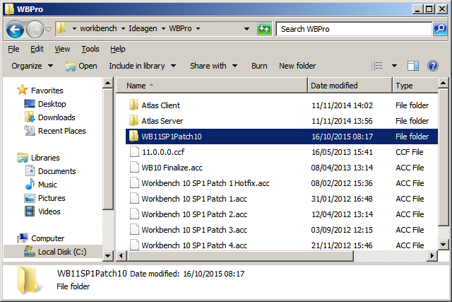

In the WB11SP1Patch10 folder, Double-click the WB11SP1Patch10Installer.exe file. On the Service Pack Installer Welcome screen, providing you have a complete backup of your system, check the box and then click [Next].

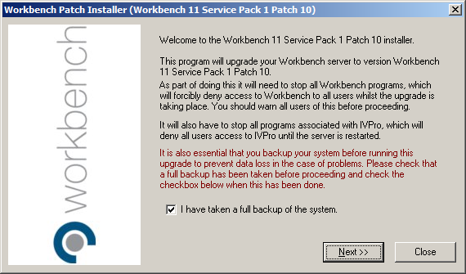

The installer will need to stop the IVPro services so click [Next].

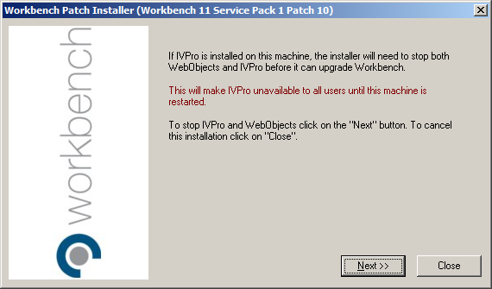

The installer now needs to stop the Workbench services so click the [Next] button.

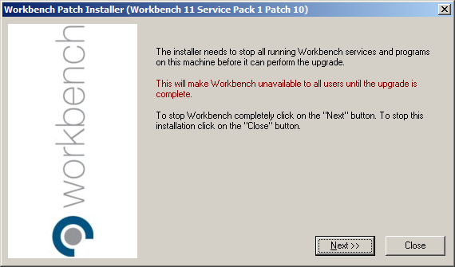

The installer is now ready to apply the changes so click the [Next] button.

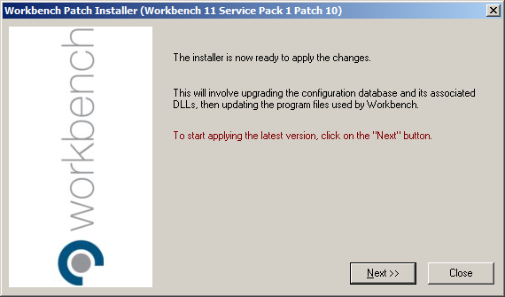

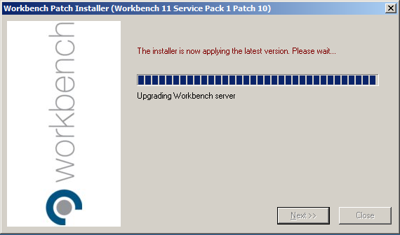

A licence is not required for this patch so click [Next].

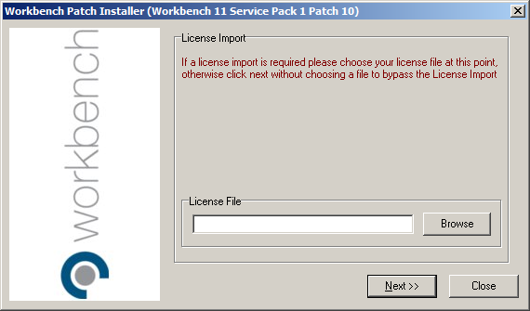

Click the [Next] button to restart the server. Alternatively, you can click [I will restart Windows myself later] and then click [Next] and [Close].

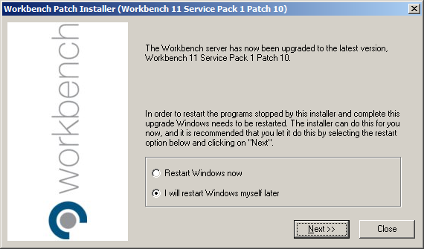

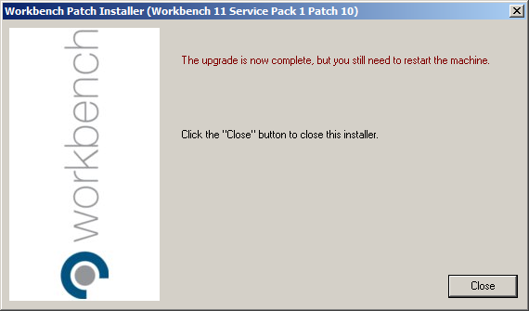

If you chose to restart later, it is recommended that you perform a Stop and Start of the Workbench Guardian service.

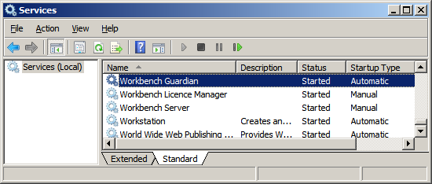

If you have IVPro, then after the server has restarted go back to the WebObjects Monitor in Internet Explorer and press the [Detail View] button.

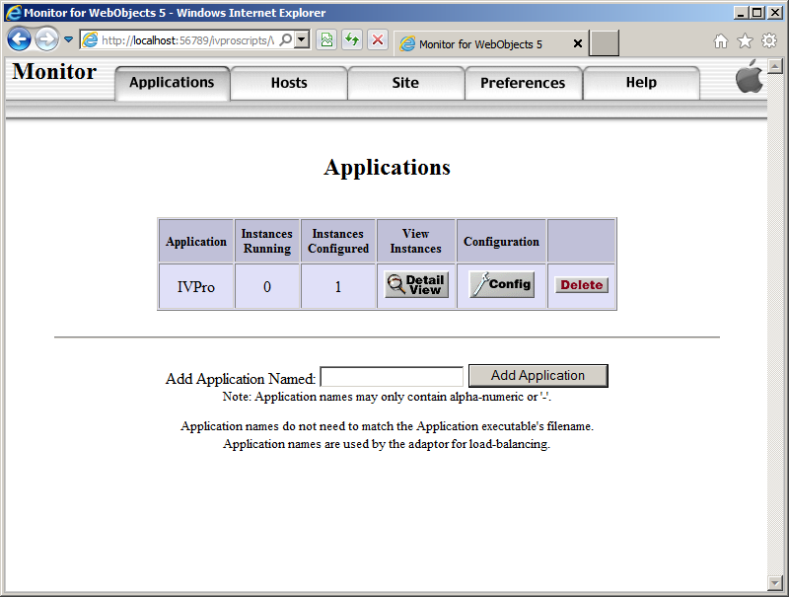

Under Auto Recover, click on the White ‘OFF# icon and it should turn to a Green ‘ON’. After a refreshing a couple of times the Status should turn back to a Green ‘ON’. IVPro has now been restarted and you can close IE.

If you have IntraVista, rename the QwbCgi.old file to QwbCgi.exe or QwbCgi.dll in the \Inetpub\ivscripts folder.

Regarding upgrading Workbench clients, just run the client, and once the client connects to the server, the upgraded files will automatically be downloaded.

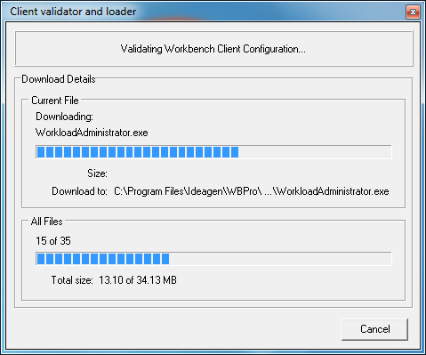

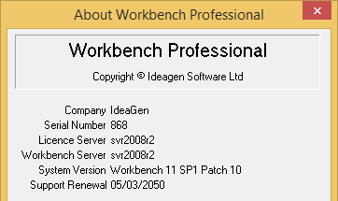

Workbench Office Add-ins

Depending on the version of Workbench you are upgrading from, you might need to install the new versions provided with Patch 10. Check the version number of the add-ins in Word and Excel, and if they are not 11.1.8.100 then they will need to be re-installed.

In the WB11SP1Patch10\Workbench Office folder in workbench\Ideagen\WBPro, Copy the three folders and paste them into the \workbench\qwb_pro\Clients\Workbench Office Installers folder. It is recommended that you remove the existing folders to avoid confusion.

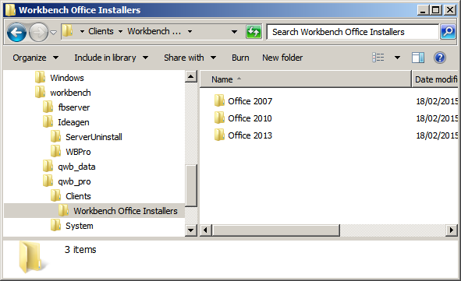

Once installed the add-in versions should be 11.1.8.100 for Excel & Word.

