Workbench Solus Module Training Notes

Table of Contents

Solus Remote Document Viewer System 1
An Introduction to the Workbench Family of Software 4
Document Control Module 5
Solus 6
Solus Configuration Manager 7
Synchronisation log on the server 9
When the user logs on 10
Login Dialog: 10
“Keep user logged in?” option when logging in 10
Active Directory Login 10
Solus in the system tray. 11
Open Solus 11
Synchronise Now 11
Database Selection 11
Options: 11
Viewing documents 13
Highlight changed documents 15
Ability for the client to only select the databases that they need to synchronise with 15
Validity/expiry of document 16
Synchronise the document 17
Unsuccessful Synchronisation 17

An Introduction to the Workbench Family of Software

The notes in this document are designed to give users an overview of this module of Workbench to help get started with the implementation of the software.

Workbench is a collection of software modules designed to assist in the implementation and smooth operation of day-to-day management control. The overall system consists of the following modules: -

- Audits | - Nonconformities | - ReportQuest *
- Customer Care | - Test and Calibration | - Document Control
- Training | - Solus *

* ReportQuest is different in concept to the other six modules; it is a ‘plug-in’ rather than a ‘stand-alone’ module. It integrates with any or all other modules and utilises the information stored in them.
Each module (apart from ReportQuest) has been carefully designed to be a powerful individual management aid and for many organisations, it may be entirely appropriate to run any on a ‘stand-alone’ basis. There is, however, considerable integration between the different modules and this could offer many benefits to organisations running a comprehensive quality or other compliance management system. Any company that wishes to adopt a ‘phased’ implementation can add modules to the system as and when required.
Workbench works with, and assumes a basic knowledge of, Windows 98 or above.
Each module has its own electronic reference manual and on-screen Help system but these guides should not be seen as a substitute for professional advice and training. Workbench is designed to be extremely easy to use in its daily operation but the preliminary setting up of a module can be relatively complex.

*Solus is a utility to enable offsite Workbench users who may not have a permanent connection to the Workbench system to be able to synchronise and download the latest version of documents to a laptop. It enables them to synchronise to the Workbench system when they do connect to the network, advise them when documents become out of date and download updated versions of their required documentation.

Document Control Module

Workbench Document Control is well suited to management systems which need to cope with documentation that changes dynamically over time in response to all manner of internal and external, possibly statutory, demands. These include not only Quality Management Systems (such as ISO 9000) but also Health & Safety and Environmental systems and virtually any project that requires carefully monitored design or requirements specifications.
The essence of a Document Control system lies in its ability to control document content and its availability to personnel within an organisation. This contrasts with Document Management Systems, which typically allow documents to be stored electronically and to be suitably indexed and organised. This facilitates straightforward retrieval of any given document but does not normally impose any controlling mechanism on the document’s content. Indeed, in many systems of this type, documents will remain largely static entities as far as their content is concerned. Document Control Module combines the best of both systems.
The objective of the Workbench Document Control Module is to manage the process of change in a controlled and manageable fashion, as well as allow the storage and retrieval of those static documents usually handled by Document Management Systems.
Document Control offers the best of both worlds, allowing documents requiring the strictest of control, and at the same time storing and making available those documents, e-mails, scanned letters, graphic layouts etc, which require simple storage and distribution.
While doing so, the module still allows access to the analysis schemes and categories typical of a Document Management System that permit easy searching for and location of key documents. It also offers a solid and auditable record of the whole history of change to which any given document has been subjected.
The Document Control module is also designed with security and ease of use features very much in mind. This ensures that, where needed, documents can be changed in a controlled manner, stored as read only, or kept as general documents, editable at any time, and that the distribution of these documents is to relevant and authorised personnel.

Solus extends the document control system to users who do not have permanent access to the network and consequently to the current up to date documents which reside inside the Workbench database.
It is designed to allow the synchronisation of documents from the current active Workbench database and keeps copies of them on a local computer which can then be detached from the network. The documents will be as up to date as the last time the local computer was synchronised by connecting to the main network.
Solus will synchronise documents and the attributes of those elements that have changes since the last synchronisation.
The document security and access features applied within Workbench are also carried across to Solus, and all users of Solus need to be logged as users in Workbench.



Solus is a new licensed application that is compatible with Workbench 2008 Service Pack1 Patch3 WB10 and above. It is an application which helps with the distribution of documents to offsite Workbench users that may not have a direct network connection to the Workbench system and can therefore not see the latest issued version of documents.

The server side consists of a web service which is external facing, providing an interface between the offsite users’ laptops and the Workbench system and a synchronisation service that connects to the workbench server (this web service makes use of a Microsoft SQL Server Express database and a file storage area).

The server side application can be set to poll the server side web service at given periods, any changes to an issued document and/or settings that the client user is allowed access to, will be downloaded to the client synchronisation service and stored in a Microsoft SQL Server Compact database and relevant file storage area. All documents will be stored in an encrypted and compressed state. A document will only be decrypted and uncompressed when required to be viewed by the user.

The system will notify users of when their cached copies of the documents are out of date, prompting the user to synchronise whenever the laptops are connected to the internet.

Solus client is a Window’s application which should be installed onto all the offsite users’ laptops, and will communicate with the web service to retrieve the latest copies of all the necessary, out of date documents

The client application allows the user to search for a document and will notify that user when their copies of documents are out of date, but can also be configured to run on Windows start up so that, if the connection to the web service is available, the documents can be downloaded in the background.

Solus Configuration Manager

This program forms part of the Solus module and enables the server side of the system to be configured. The purpose of this program is to configure the Solus server settings and also some settings that filter down to the client i.e Login configuration.

Logging into the Solus Configuration Manager requires a login to confirm access rights. The default password is “masterkey”.

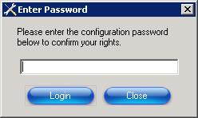

The Server, Workbench and Web Service tabs will have been completed at the time of installation and should not require amendment.

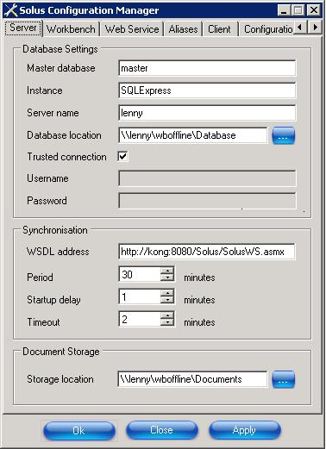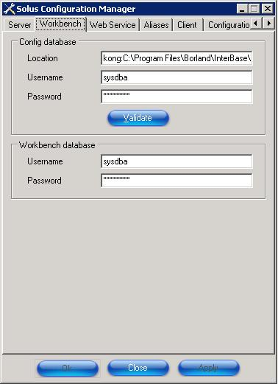

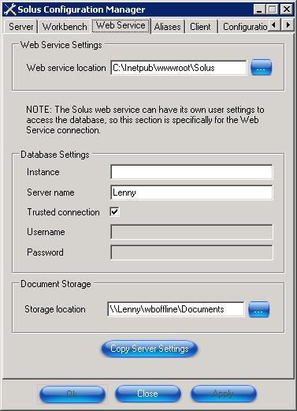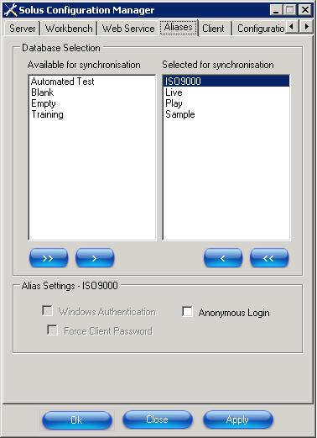

The Aliases tab lists the databases available for synchronisation. This only need be amended if a new database needs to be added to the system for synchronisation or an old one is to be removed from the list.

The Alias settings box allows the system administrator to define if, for a given database, the user will use a windows authenticated login, and to define whether the user still needs to enter a valid password to access that database before synchronisation can start.

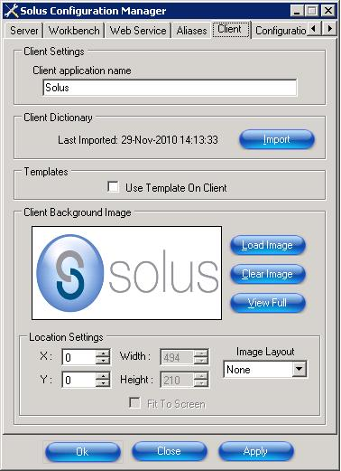

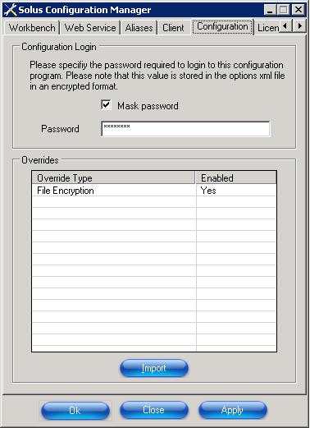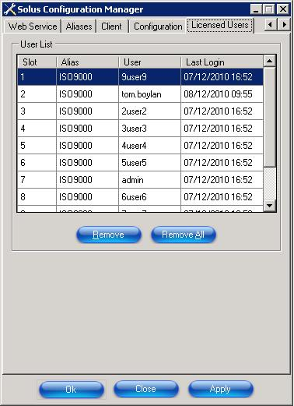

Synchronisation log on the server

A Synchronisation log is created on the server to show when users have successfully synchronised their system with the server.

The Table will store, date and time, databases, user and machine ID (MAC address/IP address).

This section covers the elements of Solus available to the end user.

When the user logs on

Once the user has started the application from either the All Programs menu or from the system tray icon the select database screen is presented.

Login Dialog
The settings defined for each database in the Configuration Manager are passed to the Login dialog when it is displayed. If the Options dialog does not have a database selected in the Default Database Alias drop down, the databases selected for synchronisation in the Database Selection dialog will be available for selection.
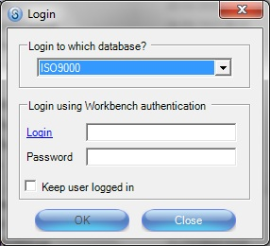

“Keep user logged in?” option when logging in

When the client application is started and this option is enabled then the user will stay logged in to this database until another database has been selected.

Active Directory Login

If Active Directory login has been enabled as part of the Workbench Server configuration, then the user should be able to use active directory login on the client application.

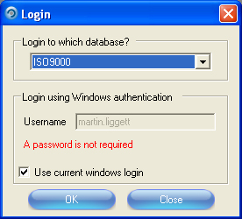

Solus in the system tray.

Solus is installed on to the local client machine and creates an icon in the user’s system tray as well as an icon on the desk top and a program in All Programs.
This then gives the user the ability to right click and be presented with a list of functions they can perform.

Open Solus

Will allow the user to open the application and view documents if already logged in to a database, or will present the user with a list of the databases available to log into.

Synchronise Now

Synchronises all the databases selected in the Database Selection dialog for every user who has logged into the selected databases.

Database Selection

Database Selection dialog:
Lists all databases available for synchronisation (controlled by the system administrator) on the left and those selected for synchronisation on the right. Only documents from the selected aliases will be downloaded on synchronisation.

The Database Alias Selection dialog also offers the following information via a right-click menu for each selected database:-
- Display Information
- Compress Database
- Verify Database

Options:

Options dialog:

The Options dialog allows the user to configure the synchronisation for each individual database that they have access to.
The Options dialog also allows the user to select Default Database Alias and offers the option of a Default Search box which allow search by – Serial Number, User Reference, Title, Author, Owner and Review Responsibility.

Solus can be set to run on Window’s start up and therefore start downloading the changed documents (providing there is an active connection to the web service).

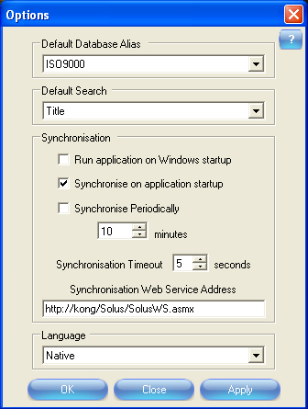
The Synchronisation Options are as follows:-
‘Run application on Windows start up’ – if this checkbox is checked Solus will automatically run when Windows is started up, but will only download updates if the 2nd checkbox ‘Synchronise on application start up’ is checked.
‘Synchronise on application start up’ – if this checkbox is checked synchronisation will take place each time Solus is started up.
‘Synchronise Periodically’ – checking this checkbox allows you to select the frequency of synchronisation e.g. if you set ‘20’ in the minutes field, then synchronisation will automatically take place every 20 minutes. The minimum time is 10 minutes.
The ‘Synchronisation Timeout’ refers to the number of seconds that are allowed to pass whilst trying to synchronise (maximum 5 seconds). If nothing happens during this time, the application waits until the next automatic synchronisation is scheduled or the right-click Synchronise Now option is selected from the Solus task tray icon.
Information shown at the bottom left of the main Solus screen shows the date and time of the last successful synchronisation for the current database. The Synchronisation Web Service Address is set by the system administrator.
- About: About Solus dialog displays the Solus version numbers and a link to the Ideagen website.
- Exit: Logs users out of Solus.

Viewing documents

The document view screen is similar in operation to the IntaVista Pro and Workbench Doclists.
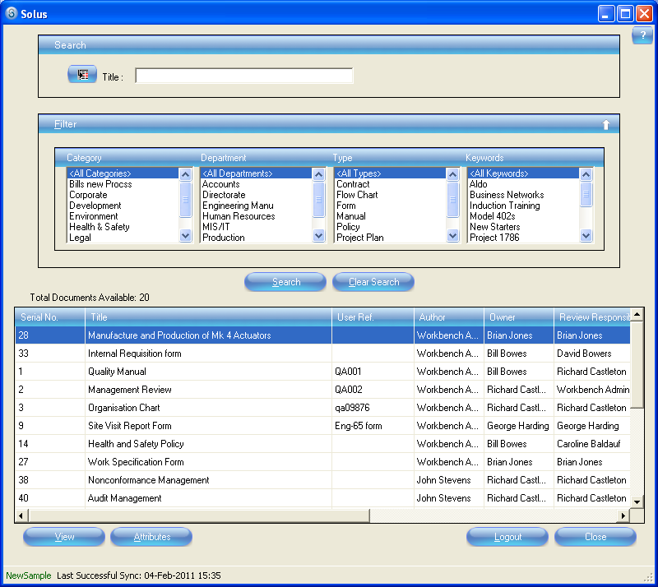

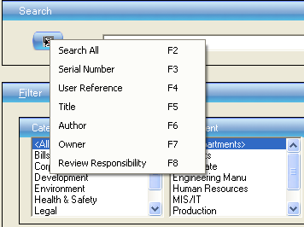

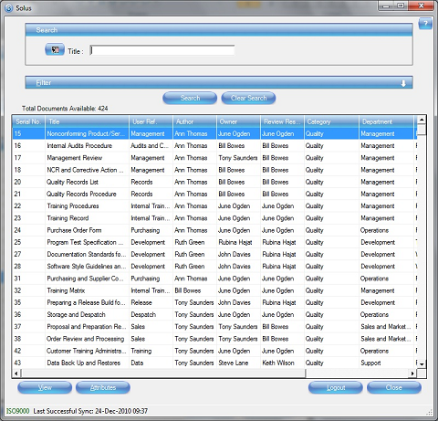

Documents that have been withdrawn, or have had the requirement to be synchronised switched off in the Workbench Document Workflow settings, will be removed from the synchronised database and will no longer be available to be viewed through Solus.

The view access for documents created within Workbench will determine whether a document can be viewed through Solus.

Highlight changed documents

When a document has been changed or updated in Workbench, either by re-issuing the document after a change, or has had its attributes changed, then a highlighted colour designates which documents have changed since last synchronisation.

An extra column will also show stating “New!” will appear and highlight row with a different colour and an arrow next to the changed document, making it easier to find in the list.

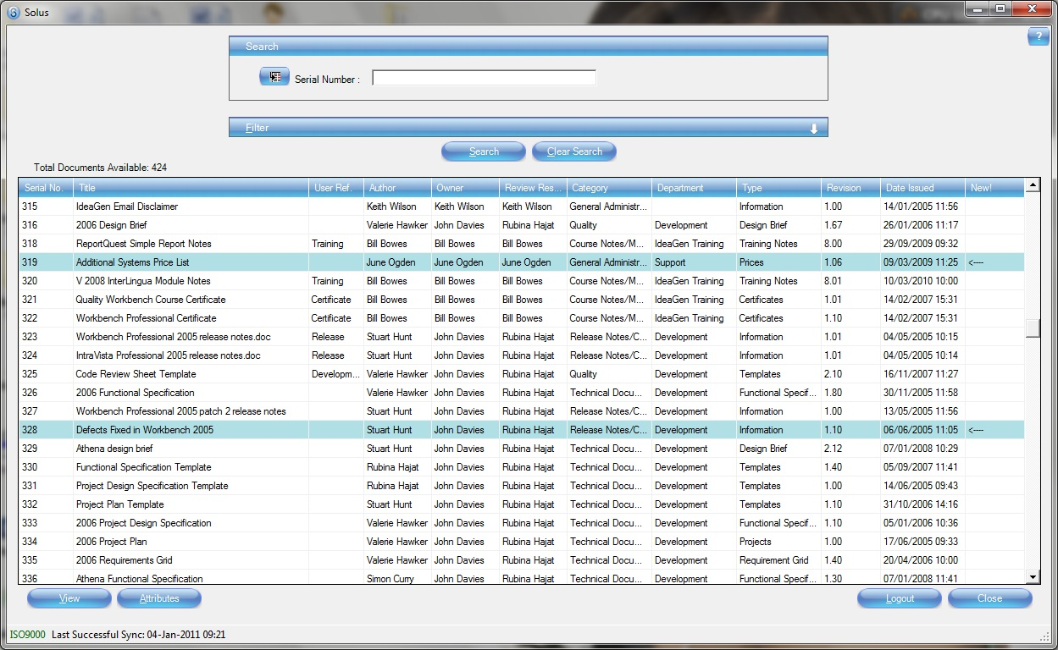

Ability for the client to only select the databases that they need to synchronise with

When the user logs on to Solus they will be able to select a list of available database aliases to choose from. Only documents from these aliases will then be downloaded on synchronisation. This is available as a right click option.
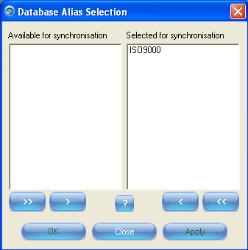

Validity/expiry of document

A workflow setting in the Document Workflow settings (WB 10 & above only) will enable the default to be set for the validity/expiry of a document.
The settings can be pre-defined in the Workflow Configuration Centre under New Documents Settings, but will be configurable for each document.

The settings needs to be specified as a number of days (weeks, months or years) and if the difference between the current date and the last synchronised date is greater than this value then the document will still be displayed in the list, and is still viewable but an appropriate message explaining the document is out of date will be shown.
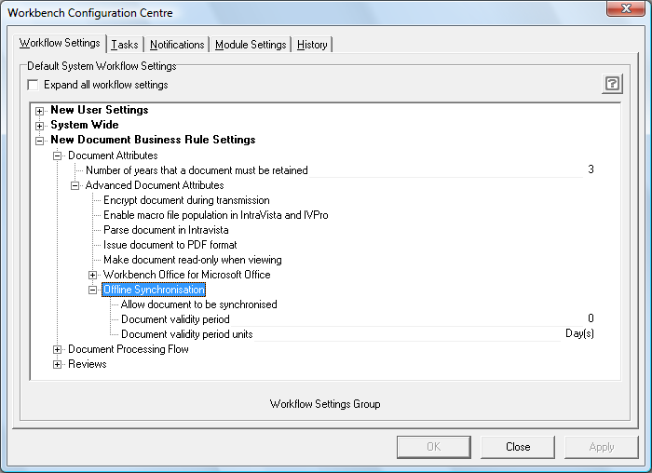

Synchronise the document

Documents already in Workbench will have the Offline Synchronisation functionality switched off by default and will have to be changed on an individual document basis.

Select the “Allow document to be synchronised” setting, and if needed, select the validity of the document.

If no validity period is set, the document will only be re-synchronised when changes to the issued document or its attributes are made in Workbench.

If the document has a validity period set, and synchronisation has not taken place during that validity period, then the document will be synchronised, even if no changes have been made in Workbench.
Effectively the Validity period will determine whether a message is displayed warning the user that the document is outside the synchronisation period and may not be the latest version.
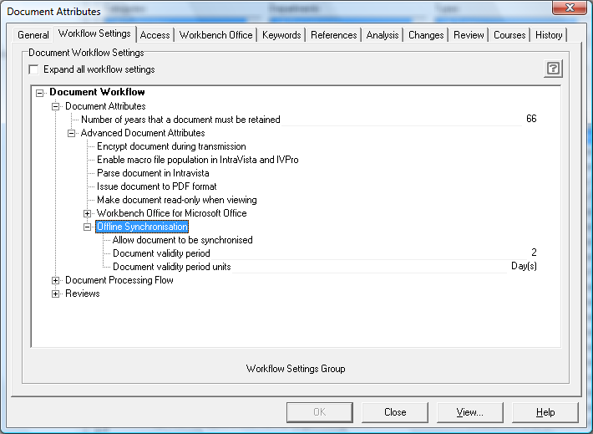

Unsuccessful Synchronisation

If synchronisation is unsuccessful a message will be displayed advising user that synchronisation was unsuccessful.

However in the event that synchronisation has been unsuccessful but some of the documents may still have been successfully cached, the documents that have been synchronised successfully will be highlighted in blue on the document grid and be available for viewing.

Therefore whenever a ‘synchronisation was unsuccessful’ message is displayed it would be necessary to repeat the synchronisation process in order to ensure all the up to date documents are downloaded to Solus for viewing.

