Installing IntraVista Professional Version 11

IMPORTANT: You must read the following section

It is essential you ensure that all your data / systems / databases are fully backed up before following any procedure or advice provided. Ideagen Software accept no liability whatsoever for any data loss / corruption / system downtime / business or monetary loss caused either directly or indirectly from the use of the information or utilities provided. Ensure all users are off the system before commencing.

Pre-requisites

You must be running version 11 of Workbench in order to use IVPro 11.

This installation was carried out on Server 2008 R2. There are some extra steps in IIS that don’t need to be done on Server 2003 and these will be pointed out.

Please make sure all users are logged out of Workbench.

The server will require a restart after the installation of IVPro 11.
Insert the IVPro 11 CD and it will auto run. On the “IVPro 11 Installation Manager” screen click the [Next] button.

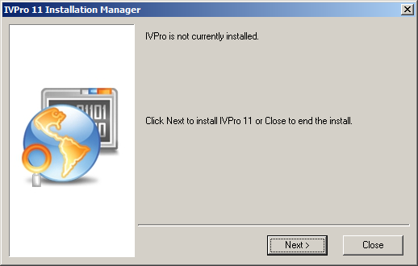

On the “Requirements” screen click [Install].

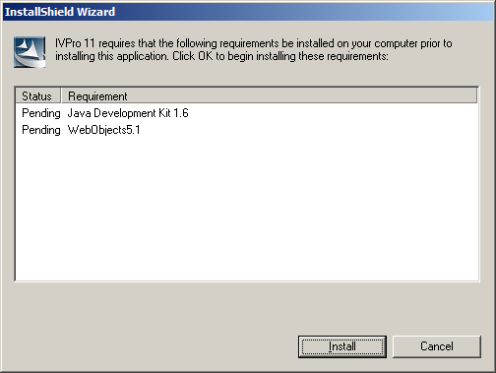
[Accept] the Java Licence Agreement.

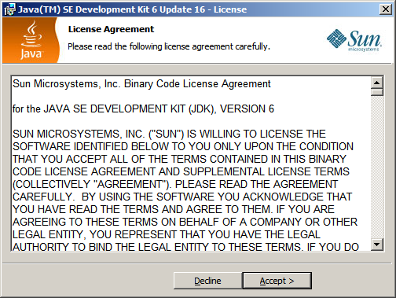

On the “Custom Setup” screen click [Next].

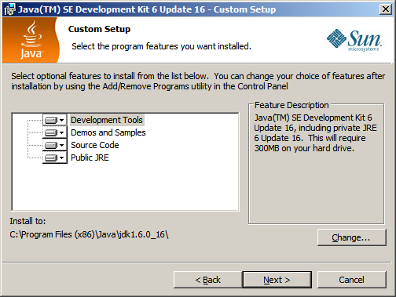
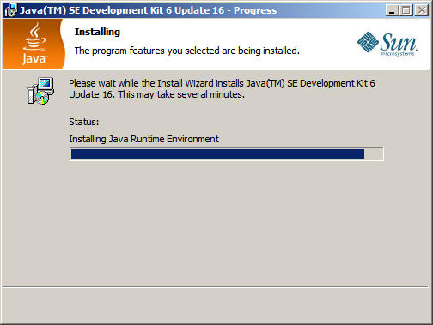

On the “Destination Folder” screen click [Next].

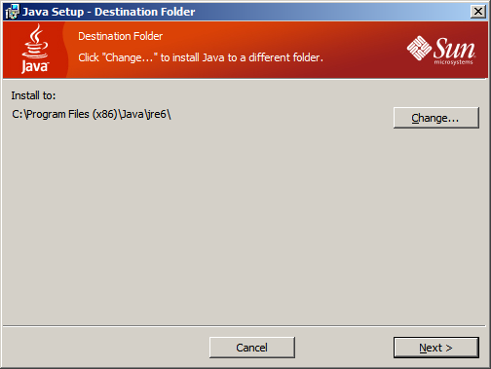
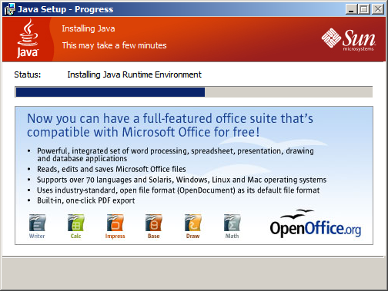

On the “Complete” screen click the [Finish] button.

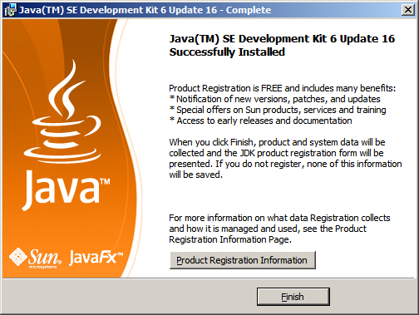
An “Internet Explorer” window will open after the install of Java but this can be closed.

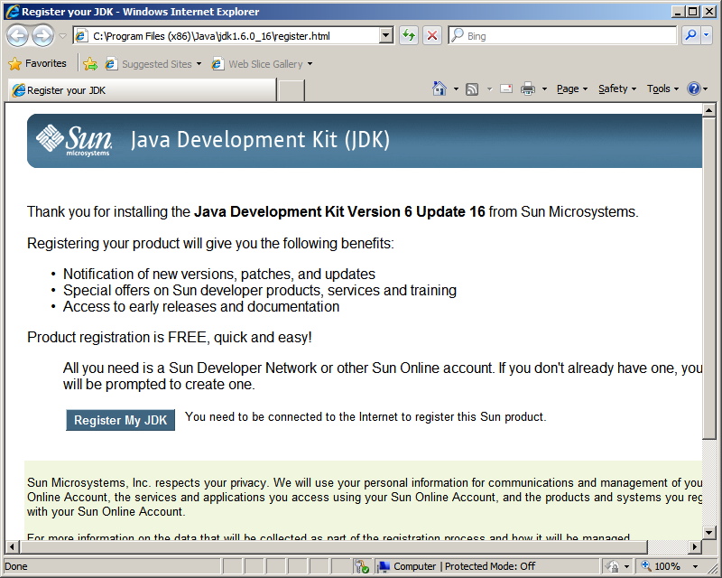
Before installing Web Objects you need to create a Virtual folder in IIS. The following steps are for IIS 6 on Server 2003, the steps for Server 2008 are shown later in the document.
Go to [Start] [A]dministrative Tools] and run “Internet Information Services (IIS) Manager”. Once in IIS, expand the local computer and then right-click on Default Web Site, then go to [New] [Virtual Directory].

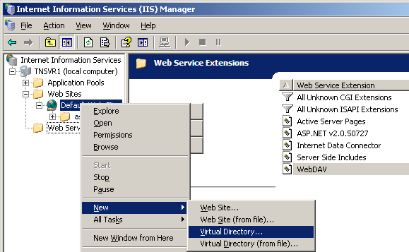

On the “Virtual Directory Creation Wizard” click [Next].

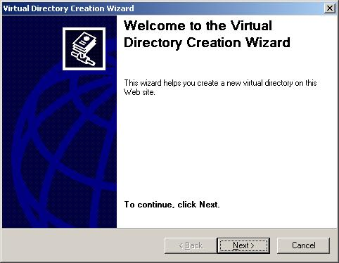
Give the Alias a name of ‘ivproscripts’ and click [Next].

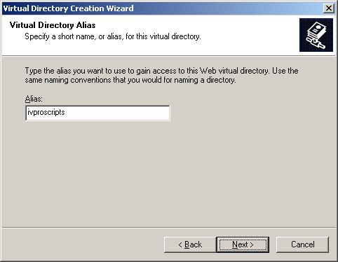

On the “Web Site Content Directory” screen click the [Browse] button.

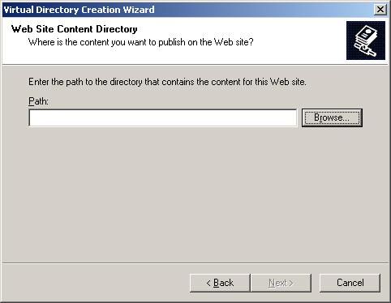

Expand the Local Disk (C:) then click on the Inetpub folder to highlight it. Click the [Make New Folder] button.

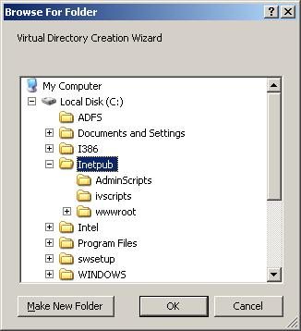

Call the new folder ivproscripts and click [OK].

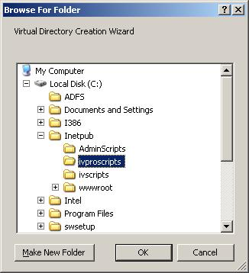

This will enter the path for you so click [Next].

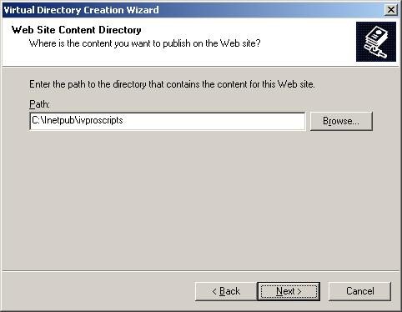

Make sure you have Read and Execute (such as ISAPI applications or CGI) selected and then click [Next].

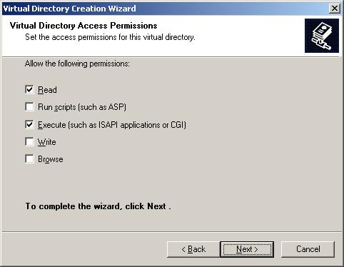

To complete the setup of the virtual folder, click the [Finish] button.

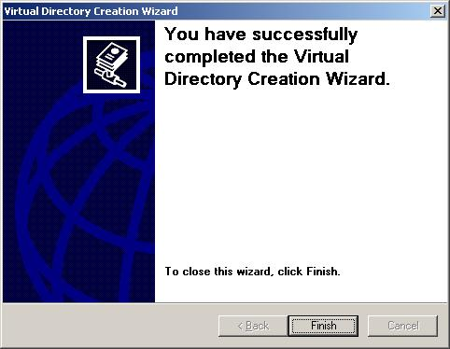
To create the Virtual folder in IIS 7 on Server 2008 go to [Start] [Administrative Tools] and run Internet Information Services (IIS) Manager. Expand the server, then Sites, then right-click on [Default Web Site] and choose [Add Virtual Directory].

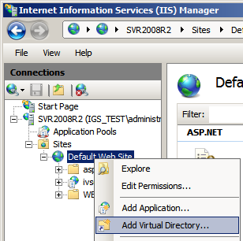

Enter ivproscripts as the Alias name and then click the [browse (…)] button at the end of the Physical path field.

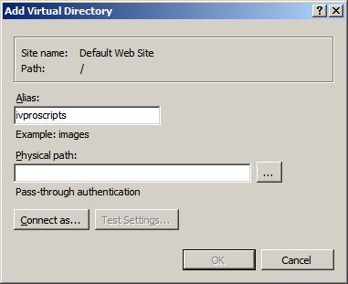
Locate the Inetpub folder and click on the folder name to highlight it. Click the [Make New Folder] button and create one called ivproscripts and click [OK].

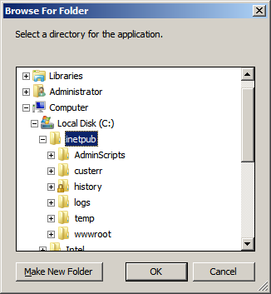

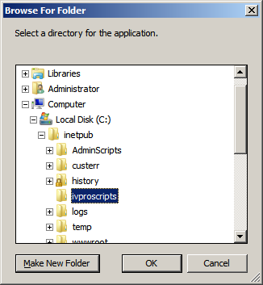
Click [OK].

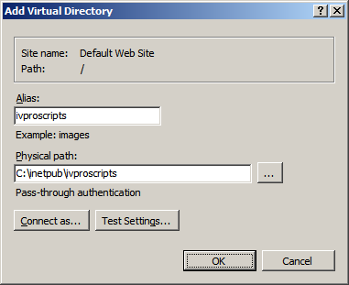

With ivproscripts highlighted in the “Connections” window, double click on Handler Mappings in the IIS section.

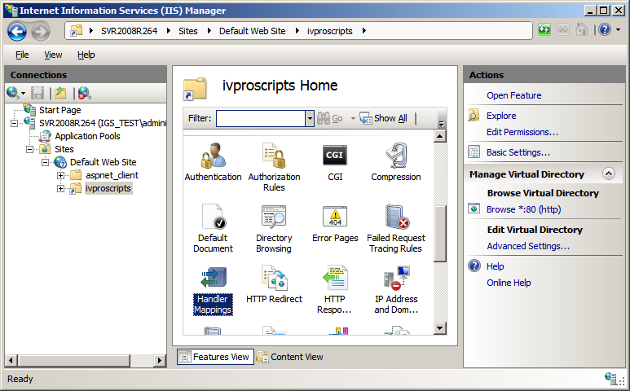
In the “Actions” window click on [Edit Feature Permissions].

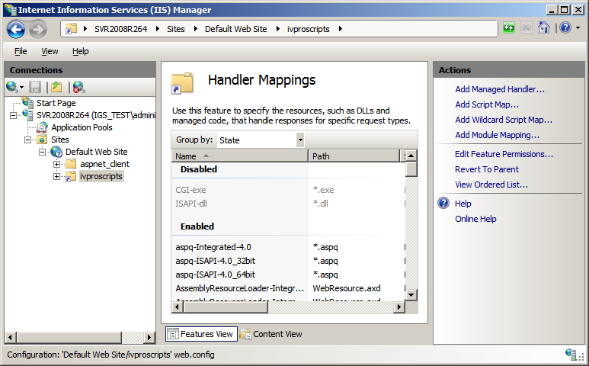

Check the Execute checkbox and click [OK].

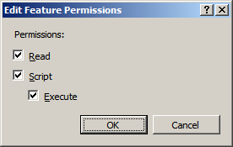
In the “Connections” window right-click on Application Pools and choose [Add Application Pool].

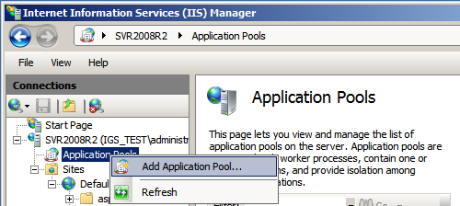

Name the new Application Pool ‘IVPro’ and then click [OK].

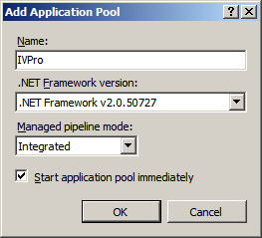

Right-click the IVPro Application Pool and select “Advanced Settings”. In the General section change the status of Enable 32-Bit Applications to ‘True# and then click [OK]. You can now close IIS.

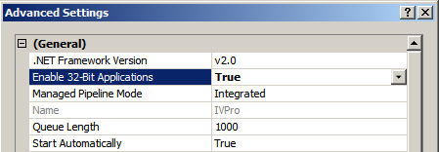

Right-click on the ivproscripts virtual directory and choose [Convert to Application].

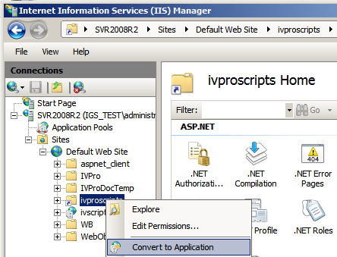

On the “Add Application” screen click the [Select] button and choose ‘IVPro# from the pick list and then click [OK]. Click [OK] to close the Add Application dialog.

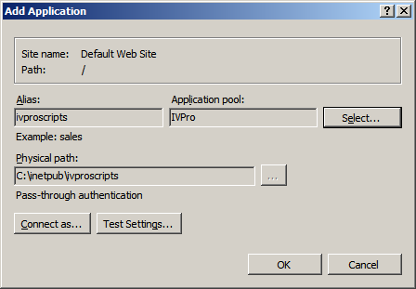

Restart IIS.

On the “Welcome” screen for the install of WebObjects click [Next].

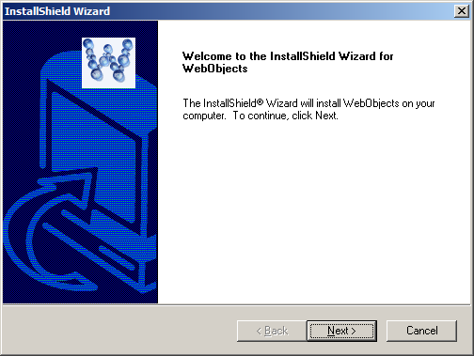

After accepting the Licence Agreement click [Next].

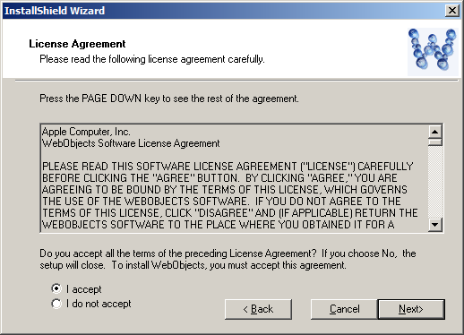
Enter the WebObjects key and click [Next].

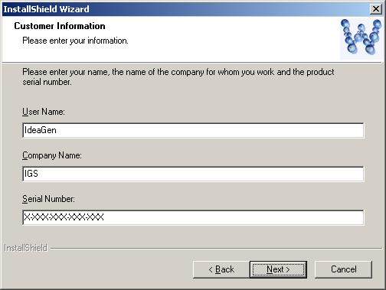

On the “Setup Type” screen click [Next].

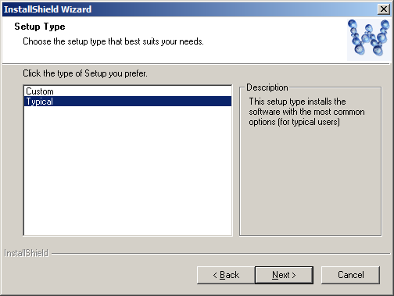
On the “Choose CGI-BIN Directory” screen click the [Browse] button and point to the ivproscripts folder you created earlier and then click [Next].

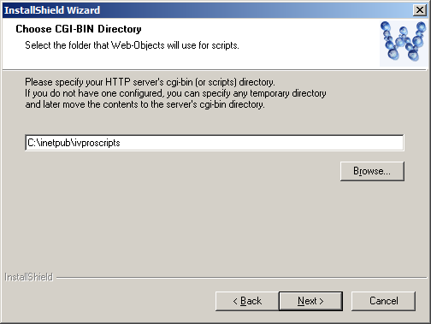

On the “Choose Document Root Directory” screen click [Browse] and point to the wwwroot folder and then click [Next].

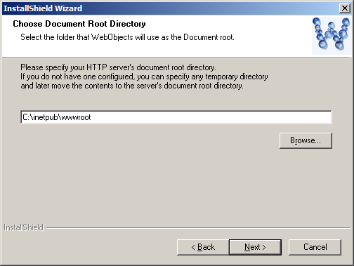
On the “Select Program Folder” screen click [Next].

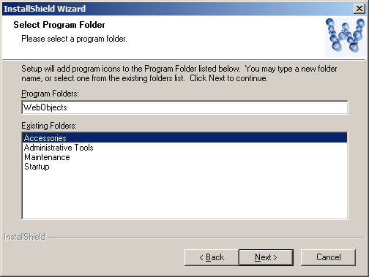

On the “Start Copying Files” screen click [Next].

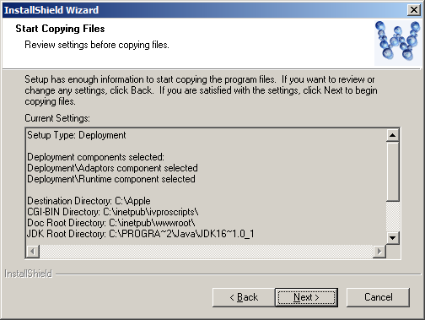
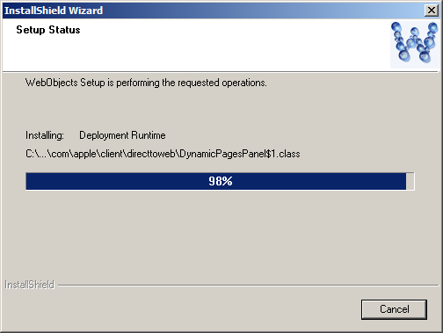

On the “Complete screen” check the No, I will restart my computer later radio button and then click [Finish].

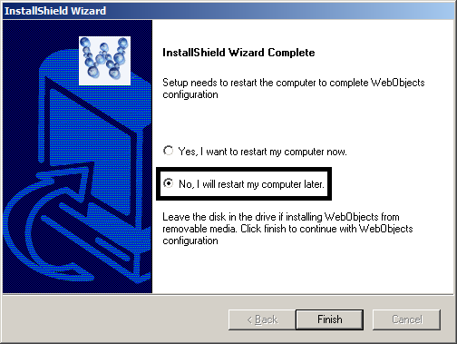
On the “Maintenance Complete” screen click [Finish].

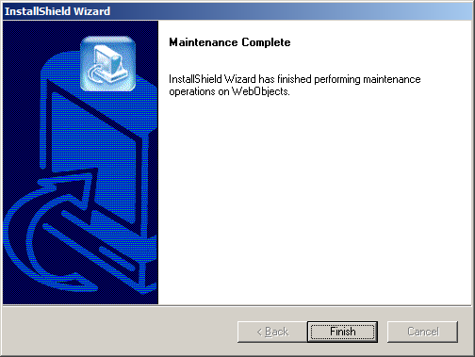
On the “IntraVista Professional 11 Welcome” screen click [Next].

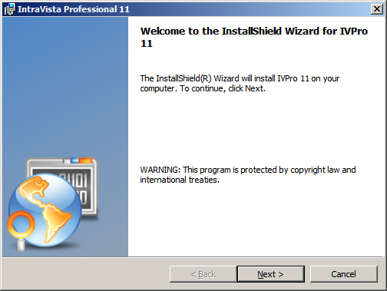

After accepting the Licence Agreement click [Next].

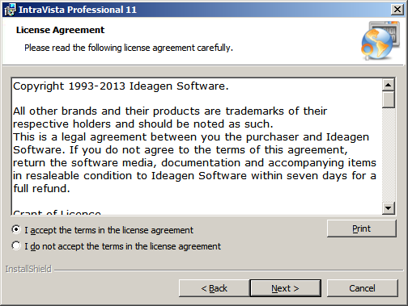
On the “Destination Folder” screen click [Next].

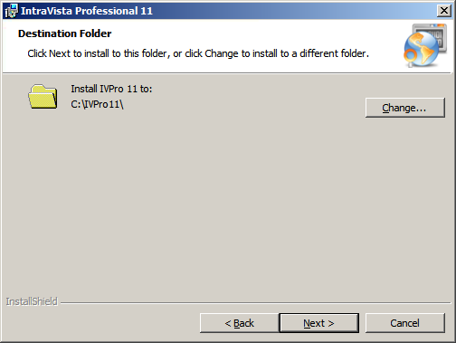

On the “Configuration” screen fill in the Location of Config2005.fdb (prefix this with the server name and a colon), this should be in the root of the fbserver folder (see screenshot below). Enter ‘sysdba’ as the Firebird Username and ‘masterkey’ as the Firebird Password and then click [Next].

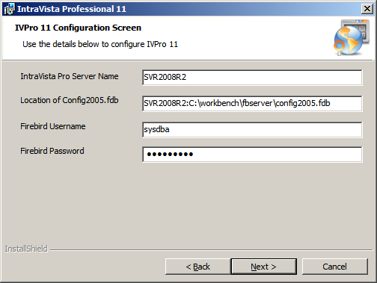
On the “Ready to Install the Program” screen click [Install].

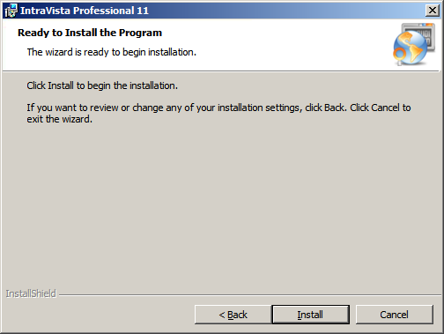

On the “Install Complete” screen click [Finish].

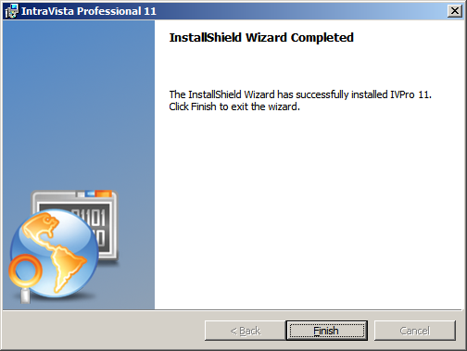
Once the installation has completed click the [Next] button to restart the server.

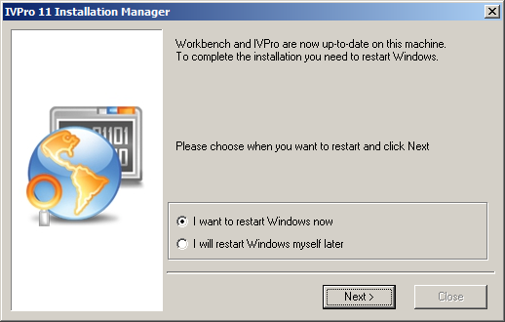

After the server has restarted, open IIS, and with the server name high-lighted, double-click ISAPI and CGI Restrictions.

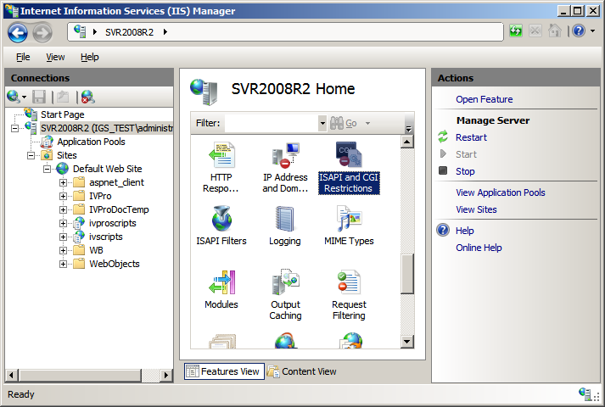

Ensure the WebObjects.dll and .exe files are listed. Close IIS.

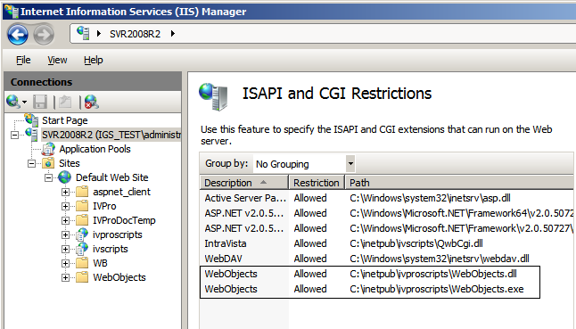

There is a shortcut on the server desktop to IntraVista Professional 11, and this can be sent to all users. The format of the address will be http://IVProServerName/ivproscripts/WebObjects.dll/IVPro.

