Installing Workbench Office V11

Important: You must read the following section

It is essential you ensure that all your data / systems / databases are fully backed up before following any procedure or advice provided. Ideagen Software accept no liability whatsoever for any data loss / corruption / system downtime / business or monetary loss caused either directly or indirectly from the use of the information or utilities provided. Ensure all users are off the system before commencing.

Pre-requisites
You must be running version 11 of Workbench in order to use Workbench Office 11.

It is recommended that Workbench Office be installed on the Workbench server, but it can be installed on any server running IIS 6.0 and above.

You will need a licence file with Workbench Office enabled in order to use it. Please contact Ideagen Software Support to acquire a licence.

Separate add-ins will be required for Office 2007, Office 2010 and Office 2013, these are supplied on the Workbench CD.

You must be running .NET Framework v4.0 or above on your server in order to install Workbench Office.

Workbench client machines must be running .NET Framework v4.0 in order to run Workbench Office.

On the Workbench server, start IIS and click on [Application Pools]. Right-click the Default Application Pool and choose [Advanced Settings]. Ensure .NET Framework Version is ‘v4.0’, Enable 32-Bit Applications is set to ‘True#, and Identity is set to ‘ApplicationPoolIdentity#. Close the Advanced Settings.

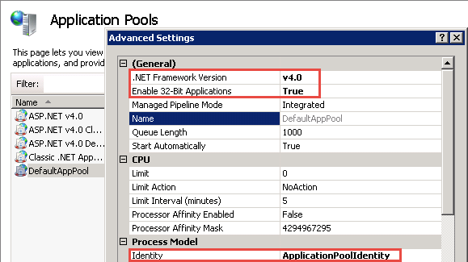

Insert the Workbench CD, and if it auto runs close the [Installation Menu] and instead open the CD in My Computer. Open the Workbench Office | Web Service folder and double-click on the relevant folder for your server type i.e. 64-bit. Double-click the WBOfficeWebServiceSetup file.

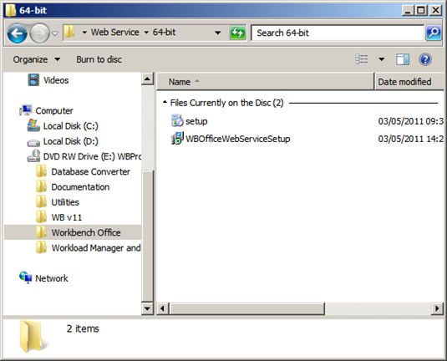
On the “Welcome” screen click [Next].

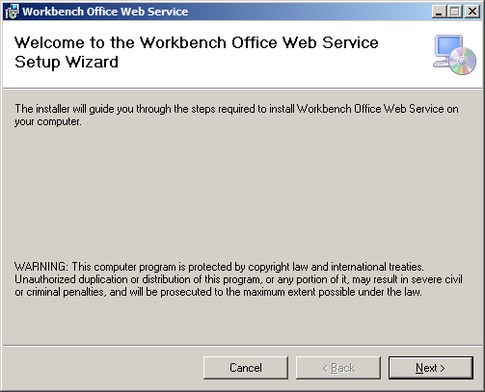

On the “Select Installation Address” screen, the locations can be left as default so click [Next].

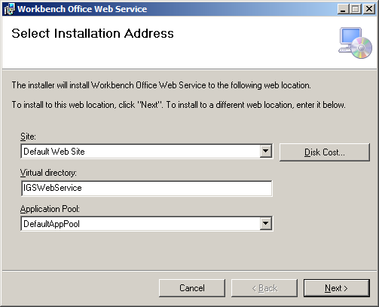

On the “Workbench Office Web Service” screen there are some details to fill in.
The Database server name is the name of the Workbench server.
The Database location asks for the location of the config2005.fdb file. This file is always in the \fbserver folder, but the location of the fbserver folder can vary depending on your install of Firebird\Workbench (see below for an example).
Database username is ‘sysdba’.
Database password is ‘masterkey’.

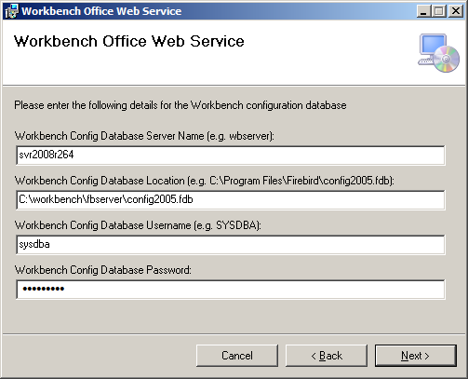

The only difference is if you are installing onto a different server than the one Workbench is installed on. In that case you would add the name of the Workbench server and a colon to the start of the path to the config2005.fdb file (see below).

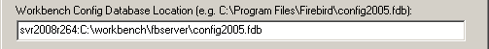

Once this screen has been filled in click the [Next] button.

On the “Confirm Installation” screen click the [Next] button.

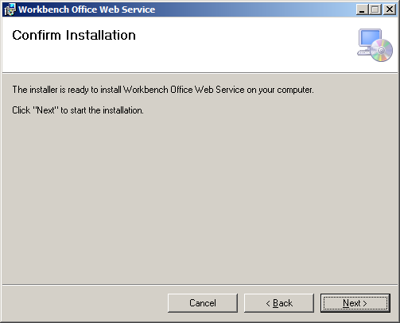

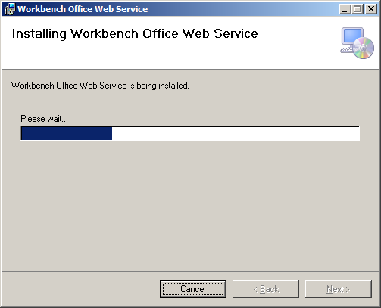

IMPORTANT! On the “Installation Complete” screen there is a URL displayed in a window in the middle of the screen, copy this before clicking the [Close] button.

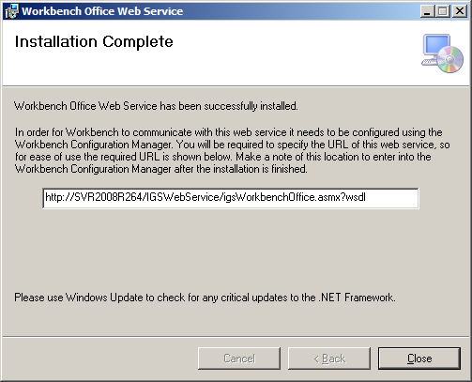

On the Workbench server open the Workbench Configuration Manager and go to the [Workbench Office] tab. Paste the URL into the Location field (the IntraVista Domain Name field is left blank), and then click [Apply] (when asked if you want to restart the services for Workbench click [Yes]). You can then close the Workbench Configuration Manager.

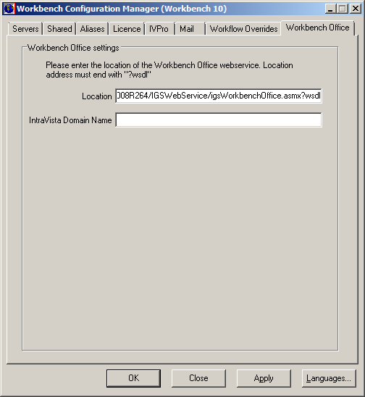

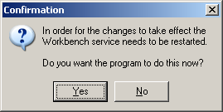
In order for Workbench Office to work with Microsoft Office some add-ins need to be installed (one each for Word, Excel, PowerPoint & Outlook). There are also 32 & 64-bit versions. In the \workbench\qwb_pro folder on the server, there is a folder called Workbench Office Installers.

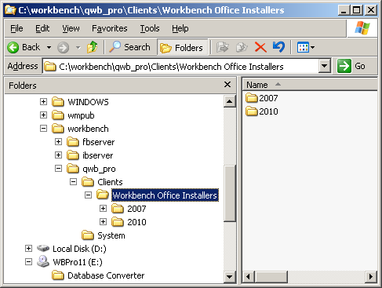
On a Workbench client machine access the share on the Workbench server using the Run box (Windows key + R).

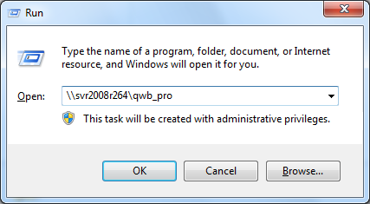

Open the Workbench Office Installers folder and then go to the relevant folder for your Microsoft Office version (for Office 2010 there are both 32 & 64-bit versions). Each Microsoft Office application will have its own installation so open the relevant folder and double-click the setup.exe file.

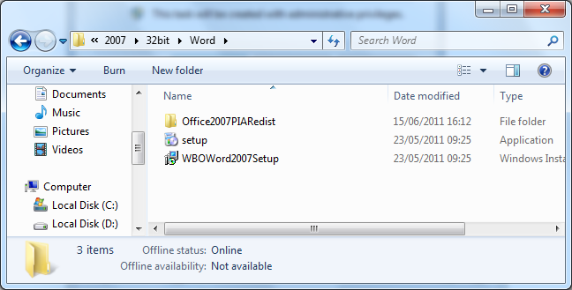
If you receive the following screen it means .NET Framework 4 is not installed. Click the [Accept] button and .NET Framework 4 will be downloaded and installed, and then you can continue with the installation.

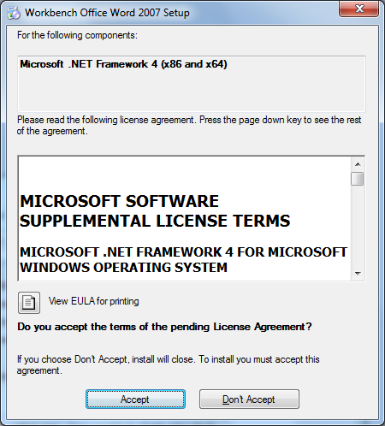
On the “Welcome” screen click [Next].

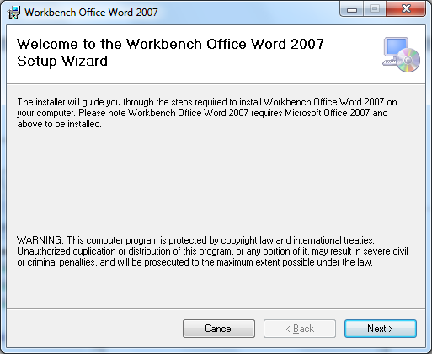

On the “Select Installation Folder” screen click [Next].

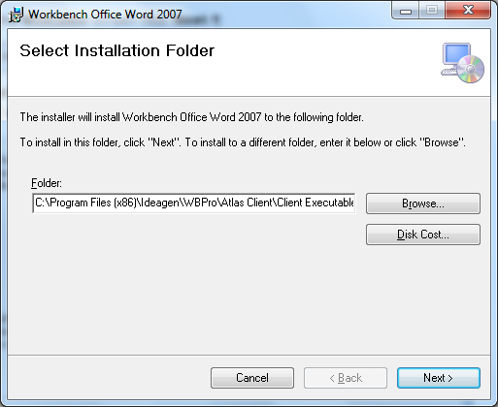
On the “Select Web Service Location” screen you need to enter the URL for the Workbench Office Web Service (this will be on the [Workbench Office] tab of the Workbench Configuration Manager on the server). Click [Next].

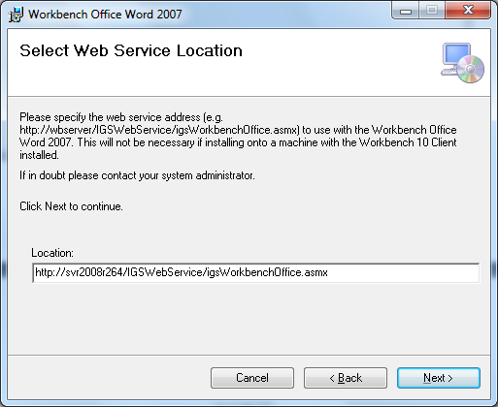

On the “Web Service Cookie Domain Names” screen you only need to enter information in the IVPro Domain and IntraVista Domain fields if you are installing onto a machine that does not have the Workbench client installed. If you do need to enter information into either of these fields it will be the name of the server IVPro or IntraVista is installed on. Click [Next].

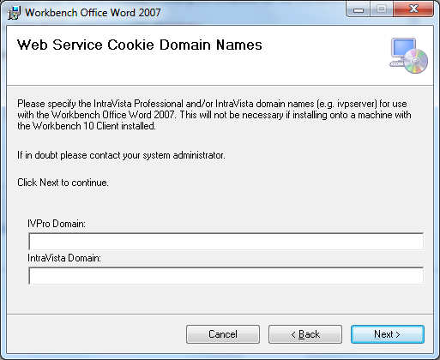
On the “Confirm Installation” screen click [Next].

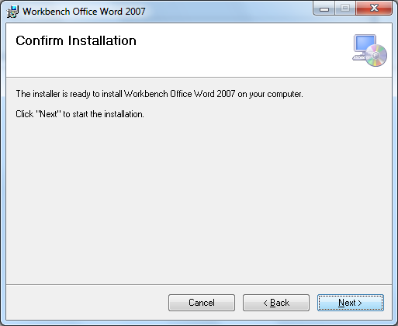
On the “Installation Complete” screen click [Close].

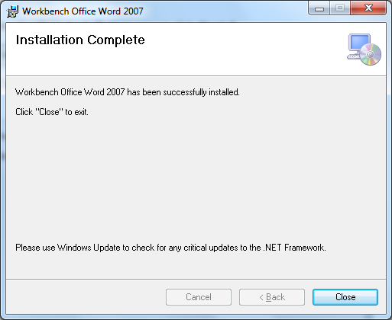

You will need to repeat this process for the Microsoft Office applications you want Workbench Office to work with.

After the installation of the Workbench Office add-ins, run a Workbench client and the options for Workbench Office will appear in the [Workbench Configuration Center] (System Manager module). Expand [New Document Settings] [Document Attributes] [Advanced Document Attributes] and click on Workbench Office for Microsoft Office? Check the Use this workflow setting? checkbox and then [Apply] and [OK]. This means Workbench Office will be enabled for any document created from this point on. If you edit existing documents and add Workbench Office Tags to Word documents, you will need to enable the Workflow on those documents.

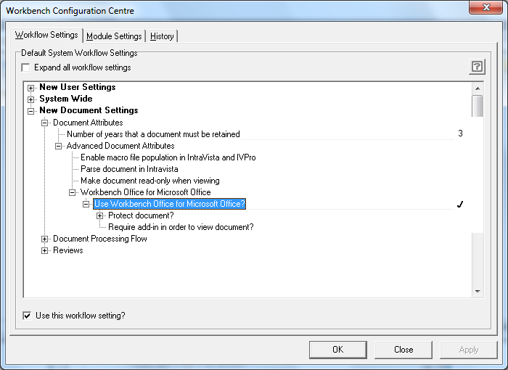

Providing Workbench Office is licenced there will be an extra menu item in the Microsoft Office applications.

