Installing Workbench Version 11

IMPORTANT: You must read the following section

It is essential you ensure that all your data / systems / databases are fully backed up before following any procedure or advice provided. Ideagen Software accept no liability whatsoever for any data loss / corruption / system downtime / business or monetary loss caused either directly or indirectly from the use of the information or utilities provided. Ensure all users are off the system before commencing.

Pre-requisites

You will require a licence file to access the features in Workbench 11.

Installing Workbench

Insert the Workbench 11 CD and it will Autorun. Click the [Workbench 11] icon to start the installation.

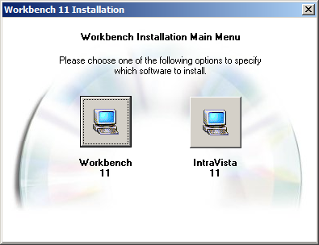

The default language is English so click [OK].

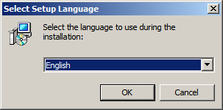

On the “Firebird Welcome” screen click [Next].

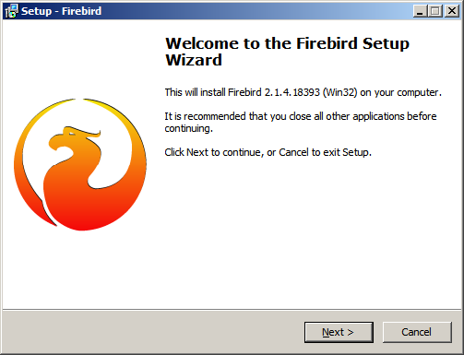

On the “Licence Agreement” screen accept the agreement and then click [Next].

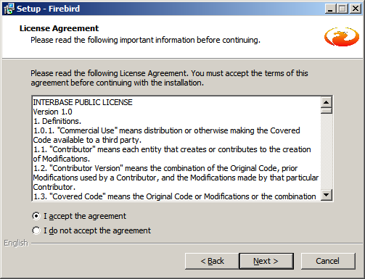

On the “Information” screen click [Next].

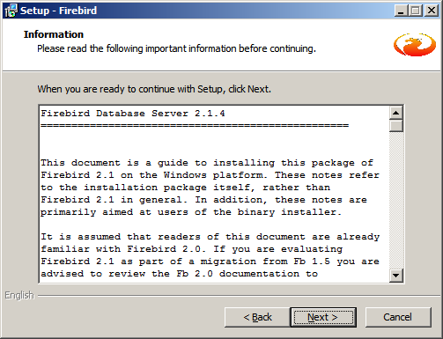

Important! Make sure to change the install folder to <drive>:\workbench\fbserver before clicking [Next].

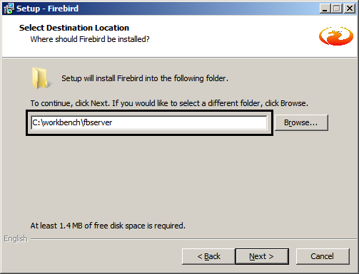

On the “Select Components” screen click Classic Server Binary (for multi-processor/64bit servers) and then click [Next].

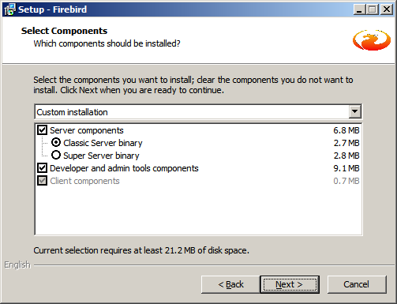

On the “Select Start Menu” screen click [Next].

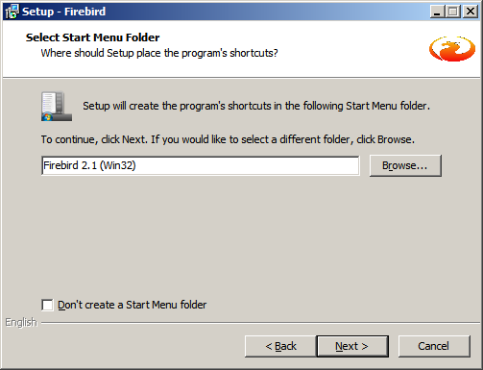

On the “Select Additional Tasks” screen click [Next].

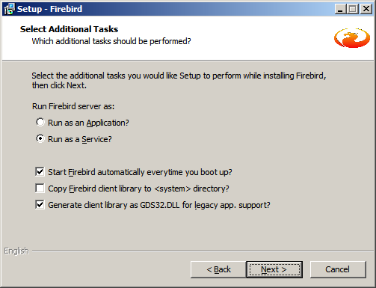

On the “Ready to Install” screen click [Install].

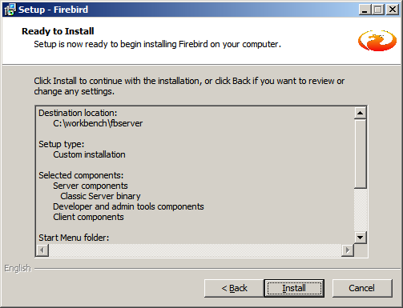

On the “Information” screen click [Next].

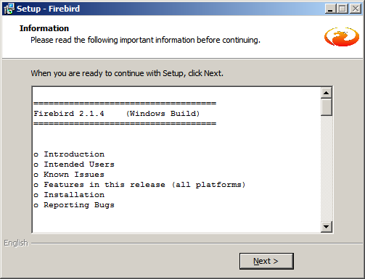

On the “Completing the Firebird Setup Wizard screen”, uncheck After installation – What Next? and then click [Finish].

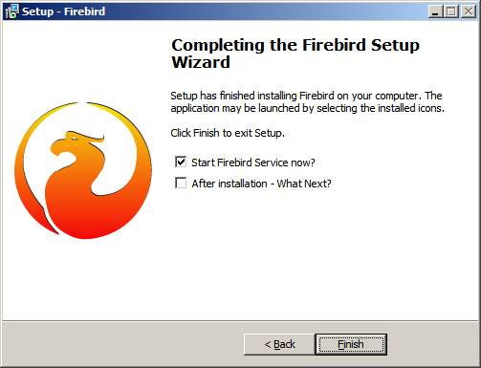

On the “Licence Agreement” screen click [I Agree].

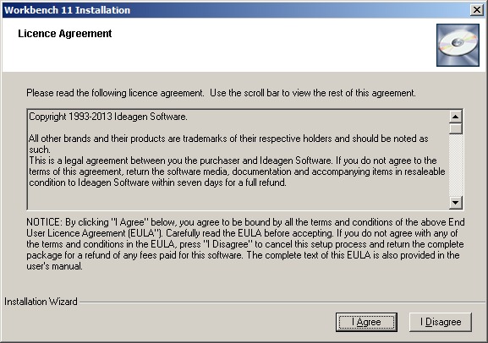

On the “Welcome” screen click [Next].

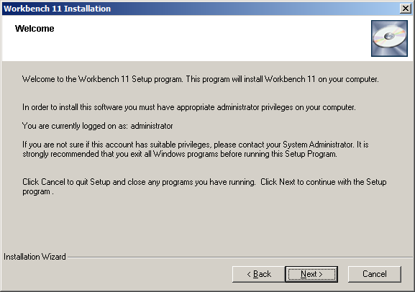

On the “Database Configuration” screen you will almost certainly want to check the Multi Core/Processor option and then click [Next].

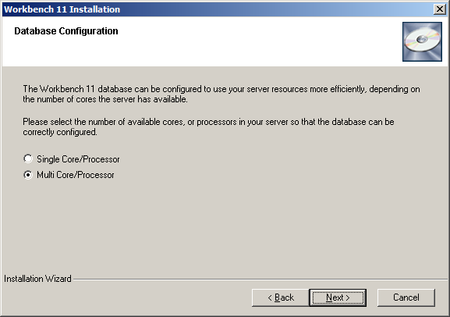

On the “Important Information for Upgrades” screen click [I Agree].

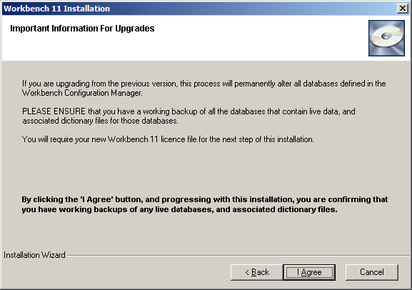

Unless you have a reason to change the Live database name click [Next].

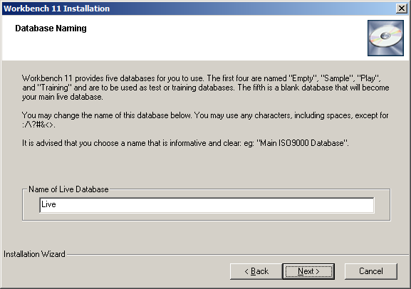

On the “Select Installation Drive” screen click the Change button and browse to the workbench folder (see below) and then click [Next].

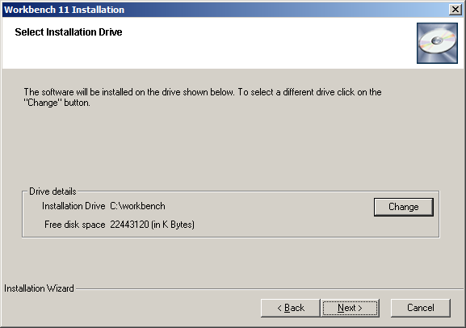

On the “Database and Shared Area Configuration” screen, use the [Browse] buttons to point to the workbench folder and then click [Next].

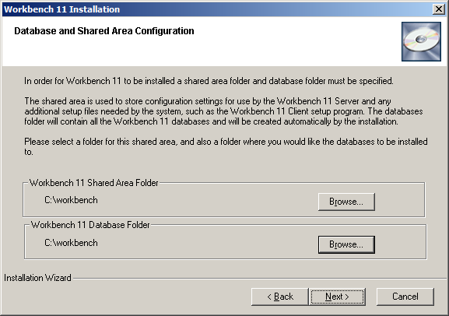

On the “Client Details” screen the default location is C:\Program Files (this is where the Workbench client will be installed to on users’ machines), so just click [Next].

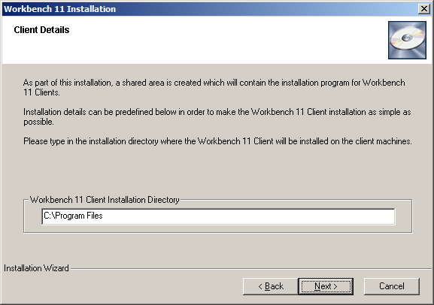

On the “Licence Details” screen use the [Browse] button to locate your v11 licence file and then click [Next].

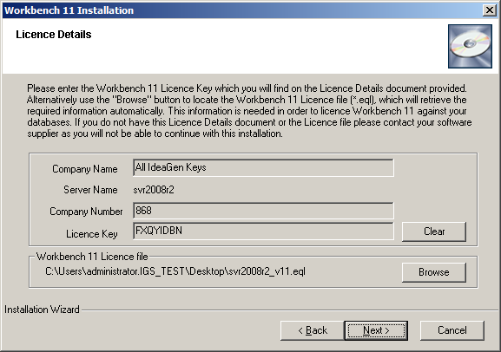

You will be told how many licences Workbench will be installed with so click [OK].

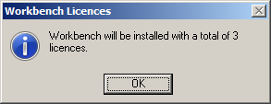

On the “Start Install” screen click [Next].

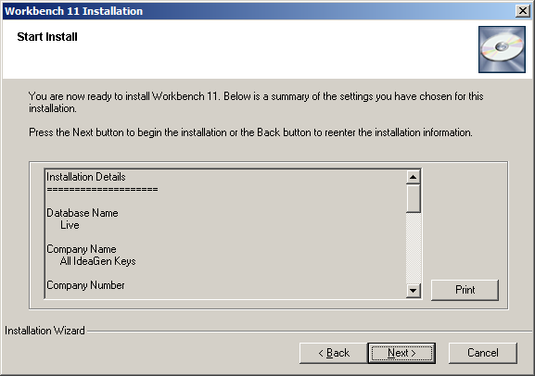

On the “Create Databases” screen click [Next].

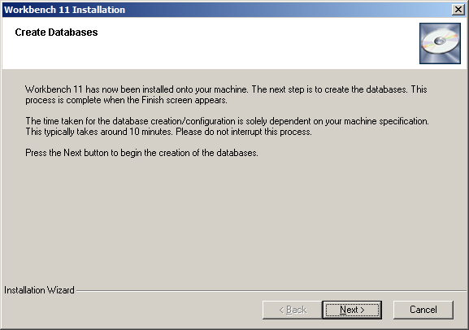

On the “Install Complete” screen click [Finish].

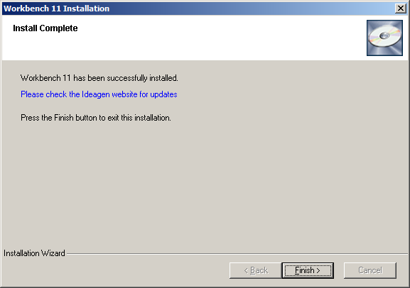

On Server 2008 R2 you need to add a rule for the Firebird and Workbench ports. In Server Manager expand Configuration | Windows Firewall with Advanced Security and right-click on Inbound Rules, and then select [New Rule].

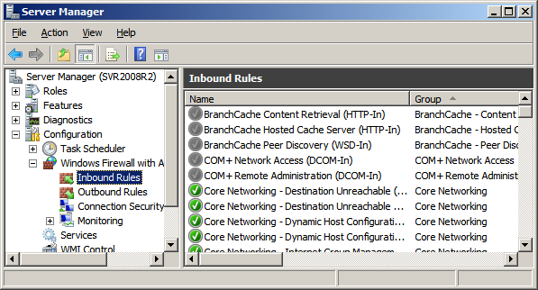

Select [Port] and then click [Next].

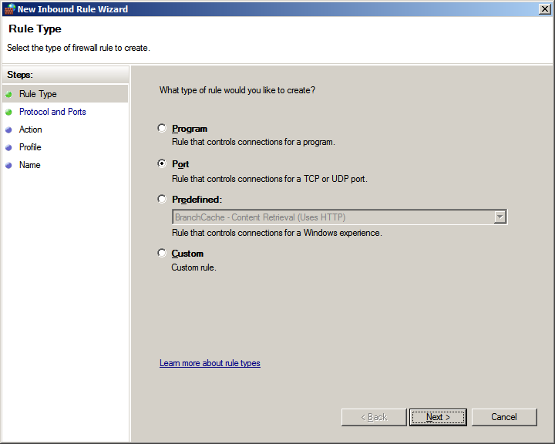

In the Specific local ports field enter 3050, 1240 (note there is a space between the comma and the 1) and then click [Next].

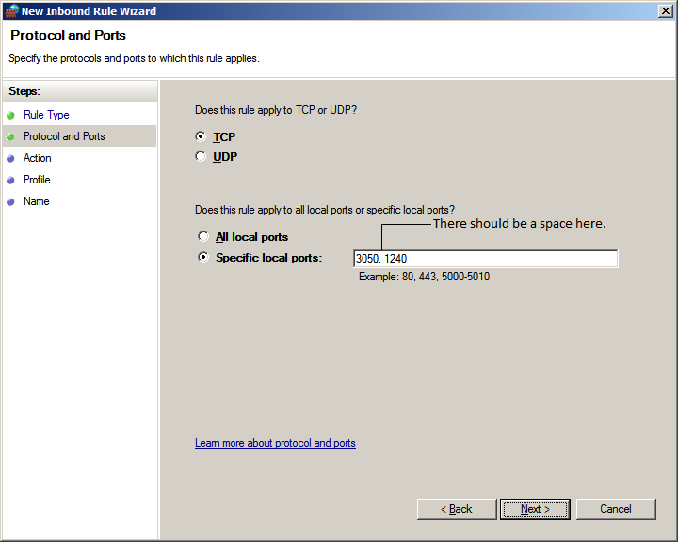

On the “Action” screen Allow the connection should be checked so click [Next].

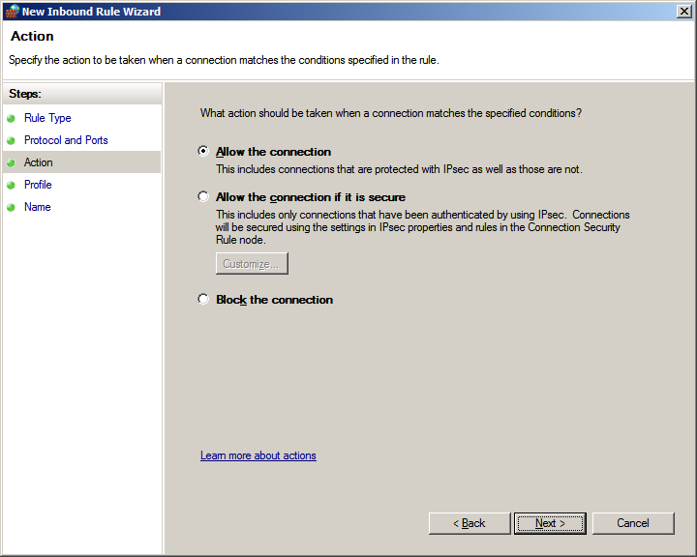

On the “Profile” screen apply the rule to the network/s and then click [Next].

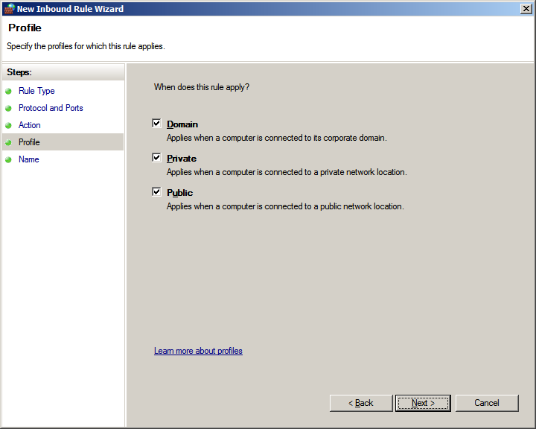

Give the rule a relevant name and then click [Finish].

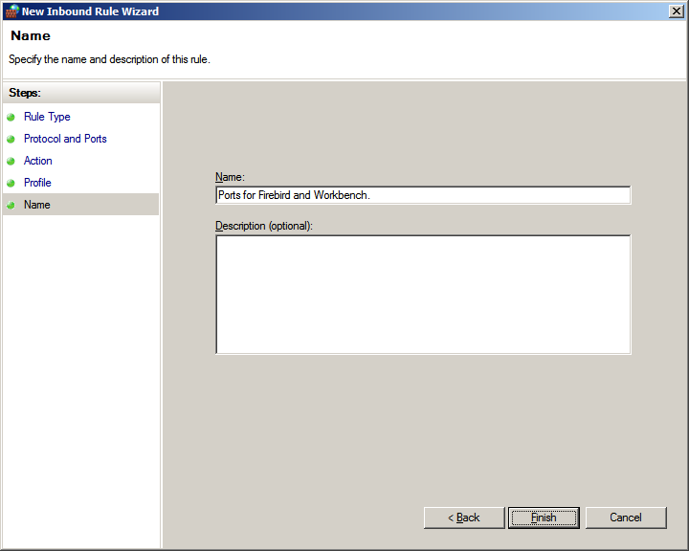

Installing IntraVista 11

If you have also purchased IntraVista 11 (not IntraVista Professional 11) then the next section covers the installation, otherwise you can go straight to the section concerning installing a Workbench client.

In Computer create a new folder called ivscripts under the Inetpub folder.

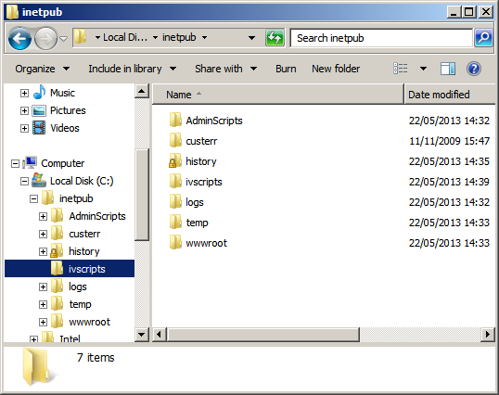

In Internet Information Services (IIS) Manager, right-click Default Web Site and choose [Add Virtual directory].

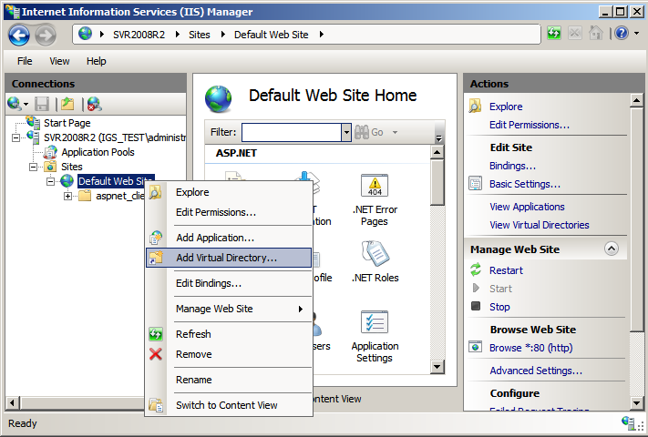

The Alias name should be ‘ivscripts’ and the Physical path should point to the \Inetpub\ivscripts folder, and then click [OK].

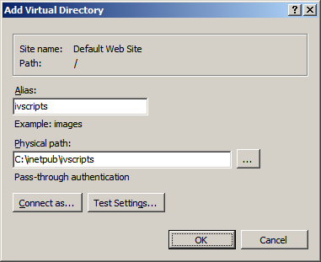

With the ivscripts folder high-lighted double-click on Handler Mappings in the Features View.

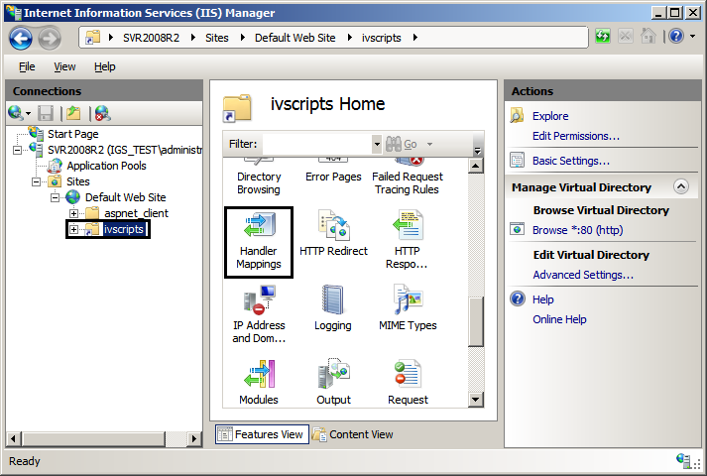

In the “Actions” pane click on [Edit Feature Permissions].

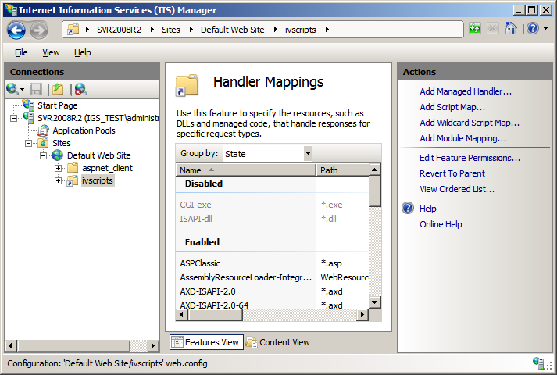

Check Execute (Read and Script will already be checked) and then click [OK].

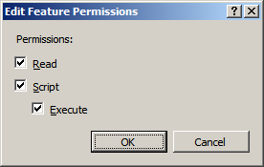

To create an Application Pool for IntraVista right-click [Application Pools] and choose [Add Application Pool].

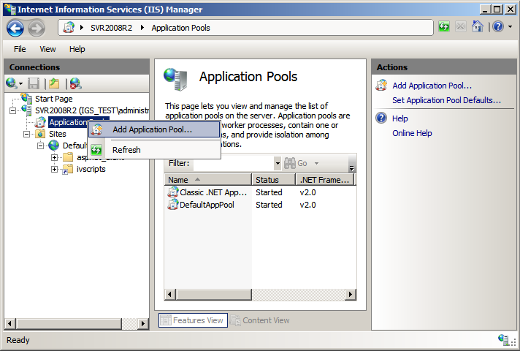

Call the application pool ‘IntraVista’ and click [OK].

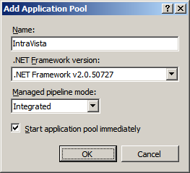

Right-click the IntraVista Application Pool and choose [Advanced Settings]. In the ‘General’ section change ‘Enable 32-Bit Applications’ to ‘True’ and then click [OK].

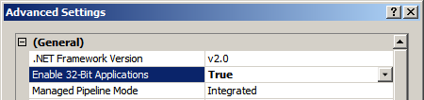

On the “Workbench 11 Installation” Main Menu click the [IntraVista 11] icon.

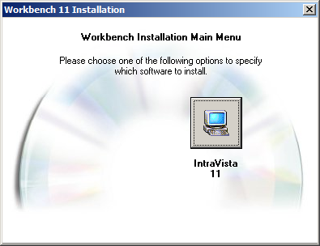

On the “Licence Agreement” screen click [I Agree].

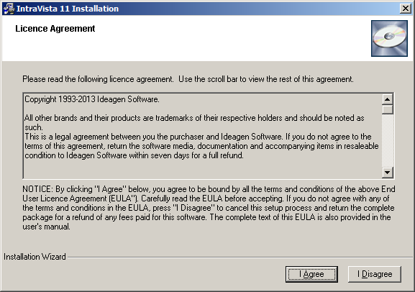

On the “Welcome” screen click [Next].

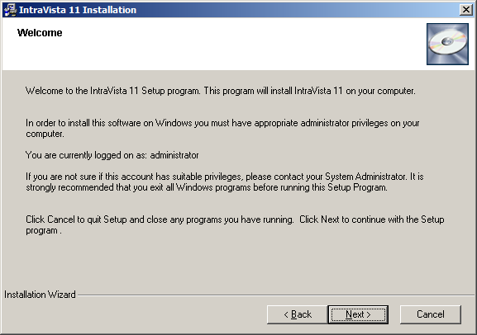

On the “Install Locations” screen, use the [Browse] buttons to point to the \inetpub\ivscripts folder for Web Server Scripts Destination Folder, and \inetpub\wwwroot for Web Server HTML Destination Folder. Click [Next].

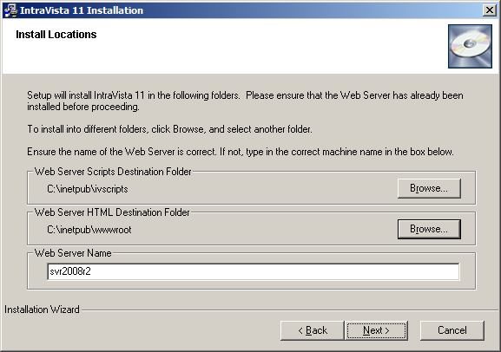

On the “Start Install” screen click [Next].

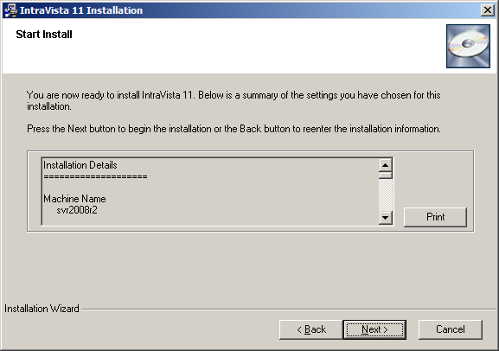

On the “Install Complete” screen click [Finish].

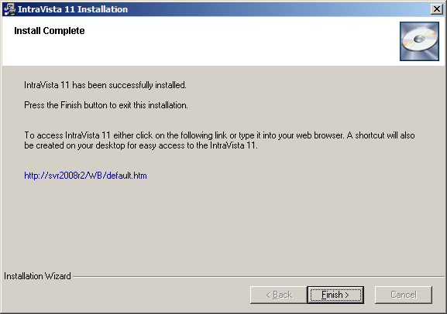

You can now close the “Workbench 11 Installation” main window.

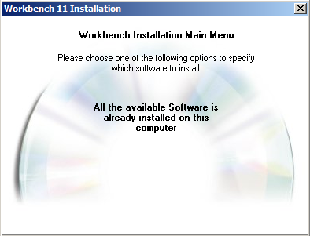

In IIS, with the server name high-lighted, double-click ISAPI and CGI Restrictions.

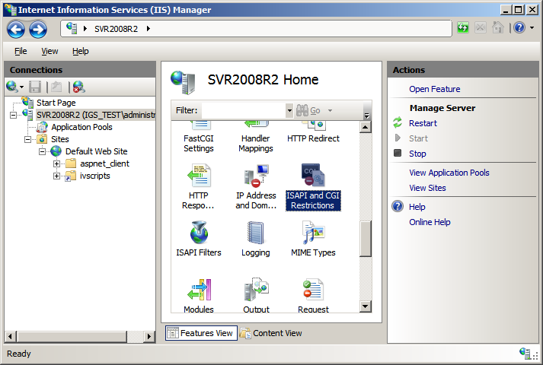

Double-click the IntraVista entry and amend the path from ‘QwbCgi.exe’ to ‘QwbCgi.dll’ and then click [OK].

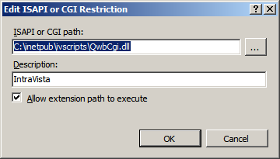

Right-click the ivscripts Virtual Directory and choose [Convert to Application].

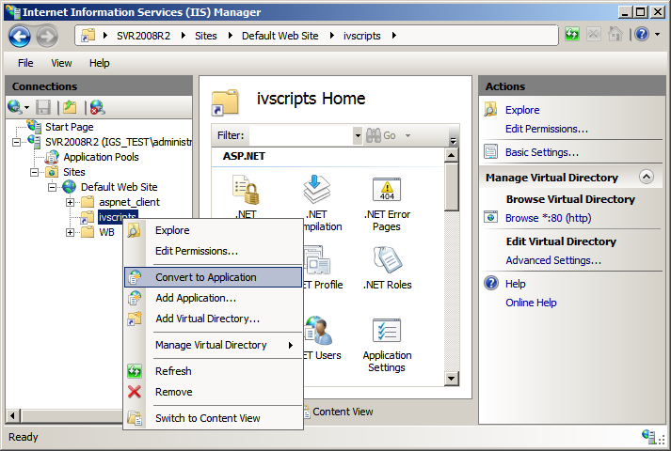

Click the [Select] button and choose the IntraVista Application Pool and then click [OK].

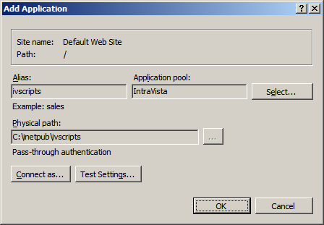

From [Start] [All Programs] [IntraVista 11], run the IntraVista 11 Configuration Manager. Enter a password of masterkey and click [OK]. Edit the Program Name field and change ‘QwbCgi.exe’ to ‘QwbCgi.dll’. Click [Apply] and then [Close].

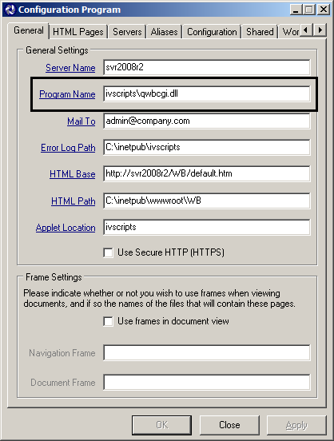

In Computer open the \Inetpub\wwwroot\wb folder and then right-click the default.htm and choose [Open with] [Notepad] (not Open!).

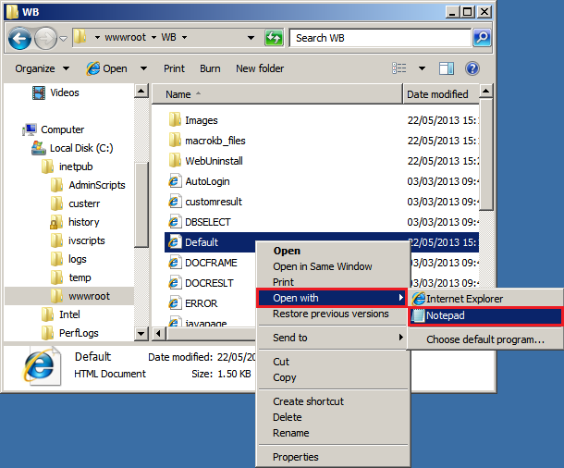

Edit the FORM METHOD, ACTION path to ‘QwbCgi.dll’ and then [Save] and [Close].

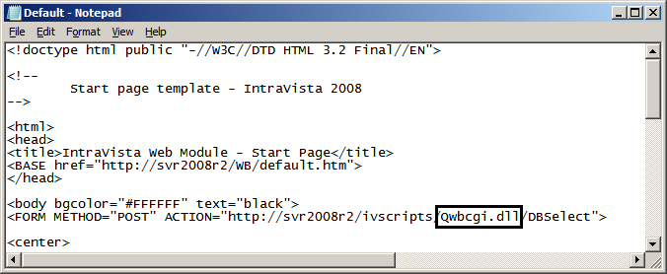

Restart IIS.

To access IntraVista enter the URL (it will be http://servername/wb) and IntraVista will display the start page.

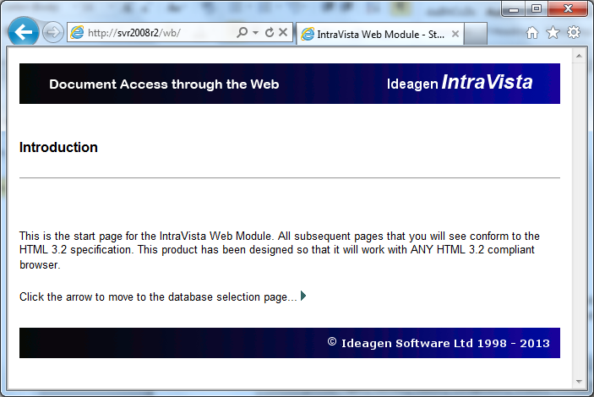

Installing a Workbench client.

From a client machine, access the Clients folder in the Qwb_pro share on the workbench server (this can be done via the Run or Search box e.g. \\server\qwb_pro\clients), and double-click on ClientSetup.exe (if the User Account Control dialog appears click [Yes]). The Workbench client will then be installed without any interaction from the user.

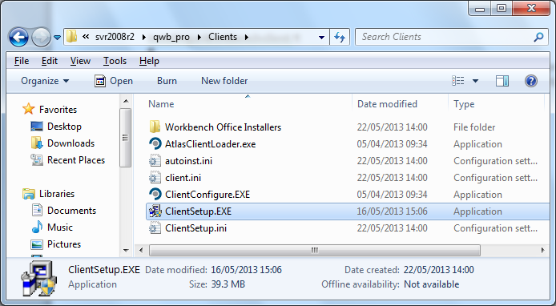

Right-click the Workbench 11 icon and choose [Run as Administrator] (this is a onetime only action). Click [Yes] to the User Account Control dialog.

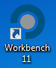

The “New Features in Workbench” dialog appears, click [Close].

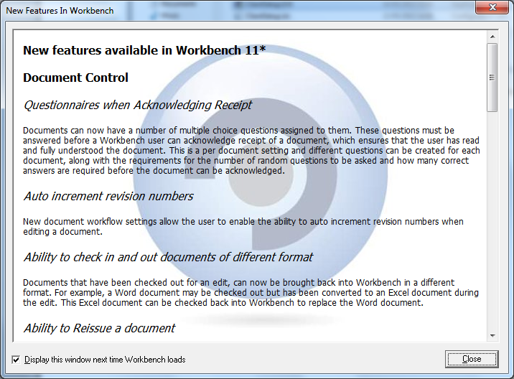

Choose a database and login.

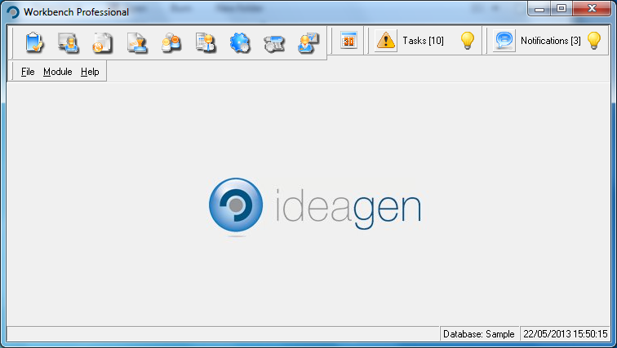

Workbench is now installed at version 11.

